

SIGN LANGUAGE RECOGNITION SYSTEM BASED ON CONVOLUTIONAL NEURAL NETWORKS (CNNS)
SignSpeak: a live webcam recogniser for the ASL alphabet with text and speech output
A project report submitted in partial fulfilment of the requirements for the award of the degree of
BACHELOR OF TECHNOLOGY
in
COMPUTER SCIENCE AND ENGINEERING
Submitted by
AJAY | 24K95A0502
A NAVADEEP REDDDY | 23K91A0514
B MANIDEEP | 23K91A0540
B MAHESHWARI | 23K91A0536
Batch A16 (CSE-A)
Under the esteemed guidance of
V. PALLAVI
[DESIGNATION]
DEPARTMENT OF COMPUTER SCIENCE AND ENGINEERING
TKR COLLEGE OF ENGINEERING & TECHNOLOGY (AN AUTONOMOUS INSTITUTION)
Medbowli, Meerpet, Balapur, Hyderabad, Telangana - 500 097
Academic year [ACADEMIC YEAR]

CERTIFICATE
This is to certify that the project report entitled "Sign Language Recognition System Based on Convolutional Neural Networks (CNNs)" is a bonafide record of the work carried out by AJAY (24K95A0502), A NAVADEEP REDDDY (23K91A0514), B MANIDEEP (23K91A0540), B MAHESHWARI (23K91A0536), in partial fulfilment of the requirements for the award of the degree of Bachelor of Technology in Computer Science and Engineering, during the academic year [ACADEMIC YEAR], under my supervision.

Project Guide | Head of the Department | Principal
V. PALLAVI | [HOD NAME] | [PRINCIPAL NAME]
[DESIGNATION] | Department of Computer Science and Engineering | TKR College of Engineering & Technology

External Examiner: [NAME AND SIGNATURE]
Place: [PLACE]
Date: [DATE]

DECLARATION
We hereby declare that the project report entitled "Sign Language Recognition System Based on Convolutional Neural Networks (CNNs)", submitted to the Department of Computer Science and Engineering, TKR College of Engineering & Technology, in partial fulfilment of the requirements for the award of the degree of Bachelor of Technology in Computer Science and Engineering, is a record of original work carried out by us under the guidance of V. PALLAVI, [DESIGNATION]. The results embodied in this report have not been submitted to any other university or institution for the award of any degree or diploma.

AJAY 24K95A0502
A NAVADEEP REDDDY 23K91A0514
B MANIDEEP 23K91A0540
B MAHESHWARI 23K91A0536

Place: [PLACE]
Date: [DATE]

ACKNOWLEDGEMENT
We express our sincere gratitude to our project guide, V. PALLAVI, [DESIGNATION], for valuable guidance, encouragement and constructive suggestions throughout this project.
We thank [HOD NAME], Head of the Department of Computer Science and Engineering, for providing the facilities and support needed to complete this work, and [PRINCIPAL NAME], Principal, TKR College of Engineering & Technology, for the encouragement given to us.
We thank the project coordinators and all faculty and staff members of the department for their help, and our families and friends for their constant support.
We also acknowledge the authors of the base paper, the creator of the public ASL Alphabet image collection on Kaggle, and the developers of the open-source software used in this project (TensorFlow, Keras, OpenCV, NumPy, scikit-learn, FastAPI, React and Vite).

AJAY
A NAVADEEP REDDDY
B MANIDEEP
B MAHESHWARI

ABSTRACT
Sign language is the main means of communication for many people with hearing or speech impairment, yet few hearing people understand it, and human interpreters are scarce, costly and rarely available for everyday exchanges. This project presents SignSpeak, a real-time recognition system for the American Sign Language manual alphabet that turns hand signs shown to a webcam into text and synthesised speech. A browser camera sends frames to a FastAPI service; a fixed region of each frame is converted to a binary hand mask by grayscale conversion, Gaussian blur, Otsu thresholding and morphology, resized to 64x64 and classified by a three-block convolutional neural network of 2,199,453 parameters into 29 classes (26 letters and the control signs space, delete and nothing). A temporal rule (confidence of at least 0.75, a majority vote over 15 frames and 18 stable frames) decides when a letter is typed; the letters form a sentence that can be spoken. The application also collects images, trains models and reports their performance, and the original desktop application is retained.
Trained on 7,250 images (250 per class) from the public Kaggle ASL Alphabet collection on a CPU-only PC, the network reaches 82.81% accuracy (macro F1 0.830) on a held-out split of 1,088 images. At the 0.75 confidence threshold the system accepts 70.3% of frames and is right on 97.1% of them. A recognition request takes a median of 57 ms (about 17.6 frames per second). 52 automated tests and a 26-check smoke test pass. The held-out split comes from the same recordings as the training images, so accuracy on unseen signers was not measured and is expected to be lower; recognition of words, evaluation on a physical webcam and a user study were not done. The base paper (MAG-KD, skeleton-based video recognition on edge devices) addresses a different task, so the comparison is given as context only.
Keywords: sign language recognition, American Sign Language, convolutional neural network, fingerspelling, hand segmentation, computer vision, deep learning, assistive technology, FastAPI, React.

TABLE OF CONTENTS
CERTIFICATE i
DECLARATION ii
ACKNOWLEDGEMENT iii
ABSTRACT iv
TABLE OF CONTENTS v
LIST OF FIGURES vii
LIST OF TABLES ix
LIST OF ABBREVIATIONS x
CHAPTER 1: INTRODUCTION 1
1.1 Domain and Background 1
1.2 Motivation 2
1.3 Problem Statement 2
1.4 Need for the Project 3
1.5 Objectives 3
1.6 Scope 4
1.7 Contributions 5
1.8 Limitations and Assumptions 6
1.9 Organisation of the Report 6
CHAPTER 2: LITERATURE SURVEY 8
2.1 Overview 8
2.2 Analysis of the Base Paper 8
2.3 Related Work by Theme 10
2.4 Datasets and Algorithms Used in This Project 12
2.5 Strengths and Limitations of the Surveyed Approaches 13
2.6 Sources Named in the Project Survey 13
2.7 Research Gap 13
CHAPTER 3: FEASIBILITY STUDY 15
3.1 Technical Feasibility 15
3.2 Economic Feasibility 16
3.3 Operational Feasibility 16
3.4 Schedule Feasibility 16
3.5 Advantages and Constraints 17
CHAPTER 4: SYSTEM REQUIREMENTS AND ANALYSIS 18
4.1 Existing System and Its Limitations 18
4.2 Proposed System and Its Advantages 18
4.3 Functional Requirements 19
4.4 Non-Functional Requirements 19
4.5 Hardware Requirements 20
4.6 Software Requirements 20
4.7 User Roles 21
4.8 Constraints and Assumptions 21
CHAPTER 5: SYSTEM DESIGN 22
5.1 Design goals 22
5.2 System architecture 23
5.3 High-level workflow 24
5.4 Data flow diagrams 25
5.5 UML diagrams 28
5.6 Database design 30
5.7 Module design 31
5.8 Algorithm design 33
5.9 API design 35
5.10 User interface design 36
CHAPTER 6: METHODOLOGY AND SOFTWARE IMPLEMENTATION 38
6.1 Overall methodology 38
6.2 Dataset 39
6.3 Preprocessing 40
6.4 Algorithm choice and justification 41
6.5 Mathematical formulation 42
6.6 Model architecture and training 43
6.7 Application architecture and implementation 44
6.8 Security and error handling 45
6.9 Installation and execution 46
CHAPTER 7: SYSTEM TESTING 47
7.1 Testing strategy 47
7.2 Unit testing 47
7.3 Integration testing 48
7.4 Functional testing: the smoke test 49
7.5 Security and validation testing 49
7.6 Performance testing 49
7.7 User interface testing 51
7.8 User acceptance testing 52
7.9 Limits of the testing done 52
CHAPTER 8: RESULTS AND OUTPUT SCREENS 53
8.1 Experimental setup and protocol 53
8.2 Output screens 53
8.3 Model performance 59
8.4 Confidence threshold analysis 62
8.5 Other evidence 63
8.6 Comparison with the base paper 63
8.7 Success and failure analysis 64
8.8 Limitations of the results 65
8.9 Objectives against outcomes 65
CHAPTER 9: CONCLUSION 66
9.1 Summary 66
9.2 Objectives achieved 66
9.3 Key findings 66
9.4 Practical applications 67
9.5 Known limitations 67
CHAPTER 10: FUTURE SCOPE 68
10.1 Improvements to the recogniser 68
10.2 Additional features 68
10.3 Scalability and deployment 69
10.4 Further research 69
REFERENCES 70
APPENDIX A: IMPORTANT CODE 72
A.1 Segmentation and normalisation (`sign_language_app/preprocessing.py`) 72
A.2 The network (`sign_language_app/model.py`) 73
A.3 The recogniser (`sign_language_app/recognizer.py`) 73
A.4 Training core (`sign_language_app/train.py`) 74
A.5 Recognition and collection endpoints (`backend/main.py`) 75
A.6 Browser camera (`frontend/src/lib/camera.ts`, frame grab) 76
A.7 Unit tests of the decision logic (`tests/test_recognizer.py`) 77
APPENDIX B: INSTALLATION AND USER GUIDE 78
B.1 Requirements 78
B.2 Installation and start 78
B.3 Preparing data and a model 78
B.4 Using the screens 79
B.5 Running the tests 79
B.6 Troubleshooting 79
APPENDIX C: ADDITIONAL SCREENS 80

LIST OF FIGURES
Figure 1: High-level workflow of SignSpeak from the camera to the spoken sentence. 5
Figure 2: System architecture of SignSpeak: presentation, application and domain tiers with the two file stores. 23
Figure 3: High-level workflow from image collection to spoken sentence. 24
Figure 4: Level 0 data flow diagram: SignSpeak as a single process with four external entities. 25
Figure 5: Level 1 data flow diagram: five processes and three data stores. 26
Figure 6: Level 2 data flow diagram: the six steps inside process 3.0, Recognise signs. 27
Figure 7: UML class diagram of the main classes and modules. 28
Figure 8: Sequence diagram of live recognition and speech. 29
Figure 9: Use case diagram: eight use cases, one human actor and two system actors. 30
Figure 10: Entity-relationship diagram of the file-system data model; SignSpeak has no SQL database. 31
Figure 11: Flowchart of the core algorithm: (A) image pipeline and (B) decision logic. 33
Figure 12: CNN architecture: three convolution blocks and a dense head (2,199,453 parameters). 34
Figure 13: Training pipeline: load and preprocess, split, augment, fit with early stopping, evaluate, save. 35
Figure 14: Landing page of the web application (dark theme). 37
Figure 15: Training pipeline used for the saved model. 38
Figure 16: Class counts and the train/validation/test split. 39
Figure 17: Sample images from the working dataset (one row of letters). 39
Figure 18: Preprocessing stages on real dataset images: colour crop, grayscale, blur, Otsu mask and the final 64x64 input. 41
Figure 19: Training and validation accuracy and loss over the 30 epochs of the saved run. 44
Figure 20: Median latency of each stage of one recognition request. 50
Figure 21: Accuracy under brightness, noise, blur and rotation changes (580 photos). 51
Figure 22: Landing page (dark theme): tagline, pipeline illustration (ROI crop, segmentation, CNN, sentence) and the statistics strip. 54
Figure 23: Landing page: the four features (collect, train, recognize, speak) and the reference to the base paper. 54
Figure 24: Dashboard: model ready, 7,250 images, 29 of 29 classes, 82.8 % test accuracy, images per class and the last training run. 55
Figure 25: Recognize screen: letter H recognised at 87 %, the segmentation mask the network sees, and the sentence built so far. 55
Figure 26: Collect screen: ROI box on the camera view, class L selected, "Captured 5 images for L", mask preview and recent captures. 56
Figure 27: Train screen: dataset coverage of 7,250 images, hyper-parameter fields and the finished run (82.8 % test accuracy). 57
Figure 28: Train screen: live accuracy and loss charts of the run. 57
Figure 29: Model screen: test accuracy and the per-class precision, recall and F1 table. 58
Figure 30: Model screen: confusion matrix of the 1,088 test images. 58
Figure 31: Model screen: training curves. 59
Figure 32: About screen: abstract, the eight pipeline steps and the base paper. 59
Figure 33: F1 of each of the 29 classes on the test split, beside accuracy on other archive photos (optimistic). 60
Figure 34: Confusion matrix of the 1,088 test images (rows true, columns predicted). 61
Figure 35: The most frequent confusions: V read as W (7), E as B (7), V as U (6), S as Y (6). 61
Figure 36: Share of frames accepted and accuracy on the accepted frames for confidence thresholds from 0 to 0.99. 62
Figure 37: Confident mistakes on other archive photos: the raw crop, the mask and the wrong reading. 64
Figure 38: Landing page, light theme. 80
Figure 39: Dashboard, light theme. 80
Figure 40: Model performance screen, light theme. 81
Figure 41: Dashboard at phone width (390x844). 82
Figure 42: Recognize screen at phone width (390x844). 82

LIST OF TABLES
Table 1: Abbreviations used in this report x
Table 2: Organisation of the report 6
Table 3: Results of the base paper [1] (as stated in the paper) 9
Table 4: Comparison of the surveyed work 11
Table 5: Approach families compared 13
Table 6: Additional sources named in the project literature survey 13
Table 7: Technical feasibility checks and what was measured 15
Table 8: Project phases and their products 17
Table 9: Functional requirements and how they are realised 19
Table 10: Non-functional requirements and the measured outcome 19
Table 11: Hardware used for development and measurement 20
Table 12: Software used 20
Table 13: Persistent and in-memory data of SignSpeak 30
Table 14: Module breakdown 31
Table 15: Layers of the network 34
Table 16: The 16 endpoints 35
Table 17: Screens 36
Table 18: Preprocessing steps and their reasons 40
Table 19: Training configuration 43
Table 20: Test layers and results 47
Table 21: Selected unit test cases 47
Table 22: Selected integration test cases 48
Table 23: Latency per frame (milliseconds, 300 frames) 50
Table 24: Accuracy under perturbation 51
Table 25: Held-out test split (n = 1,088) 59
Table 26: Per-class precision, recall, F1 and support (test split) 60
Table 27: Confidence threshold trade-off (test split) 62
Table 28: SignSpeak against the base paper (different tasks, data and hardware) 63
Table 29: Objectives (from the project's objectives document) against outcomes 65
Table 30: User guide 79
Table 31: Common problems 79

LIST OF ABBREVIATIONS
Table 1: Abbreviations used in this report
Abbreviation | Expansion
API | Application Programming Interface
ASL | American Sign Language
BN | Batch Normalisation
CNN | Convolutional Neural Network
CORS | Cross-Origin Resource Sharing
CPU | Central Processing Unit
DFD | Data Flow Diagram
ER | Entity-Relationship
FPS | Frames Per Second
GCN | Graph Convolutional Network
GPU | Graphics Processing Unit
HTTP | Hypertext Transfer Protocol
JPEG / PNG | Image file formats
JSON | JavaScript Object Notation
KD | Knowledge Distillation
MAG-KD | Mask-Guided Adaptive Gating Knowledge Distillation
ReLU | Rectified Linear Unit
REST | Representational State Transfer
ROI | Region of Interest
SLR | Sign Language Recognition
SPA | Single-Page Application
SQL | Structured Query Language
TTS | Text-to-Speech
UI | User Interface
UML | Unified Modeling Language

CHAPTER 1: INTRODUCTION
This chapter introduces the domain of the project, the motivation for building SignSpeak, the problem it addresses, the objectives set for it, the scope that was actually delivered, the contributions, and the limitations and assumptions that govern every result reported later. It closes with a map of the rest of the report.

1.1 Domain and Background
Sign languages are complete natural languages that use the shape, position and movement of the hands, together with the face and body, to carry meaning. For many people with hearing or speech impairment a sign language is the primary means of communication, and it is the way they take part in family life, education and work. Most hearing people, however, never learn a sign language, so a signer who has no interpreter at hand meets a communication barrier in ordinary situations such as a shop counter, a bank queue or a clinic reception [2], [3].
Sign language recognition (SLR) is the branch of computer vision that tries to remove this barrier automatically: a camera observes the signer and software turns the signs into text or speech. Research covers three levels of difficulty [3]. The first is isolated static signs, such as the hand shapes of the manual alphabet. The second is isolated dynamic signs, usually whole words, which need the motion of the hands over time. The third is continuous signing and its translation into sentences of a spoken language [16]. Static recognition is the simplest of the three, but it is also the part that cannot be avoided: names, places and technical terms that have no established sign are spelled out letter by letter with the manual alphabet, called fingerspelling.
This project works at the first level. American Sign Language (ASL) has a manual alphabet of 26 letters, of which 24 are static hand shapes and two (J and Z) are traced in the air. SignSpeak recognises the 26 letters plus three control signs (space, delete and an empty-hand state called nothing) from a live webcam, assembles the letters into a sentence on screen and can read the sentence aloud. The recogniser is a convolutional neural network (CNN), a model family that has been the standard tool for image classification since the work of LeCun et al. [7] and the large-scale results of Krizhevsky et al. [8].

1.2 Motivation
Three observations motivate the project. First, a human interpreter is not available for every conversation: interpreters are scarce and costly, and everyday spontaneous interaction cannot be scheduled in advance. A tool that runs on an ordinary computer with a webcam can cover the many short exchanges for which an interpreter is out of proportion.
Second, the manual alphabet is a practical entry point. A recogniser that reads fingerspelling can already help a signer say a name or a word that has no sign, and it can be trained from a modest number of labelled images, in contrast to word-level video recognition that needs large video corpora [14], [15]. The base paper chosen for this batch, MAG-KD [1], targets the harder video-based problem on edge devices; its concern with real-time operation on modest hardware is shared by SignSpeak, which also aims to run live without a graphics processor.
Third, published systems often stop at a trained model and an accuracy number in a notebook. A working application - one that captures the camera, shows what the model sees, lets a user collect new images, retrain, inspect the results and hear the output - is what turns a classifier into an assistive tool. The team therefore decided to deliver the whole chain from camera to speech and to measure each link honestly.

1.3 Problem Statement
Given a live webcam stream of a signer's hand, recognise the ASL fingerspelling letter being shown (and the control signs space and delete), turn the letters into a sentence on screen and speak it aloud, fast enough to follow the signer and with a stated, measured accuracy - through an application that a non-expert can run.
The project's own problem analysis lists four difficulties that the design must respect:
• Communication between deaf and hearing people breaks down without a human interpreter.
• Interpreters are scarce, costly and unavailable for everyday spontaneous interaction.
• Recognition accuracy degrades with background clutter, lighting change and unseen signers.
• Many published systems classify static images only and cannot run in real time.

1.4 Need for the Project
A usable recogniser has to satisfy several needs at once, and existing work tends to satisfy only some of them. It must be fast enough to follow a signer, which means a response of a few tens of milliseconds per frame and a frame rate of more than ten per second. It must be accurate enough that a typed letter can be trusted, which requires both a good classifier and a rule that refuses to type when the classifier is unsure. It must be robust to ordinary changes in lighting and background, and it must be usable by a person who is not a machine-learning engineer. Finally, it must be reproducible: the dataset, the preprocessing, the training run and the measurements have to be inspectable and repeatable.
The survey of the literature in Chapter 2 shows that the field has moved towards skeleton-based and knowledge-distillation methods for accuracy and efficiency [1], while the gap named in the batch survey is an accessible end-to-end system that recognises signs live and renders them as both text and speech. SignSpeak is built to close that gap for the fingerspelling case, and to report plainly where it does not.

1.5 Objectives
The six objectives approved for the project are:
1. Build a dataset of hand gesture images covering the target sign alphabet and common words.
2. Preprocess images with segmentation, resizing and augmentation to improve generalisation.
3. Design and train a CNN architecture for gesture classification.
4. Optimise the model for real-time inference from a live camera feed.
5. Convert recognised signs into on-screen text and synthesised speech output.
6. Evaluate accuracy, per-class performance and inference latency on unseen signers.
Chapter 8 measures each objective against the outcome. In short, objectives 2, 3 and 5 were met, objectives 4 and 6 only in part and objective 1 only for the alphabet: the recogniser covers letters and control signs, not common words, and no evaluation on signers who were absent from the training data could be made, because the dataset carries no signer identifiers.

1.6 Scope
In scope are the following items, all of which exist in the delivered code base:
• a dataset of 29 classes (A-Z, space, del, nothing): a working set of 7,250 images drawn from the public Kaggle ASL Alphabet archive [25], plus in-application collection of new images from the webcam;
• a preprocessing pipeline of region-of-interest cropping, grayscale conversion, Gaussian blur, Otsu thresholding [17], morphological clean-up and resizing to 64 x 64 pixels;
• a three-block CNN with 2,199,453 parameters, trained with augmentation and evaluated on a held-out split;
• live recognition with confidence thresholding, majority-vote smoothing and a stable-frame rule that decides when a letter is typed;
• a sentence builder and speech output (an offline engine on the host with a browser-voice fallback);
• a FastAPI service with 16 endpoints and a React web interface with a landing page and six application screens, in addition to the original desktop application;
• 52 automated tests, a 26-check smoke test and a measurement script that regenerates every number in this report.
Out of scope are word-level and sentence-level recognition, the motion letters J and Z as motion (they are read from a single frame), two-handed or two-way translation, mobile deployment, user accounts and a clinical or educational field trial.
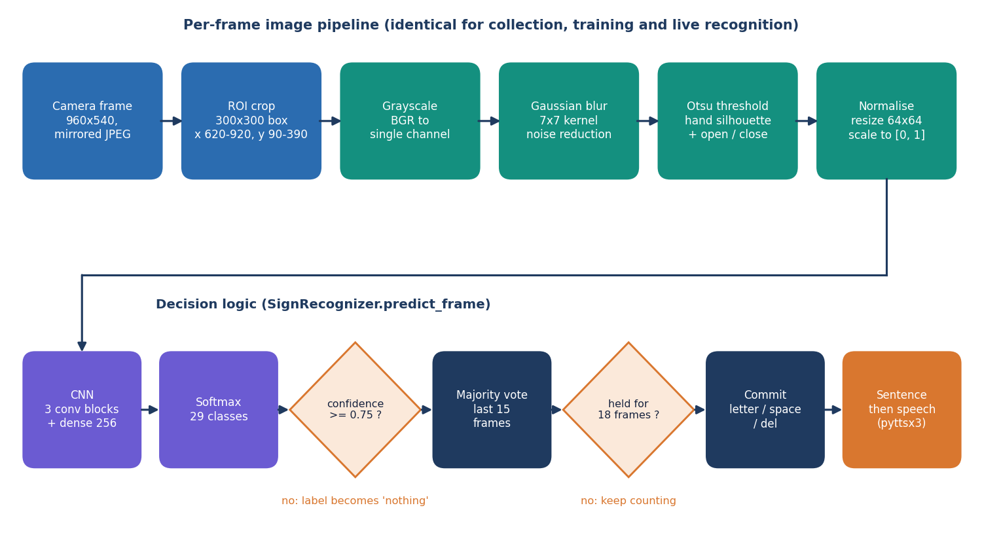
Figure 1: High-level workflow of SignSpeak from the camera to the spoken sentence.

1.7 Contributions
The contributions of the work are practical and are stated at the level the evidence supports:
1. An end-to-end, runnable system for ASL fingerspelling - camera, segmentation, CNN, smoothing, sentence builder and speech - in two forms that share one code path: a desktop application and a web application.
2. A measured baseline for a compact CNN on this task: 82.81% accuracy, macro F1 0.830 and top-3 accuracy 92.9% on a held-out split of 1,088 images, with per-class scores, a confusion matrix and the most frequent confusions.
3. A quantified accept-or-reject rule: at the confidence threshold of 0.75 the system accepts 70.3% of frames and is right on 97.1% of those, which is what makes typed output trustworthy.
4. Measured latency on a CPU-only machine: a median of 52.9 ms per frame on the server and 56.7 ms over HTTP (about 17.6 frames per second).
5. A robustness study (brightness, noise, blur and rotation) and a frank analysis of the dataset's near-duplicate frames, so that readers know which numbers are optimistic.
6. Complete documentation and a verification script that checks the documents against the code and the measurements.

1.8 Limitations and Assumptions
The main limitations are stated here once and repeated where they matter:
• The dataset is made of frames taken from video of a few recordings; neighbouring frames are near-duplicates and no signer identifier is given. The held-out split is therefore a random split of the same recordings and is not an unseen-signer test.
• The Otsu mask often contains background structure, so the CNN partly learns the scene; accuracy on a new background or a new signer is expected to be lower than reported.
• The model is sensitive to hand orientation: a rotation of 10 degrees lowers accuracy from 85.0% to about 68%.
• Only static letters are recognised; there is no word vocabulary and no motion modelling.
• The end-to-end browser test used Chromium's fake camera fed with real photographs; the live webcam path was not exercised on a physical camera on the build machine.
The assumptions are that the signer shows a single hand inside the on-screen box, that the lighting is ordinary indoor lighting, that the background behind the hand is plain, and that the user runs the system on a personal computer with a webcam. The system is a research and teaching prototype and is not a certified assistive device.

1.9 Organisation of the Report
Table 2: Organisation of the report
Chapter | Title | Content
1 | Introduction | Domain, motivation, problem, objectives, scope, contributions, limitations
2 | Literature Survey | Base paper analysis, related work by theme, datasets and algorithms, research gap
3 | Feasibility Study | Technical, economic, operational and schedule feasibility
4 | System Requirements and Analysis | Existing and proposed system, functional and non-functional requirements, environment
5 | System Design | Architecture, workflow, data-flow diagrams, UML, storage design, modules, interface
6 | Methodology and Software Implementation | Dataset, preprocessing, CNN, training, decision logic, API, security, installation
7 | System Testing | Strategy and results of unit, integration, functional, security and performance tests
8 | Results and Output Screens | Measured results, comparison with the base paper, screens, failures, objectives versus outcome
9 | Conclusion | Summary, findings, applications, known limitations
10 | Future Scope | Improvements, features, scalability, research directions

References and three appendices (important code, installation and user guide, additional screens) follow Chapter 10.

CHAPTER 2: LITERATURE SURVEY

2.1 Overview
This chapter reviews the work on which SignSpeak builds and against which it must be judged. It starts with the base paper assigned to the batch [1], analyses it in detail, and then groups related work by theme: early and sensor-based recognition, image-based CNN recognition of the manual alphabet, video and skeleton methods, translation, and model compression. It then describes the dataset and the algorithms that SignSpeak itself uses, summarises the strengths and limitations of the approaches, lists the additional sources named in the project's literature survey, and ends with the research gap.
Two comments on method. Numerical results are quoted only where we read them in the paper itself (this holds for the base paper, from which we extracted the figures directly) or where the reference list of the base paper states the bibliographic details. For the other works the table gives the approach and the stated limitation without reproducing accuracy figures that we did not verify.

2.2 Analysis of the Base Paper
The base paper is "MAG-KD: Mask-Guided Adaptive Gating Knowledge Distillation for Skeleton-Based Sign Language Recognition on Edge Devices" by Vo, Nguyen, Nguyen and Vo, published in IEEE Access in 2026 [1]. Its subject is not the recognition of single hand shapes but the recognition of signs in video with a graph convolutional network (GCN) that works on a skeleton - the coordinates of body, arm and hand joints extracted from each frame by a pose estimator.

Problem and idea
Skeleton-based GCNs, beginning with ST-GCN [11], are efficient and largely indifferent to background, but the strongest models are large. Knowledge distillation [12] compresses a large teacher network into a small student that imitates the teacher's output probabilities. The authors argue that existing multi-teacher distillation assumes that teachers are always right, whereas skeletons from pose estimators (the paper names HRNet and MediaPipe [13]) are noisy because of missing joints, jitter and self-occlusion, so teachers are sometimes confidently wrong and the student copies the error - a failure called negative transfer.
MAG-KD therefore has two mechanisms. A hard correctness mask compares each teacher's top prediction with the ground-truth label and sets the teacher's weight to zero when it is wrong. An adaptive gating network - a small multilayer perceptron over the student's pooled features and the teachers' logits - assigns the remaining teachers their importance, and the masked weights are renormalised so that they sum to one. Distillation is decoupled: intermediate features are aligned by static averaging with a mean-squared-error loss, while the logits are distilled with the gated Kullback-Leibler loss. The input is modelled as a spatio-temporal graph of 27 keypoints per frame, with the usual graph-convolution update
H(l+1) = sigma( sum_j D~_j^(-1/2) A~_j D~_j^(-1/2) H(l) W_j(l) ) (1)
and the gated weight of teacher m for sample i is w_m,i = (w_raw_m,i x M_m,i) / (sum_j w_raw_j,i x M_j,i + epsilon), where M is the binary correctness mask [1].

Experimental set-up reported
The teachers are SL-GCN, CTR-GCN and TD-GCN, frozen and pre-trained; the student is the lightweight STA-GCN. Training used PyTorch 2.1.2 on one NVIDIA RTX A4000 with SGD (Nesterov momentum 0.9, weight decay 1e-4), batch size 64, 150 epochs, initial learning rate 0.1 divided by 10 at epochs 60, 90 and 120. The distillation temperature was 4, both loss coefficients were 1.0, and runs used seeds 1, 42 and 100. The gating module raised the training time per epoch from 82.5 s to 188 s, a cost paid only during training. For deployment the student was exported to ONNX and compiled to a TensorRT FP16 engine on a Jetson Nano (4 GB, 10 W MAXN mode).
Two datasets were used. AUTSL [14] holds 38,336 Turkish Sign Language videos from 43 signers in 20 backgrounds covering 226 sign classes, recorded with a Kinect V2. WLASL-100 [15] is a 100-class subset of the word-level ASL dataset, with 1,442 training and 596 validation videos.

Results reported
Table 3: Results of the base paper [1] (as stated in the paper)
Item | Reported value
AUTSL Top-1, MAG-KD student (0.48 M parameters, mean of three seeds) | 94.25 % +/- 0.19
WLASL-100 Top-1, student baseline STA-GCN | 54.92 % +/- 0.77
WLASL-100 Top-1, MAG-KD | 66.33 % +/- 0.54 (+11.41 points)
AUTSL ablation: correctness mask removed | 85.30 % (a drop of 8.95 points)
AUTSL: soft mask instead of hard mask | 94.20 % (hard mask 94.25 %)
Jetson Nano: throughput and power | 33.13 FPS at 6.23 W
Training time per epoch, baseline versus MAG-KD | 82.5 s versus 188 s

Strengths and stated limits
The paper is careful in several respects: results are averaged over three seeds with standard deviations, an ablation isolates the mask, a second dataset tests language independence, and the edge measurements (latency, power, utilisation, model size) are made on real hardware with a warm-up phase. The authors themselves state two limits: the correctness mask needs ground-truth labels, which rules out semi-supervised use, and the whole system is bottlenecked by the latency and accuracy of the upstream pose extractor in difficult environments [1].

Relation to SignSpeak
It is important to be precise about what SignSpeak takes from this paper and what it does not. SignSpeak does not implement knowledge distillation, graph convolution, skeleton extraction or TensorRT export, and it does not recognise word signs from video. What it shares with the base paper is the motivation - a sign language recogniser should run in real time on modest hardware and be usable outside a laboratory - and the observation that background and pose noise are the practical enemies of recognition. SignSpeak answers with a different modality (a segmented single-hand image classified by a small CNN) for a different task (the static manual alphabet). For that reason the numbers of the two works are not comparable, and Chapter 8 presents the comparison as context only.

2.3 Related Work by Theme

2.3.1 Early and sensor-based recognition
Starner, Weaver and Pentland recognised sentence-level ASL in real time from a desk-mounted camera or a camera worn on the body, using hidden Markov models [4]; the system worked with a restricted vocabulary and grammar. Pugeault and Bowden used a Kinect sensor, which provides colour and depth, to read fingerspelled letters in real time [5]. These works show that fingerspelling is recognisable live, but they depend on special sensors or controlled settings.

2.3.2 CNN recognition of the manual alphabet from images
After CNNs became the standard for image classification [7], [8], several authors applied them to static ASL images. Bheda and Radpour used a deep convolutional network to classify images of ASL letters and digits [6]. The public ASL Alphabet archive on Kaggle [25] made this setting easy to reproduce and is the data source used here. The survey by Rastgoo et al. [3] and the review by Al Abdullah et al. [2] place this static, image-based setting in the wider field and list its recurring difficulties: background clutter, lighting, similar hand shapes (for example the closed-fist letters A, E, M, N, S and T) and dependence on the signer.

2.3.3 Video and skeleton methods
Word-level and continuous recognition needs motion. Three-dimensional convolutions [9], inflated 3D networks [10] and recurrent models process RGB video directly, at a high computational cost. Skeleton-based graph networks such as ST-GCN [11] and its successors operate on joint coordinates and are much cheaper. Pose extraction frameworks such as MediaPipe [13] supply the skeletons. Large benchmarks - AUTSL [14] and WLASL [15] - allow these methods to be compared, and the base paper is a current representative of the line [1].

2.3.4 Translation of signing into text
Camgoz et al. posed sign language translation as a sequence-to-sequence problem that maps sign video to spoken-language sentences [16]. This is the long-term direction of the field; the present project is a small first step at the letter level, followed by a sentence builder that is rule-based rather than learned.

2.3.5 Efficiency and model compression
Edge deployment motivates compression. Knowledge distillation [12] trains a small student on the soft outputs of a large teacher, and the base paper extends it to multiple noisy teachers [1]. SignSpeak takes the other route to efficiency - a model that is small from the start (2.2 million parameters, 26.48 MB) - and reports what that achieves on a CPU.
Table 4: Comparison of the surveyed work
Work | Approach | Data | Reported result | Limitation
Vo et al. 2026 [1] (base paper) | MAG-KD: a small skeleton GCN student distilled from three GCN teachers with a hard correctness mask and an adaptive gate | AUTSL (38,336 videos, 43 signers, 226 signs); WLASL-100 | 94.25 +/- 0.19 % Top-1 on AUTSL with 0.48 M parameters; 66.33 +/- 0.54 % on WLASL-100; 33.13 FPS at 6.23 W on a Jetson Nano | Needs a pose estimator in front of it; correctness mask needs ground-truth labels; video word signs, not fingerspelling
Starner et al. 1998 [4] | Hidden Markov models over features from a desk-mounted or wearable camera | Sentence-level ASL video, restricted vocabulary | Early real-time ASL recognition (figures not quoted here) | Restricted vocabulary and grammar
Pugeault and Bowden 2011 [5] | Colour and depth from a Kinect sensor, Gabor-filter features, classification of fingerspelled letters | ASL fingerspelling captured with a depth camera | Real-time letter recognition (figures not quoted here) | Needs a depth sensor
Bheda and Radpour 2017 [6] | Deep convolutional network on images of ASL letters and digits | Static images of ASL letters and digits | CNNs can classify static fingerspelling images (figures not quoted here) | Static images only; no live pipeline
Camgoz et al. 2018 [16] | Neural sign language translation: sign video to spoken-language text | Continuous sign video with sentence translations | First end-to-end neural video-to-text translation (figures not quoted here) | Needs large annotated video corpora
Sincan and Keles 2020 [14] | AUTSL: multi-modal Turkish Sign Language dataset with baselines | 38,336 videos, 43 signers, 226 signs, Kinect V2 | Benchmark used by the base paper | Turkish signs, not ASL letters
Li et al. 2020 [15] | WLASL: word-level ASL video dataset and method comparison | Large word-level ASL video collection | Benchmark used by the base paper (WLASL-100 subset) | Words in video; heavy models
Rastgoo et al. 2021 [3]; Al Abdullah et al. 2024 [2] | Surveys of deep-learning sign language recognition | Review of datasets and methods | Map the field: static, isolated-word and continuous recognition | Reviews, no system of their own

2.4 Datasets and Algorithms Used in This Project
The dataset is the Kaggle ASL Alphabet archive [25]. The copy used here holds 87,000 training images in 29 folders of 3,000 images (A-Z, space, del, nothing) of 200 x 200 pixels, and a separate test folder of 28 images. A working set of 250 evenly spaced images per class, 7,250 in all, is used for training and evaluation. The archive is derived from video, which is why neighbouring images are almost identical.
The algorithms are standard and are cited to their sources. Segmentation uses Gaussian smoothing and Otsu's threshold [17], which chooses the grey level that maximises the between-class variance of the histogram, followed by morphological opening and closing [18]. Classification uses a CNN whose layers are convolution, batch normalisation [19], max pooling and dropout [20], ending in a softmax over 29 classes. The network is trained with the Adam optimiser [21] on augmented images [22], using TensorFlow and Keras [23], [26]; OpenCV [24] supplies the image operations and FastAPI [27] the web service. The mathematical form of each is given in Chapter 6.

2.5 Strengths and Limitations of the Surveyed Approaches
Table 5: Approach families compared
Family | Strengths | Limitations for a live letter recogniser
Special sensors (depth, gloves) | Robust to background and lighting | Extra hardware; not available on a normal laptop
Static-image CNN | Simple, fast, trains from labelled photos | Sensitive to background, orientation and signer; letters only
RGB video with 3D CNNs | Captures motion; handles words | Heavy computation; needs large video datasets
Skeleton GCNs [1], [11] | Cheap; background-invariant | Depends on a pose estimator; noise from occlusion
Distilled students [1], [12] | Small and fast at test time | Needs trained teachers and labels; complex training

2.6 Sources Named in the Project Survey
The batch literature survey (5.LITERATURE SURVEY) lists five papers, the base paper and four others. For the four others it records only the title, the year and the venue. We were not able to verify their authors or findings, so we list them but do not quote results from them; they are not used as evidence anywhere in this report.
Table 6: Additional sources named in the project literature survey
Title as recorded | Year | Source as recorded | Reference
Sign Language Recognition | 2024 | Sign Language Processing | [28]
Gesture Recognition For Sign Language With AI | 2024 | not recorded | [29]
Implementation Of A Dynamic Gesture Recognition Based Indian Sign Language | 2024 | i-manager's Journal on Pattern Recognition | [30]
Translation Independent Gesture Recognition System for Multilingual Sign Language | 2025 | not recorded | [31]

2.7 Research Gap
The survey shows a field that has moved from image classifiers towards skeleton-based and distillation methods for accuracy and efficiency [1]. Four gaps follow, and they define what SignSpeak sets out to do.
1. Few openly available projects deliver the whole chain from live camera to spoken sentence; most report a model and a number. This is the gap named in the batch survey.
2. Static-image systems rarely report latency, a rejection rule or robustness to rotation and lighting, so their usefulness in a live setting is unknown.
3. Results on frame-derived alphabet data are often reported without noting that neighbouring frames are near-duplicates, which inflates apparent accuracy.
4. An inspectable, reproducible workflow (collect, train, evaluate, recognise) in one tool is uncommon, although it is what lets a teacher or a student retrain the model on new signers.
SignSpeak addresses the first, second and fourth gaps by construction and the third by measurement: it reports the held-out split as the headline and labels the other figure as optimistic. It does not address word-level recognition or unseen-signer generalisation, and Chapter 10 lists these as future work.

CHAPTER 3: FEASIBILITY STUDY
A feasibility study asks whether a project can be built and used with the resources at hand. For SignSpeak the question was answered partly by analysis and partly by building the system and measuring it, so most entries below carry a measured value rather than an estimate.

3.1 Technical Feasibility
The technical risk of the project lay in three places: whether a CNN small enough to train on an ordinary CPU could separate 29 classes well enough, whether the whole recognition chain could run fast enough for live use without a graphics processor, and whether a browser could supply the camera frames reliably to a Python service. The development machine is a desktop with an Intel Core i5-12500 (6 cores, 12 threads) and 15.7 GB of RAM and no GPU. On that machine:
Table 7: Technical feasibility checks and what was measured
Question | Measurement | Verdict
Can the data be loaded and preprocessed quickly? | 7,250 images loaded and preprocessed in 75 s | Feasible
Can the CNN be trained on a CPU? | about 9.9 s per epoch (2-epoch benchmark); the saved run used 30 epochs | Feasible
Is the accuracy useful? | 82.81% on a held-out split of 1,088 images; 97.1% on the frames accepted at threshold 0.75 | Feasible, with a rejection rule
Is the chain fast enough? | server time 52.9 ms median per frame; HTTP round trip 56.7 ms (about 17.6 frames per second) | Feasible
Can a browser feed the service? | getUserMedia capture, 960 x 540 JPEG of about 27 KB per frame, one request in flight | Feasible
Is the model small enough to ship? | 2,199,453 parameters, 26.48 MB file | Feasible

Where the checks are weakest is generalisation. Because the dataset has no signer identifiers, the technical feasibility of recognition for a new signer or a new background could not be established, and Chapter 8 reports that gap rather than hiding it. A second, smaller risk is the dependency chain: TensorFlow 2.15 has to be imported before scikit-learn on Windows, otherwise the native libraries fail to initialise, and the project pins the version and imports in that order.

3.2 Economic Feasibility
The whole software stack is open source: Python, TensorFlow and Keras, OpenCV, NumPy, scikit-learn, FastAPI, Uvicorn, React, Vite and Tailwind CSS. There is no licence cost, and no cloud service is needed at run time because the model and the speech engine run locally. The dataset is a public download; it carries a licence that must be checked on the dataset page before the images are redistributed, since the archive does not bundle it.
The only hardware requirement is a computer and a webcam. We did not record purchase prices and do not quote cost figures. The recurring cost of running the system is the electricity of a desktop for the few seconds of training per epoch and the interactive use. Since no data leaves the machine, there is also no per-call cost and no privacy exposure to a third party.

3.3 Operational Feasibility
A user starts the whole system with one script, run.bat, which creates the virtual environment on the first run, installs the dependencies, starts the API on port 8316 and the web interface on port 5316, and opens the browser. The interface has a landing page and six screens (Dashboard, Recognize, Collect, Train, Model, About). A first-time user can recognise signs immediately if a trained model is present, and can collect their own images and retrain from the same interface if it is not. Retraining on the 7,250-image working set takes minutes on the development machine.
Maintenance is simple because the application is a thin layer over the original modules: the API contains no recognition logic and calls the same functions as the desktop interface, so a fix in preprocessing or in the recogniser reaches both. Operationally, the main requirement is that the signer keeps one hand inside the on-screen box with a plain background; the interface shows the segmentation mask so that the user can see and correct a poor set-up.

3.4 Schedule Feasibility
The calendar dates of the work were not recorded in the project artefacts, so we do not give dates. The work was organised in dependent phases, listed in order with what each produced; the order is the order in which the artefacts exist in the repository.
Table 8: Project phases and their products
Phase | Work | Product
1 | Literature survey, base paper study, problem and objectives | Batch documents 2-6
2 | Dataset acquisition, class layout, preprocessing | preprocessing.py, dataset.py, 7,250-image working set
3 | CNN design, training and evaluation | model.py, train.py, saved model and reports
4 | Live recognition, smoothing, sentence and speech | recognizer.py, tts.py, desktop application
5 | API layer and web interface | backend/ (16 endpoints), frontend/ (landing and six screens)
6 | Testing and measurement | 52 pytest tests, smoke test, measure_metrics.py
7 | Documentation | Decks, chapter documents, report, paper

3.5 Advantages and Constraints

Advantages
• Runs entirely offline on a normal computer; no cloud account, no GPU and no licence fee.
• Fast enough for live use: about 18 frames per second end to end on a CPU.
• Transparent: the user sees the segmentation mask, the confidence and the smoothing state, and can retrain the model.
• Reproducible: one script regenerates every measurement in this report.

Constraints
• Static letters only; no words and no motion.
• Accuracy for new signers and backgrounds is unknown and expected to be lower than the reported figures.
• One hand in a fixed on-screen box; sensitivity to rotation of about 10 degrees.
• A desktop or laptop is required; mobile deployment was not attempted (the phone-width layout of the interface was checked, but the recogniser runs on the host).

CHAPTER 4: SYSTEM REQUIREMENTS AND ANALYSIS

4.1 Existing System and Its Limitations
Today a deaf or hard-of-hearing person who needs to communicate with a hearing person who does not sign relies on a human interpreter, on writing, or on lip reading. Interpreters are scarce and costly, and are rarely available for the everyday, spontaneous exchange. Writing and typing are slow compared with signing and exclude people for whom the written language is a second language.
On the technical side, research systems exist for each part of the problem [2], [3]: depth-camera fingerspelling readers [5], CNN classifiers trained on alphabet images [6], and video and skeleton recognisers for words [1], [14], [15]. Their limitations, as the survey in Chapter 2 shows, are that they usually stop at a trained model, are not packaged for a user, need special sensors or heavy computation, and seldom report latency, a rejection rule or the effect of rotation and lighting.
The project began from an earlier desktop application, written with customtkinter, which already contained the preprocessing, training and recognition modules. It was usable only on the machine it ran on, had a single window, and had no measurement tooling. That application is kept unchanged and is the basis of the web system.

4.2 Proposed System and Its Advantages
SignSpeak keeps the desktop modules and adds a service layer and a web interface. In the browser the user sees the camera with a hand box, the segmentation mask and the recognised letter; the sentence appears below and can be spoken. The same interface lets the user collect images, start and watch a training run, and inspect the resulting model. The processing is identical to the desktop application because the API calls the same functions.
• Complete: camera to speech in one tool, with data collection, training and evaluation in the same place.
• Trustworthy output: a confidence threshold, a majority vote and a stable-frame rule decide when a letter is typed.
• Measured: accuracy, per-class scores, confusion matrix, threshold trade-off, robustness and latency are produced by a script and shown in the interface.
• Private and free: it runs locally, with no cloud dependency or licence cost.
• Extensible: a new class or a new signer's images can be added by collecting and retraining.

4.3 Functional Requirements
Table 9: Functional requirements and how they are realised
ID | Requirement | Realisation in SignSpeak | Where
FR-1 | Show the live camera in the browser with a box marking the hand region | getUserMedia capture; ROI 300 x 300 at x 620-920, y 90-390 of a 960 x 540 frame | Recognize screen
FR-2 | Segment the hand and show the mask to the user | POST /api/preview returns the 128 x 128 mask | Recognize, Collect
FR-3 | Recognise the letter in the box for each frame | POST /api/recognize/frame; CNN over 29 classes | Recognize
FR-4 | Reject low-confidence frames | confidence below 0.75 becomes nothing | recognizer.py
FR-5 | Smooth predictions over time | majority vote over the last 15 frames | recognizer.py
FR-6 | Type a letter only when it is stable | 18 consecutive stable frames, not nothing, different from the last typed letter | recognizer.py
FR-7 | Support space and delete as control signs | space and del are committed labels | Recognize
FR-8 | Show and edit the sentence, and speak it | POST /api/tts/speak (2,000-character limit); offline engine with browser fallback | Recognize
FR-9 | Collect new labelled images from the camera | POST /api/collect/{class}; images saved under data/<class>/ | Collect
FR-10 | Show the dataset (counts, thumbnails) | GET /api/dataset, /api/dataset/{class}/images | Dashboard, Collect
FR-11 | Train the CNN with chosen epochs, batch size and learning rate; stop it; follow progress | POST /api/train/start, /stop; GET /api/train/status | Train
FR-12 | Show model performance: accuracy, per-class scores, confusion matrix, curves | GET /api/model | Model
FR-13 | Reload the model after training without restarting | POST /api/recognize/reload; automatic after a finished run | Train, Recognize
FR-14 | Explain the project | GET /api/about (abstract, pipeline, base paper) | About

4.4 Non-Functional Requirements
Table 10: Non-functional requirements and the measured outcome
Requirement | Target | Measured / evidence | Status
NFR-1 Latency | Server time per frame below 100 ms | median 52.9 ms, p95 57.9 ms | Met
NFR-2 Throughput | More than 10 frames per second end to end | 17.6 frames per second sequential | Met
NFR-3 Accuracy | Reported on a held-out split with per-class scores | 82.81% on 1,088 images | Reported
NFR-4 Reliability of typing | Typed letters should be mostly right | 97.1% on accepted frames at 0.75 | Met by the rule
NFR-5 Robustness | Tolerate lighting, noise and blur | clean 85.0%; noise s=25 83.3%; blur 85.0%; rotation +/-10 deg about 68% | Partly met
NFR-6 Input validation | Bad input returns a clear error and changes nothing | 400, 404, 409 responses; epochs 1-500, batch 1-1,024, learning rate 1e-6 to 1 | Met (tested)
NFR-7 Usability | Usable by a non-expert; readable at phone width | one start script; screens checked at 360, 768 and 1,440 px, light and dark | Met
NFR-8 Portability | Runs on a normal Windows PC | Python 3.11, TensorFlow 2.15 CPU; run.bat | Met on Windows only
NFR-9 Maintainability | No logic duplicated between desktop and web | API calls the same modules as the desktop GUI | Met
NFR-10 Testability | Automated tests | 52 pytest tests; 26-check smoke test | Met

The accuracy requirement is stated as a reporting requirement, not as a target number: the dataset carries no signer identifiers, so a target such as "95 % for any signer" could not be tested honestly.

4.5 Hardware Requirements
The system was developed and measured on one machine; we report its specification rather than an invented minimum. A smaller machine may work but was not tested.
Table 11: Hardware used for development and measurement
Item | Specification
Processor | 12th Gen Intel Core i5-12500 (6 cores / 12 threads)
Memory | 15.7 GB RAM
Graphics processor | none used (CPU-only TensorFlow)
Camera | a webcam is required for live use; the build-machine tests used Chromium's fake camera
Storage | model file 26.48 MB; working set of 7,250 images; the full archive is 87,000 images
Operating system | Windows 11 (Windows-10.0.26200)

4.6 Software Requirements
Table 12: Software used
Component | Version / package | Role
Python | 3.11.9 | language of the recogniser and the API
TensorFlow / Keras | 2.15.0 | CNN definition, training, inference [23], [26]
OpenCV | 4.11.0 | image decoding, thresholding, morphology [24]
NumPy | 1.26.4 | array computation
scikit-learn | latest compatible | split, metrics
FastAPI and Uvicorn | latest compatible | web service, 16 endpoints [27]
customtkinter, pyttsx3 | latest compatible | desktop interface; offline speech
Node.js toolchain | Vite 8, TypeScript 5.9 | build of the web interface
React and routing | React 18.3, React Router 7 | web interface
Tailwind CSS | 4.x | styling
TanStack Query, Recharts | 5.x, 3.x | data fetching, charts
pytest, Playwright | installed in the environment | tests, screenshots

4.7 User Roles
The system has a single role: the local user, who may be the signer or a helper. There are no accounts, passwords or permissions, because the application runs on the user's own computer and serves only that computer. The consequence is that anyone with access to the machine can collect images, retrain the model and replace it; multi-user operation would need authentication and is listed under future scope.

4.8 Constraints and Assumptions
1. The signer shows one hand inside the on-screen box; two-handed signs are out of scope.
2. The background behind the hand is plain and the lighting is ordinary indoor lighting; Otsu thresholding does not isolate a hand on a cluttered background.
3. Only the static letters, the two control signs and the empty state are recognised; J and Z are read from one frame.
4. The training data are the public ASL Alphabet frames or images the user collects; they have no signer labels, so generalisation to a new signer is not guaranteed.
5. TensorFlow is imported before scikit-learn, as required by the Windows native libraries.

CHAPTER 5: SYSTEM DESIGN

5.1 Design goals
The design follows from the requirements of Chapter 4. It must (i) run the same preprocessing and model for collection, training and recognition; (ii) keep the heavy work (TensorFlow) in one process and the camera in the browser so that no native camera code is needed; (iii) respond fast enough for a signer to see a letter within a fraction of a second; (iv) work offline on one Windows PC with no GPU; and (v) leave the original desktop application untouched so that the web version is an addition and not a rewrite.
• Reuse over rewrite. The FastAPI layer contains no recognition or training logic; every endpoint calls a function of sign_language_app.
• Stateless where possible. Only the recognition session (the smoothing history) and the training job carry state; everything else is read from files.
• Fail loudly and politely. Every endpoint validates its input and returns a clear message with a 4xx code instead of a stack trace.
• Honest numbers. The Model screen shows the true held-out accuracy of the saved model, not a figure typed into the interface.

5.2 System architecture
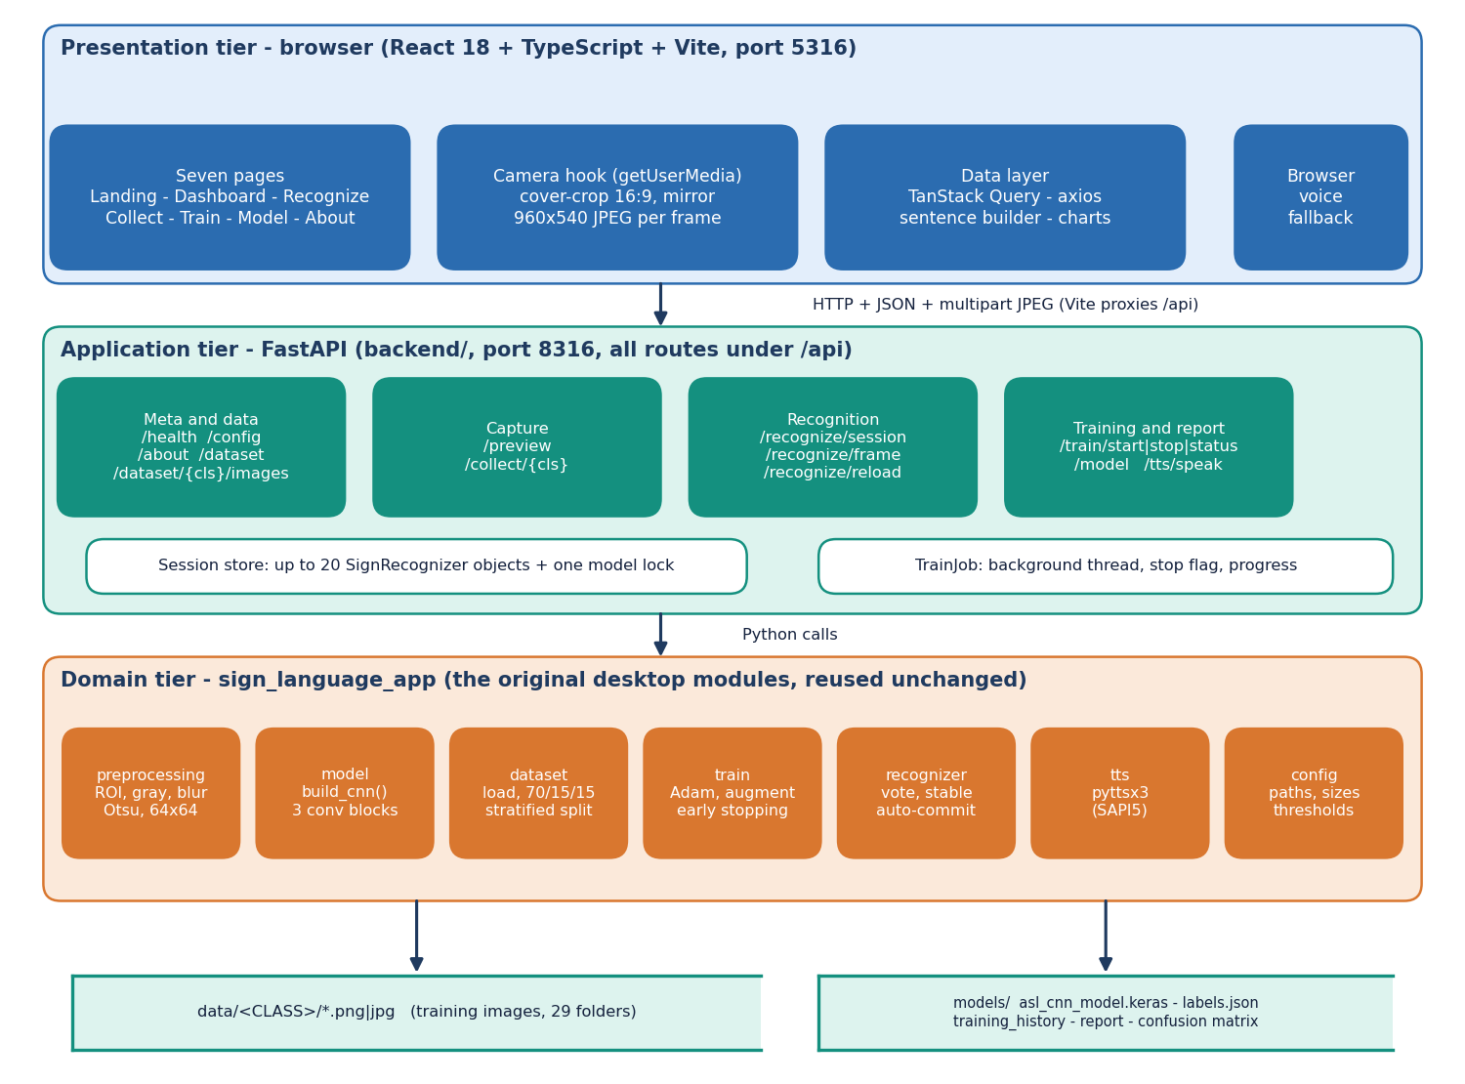
Figure 2: System architecture of SignSpeak: presentation, application and domain tiers with the two file stores.
The system has three tiers over two stores. The presentation tier is a React 18 + TypeScript application served by Vite on port 5316; it owns the webcam through the browser's getUserMedia call, cover-crops each frame to 16:9, mirrors it and uploads it as a 960x540 JPEG. The application tier is a thin FastAPI service on port 8316 (backend/): 16 endpoints under /api, a store of at most 20 recognition sessions, one lock around the Keras model and a background training thread. The domain tier is the original desktop application's package sign_language_app (preprocessing, model, dataset, train, recognizer, tts, config), reused unchanged, so the web and desktop versions cannot drift apart. Training images are kept in data/<CLASS>/ and the trained model with its reports in models/. There is no SQL database.
The browser-to-server contract is deliberately narrow: JSON for control and results, multipart JPEG for frames. In development the Vite server proxies /api to port 8316, so the interface never needs to know the API's address and CORS is not exercised; the API nevertheless allows cross-origin calls for other front ends.

5.3 High-level workflow
Figure 3: High-level workflow from image collection to spoken sentence.
The workflow has two halves. The offline half gathers labelled hand images (own captures in the Collect screen or the public ASL Alphabet set), preprocesses them with the same pipeline used at run time, trains the CNN with augmentation and early stopping, evaluates it on a held-out split and stores the model with its reports. The online half starts the camera, sends frames to the recogniser, smooths the predictions, appends a letter to the sentence when a sign has been held steadily, and speaks the sentence on request. Training and recognition share one preprocessing function, which removes a common source of train/serve mismatch.

5.4 Data flow diagrams

5.4.1 Level 0
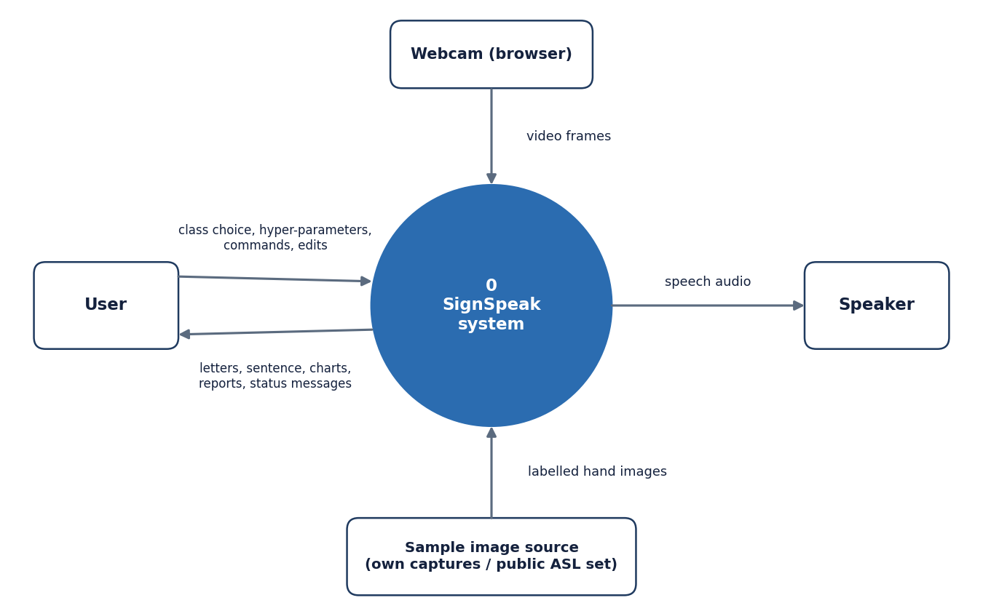
Figure 4: Level 0 data flow diagram: SignSpeak as a single process with four external entities.
At the context level SignSpeak is one process. The user supplies class choices, hyper-parameters and commands and receives letters, the sentence, charts, reports and status messages. The browser webcam supplies video frames. A sample-image source (the user's own captures or the public ASL Alphabet images) supplies labelled hand images. The speaker receives synthesised speech.

5.4.2 Level 1
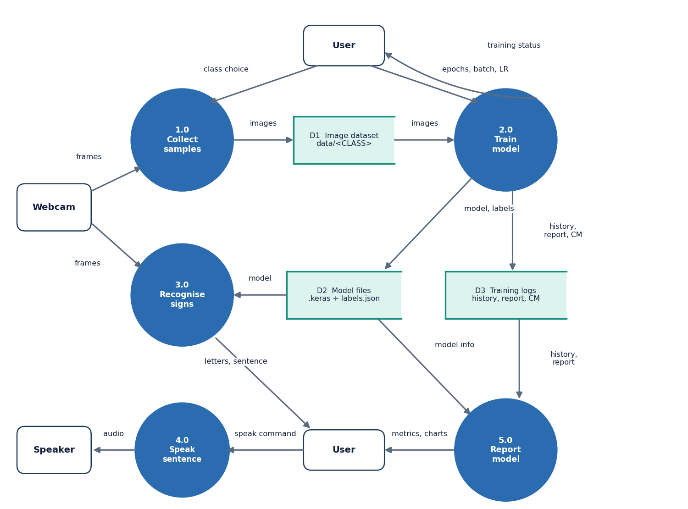
Figure 5: Level 1 data flow diagram: five processes and three data stores.
Level 1 splits the system into five processes: 1.0 Collect samples (frames in, images to store D1), 2.0 Train model (images from D1, hyper-parameters from the user; writes the model to D2 and history, report and confusion matrix to D3), 3.0 Recognise signs (frames and the model in; letters and the sentence out), 4.0 Speak sentence (text to the speaker) and 5.0 Report model (history and report from D3, model information from D2, charts to the user). D1 is the image dataset, D2 the model files and D3 the training logs. The user appears twice only to keep the arrows from crossing.

5.4.3 Level 2: recognising signs
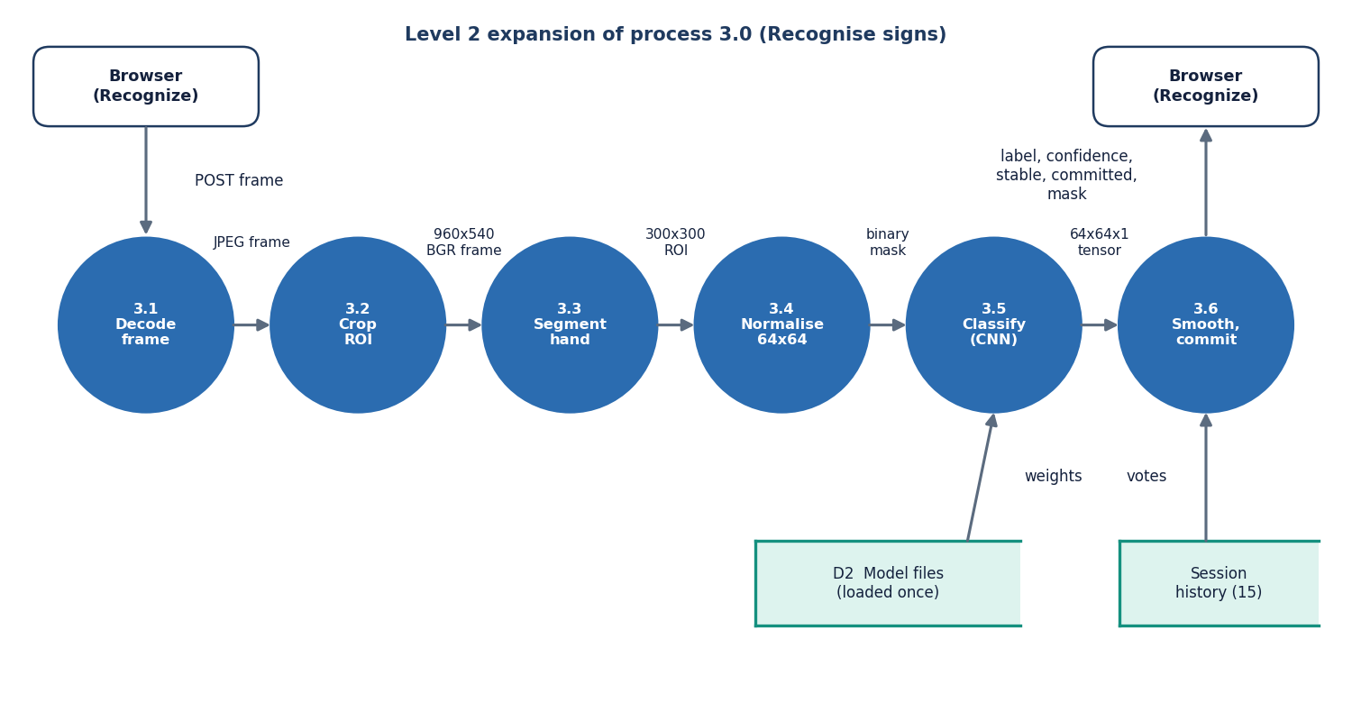
Figure 6: Level 2 data flow diagram: the six steps inside process 3.0, Recognise signs.
Process 3.0 expands into six steps that mirror SignRecognizer.predict_frame: 3.1 decode the JPEG frame, 3.2 crop the 300x300 region of interest, 3.3 segment the hand (grayscale, blur, Otsu threshold, morphology), 3.4 normalise to a 64x64 tensor, 3.5 classify with the CNN loaded once from D2, and 3.6 smooth the result with the session's history of 15 votes and decide whether to commit a letter. The result returned to the browser holds the label, its confidence, the stable label, the committed letter and the mask image.

5.5 UML diagrams

5.5.1 Class diagram
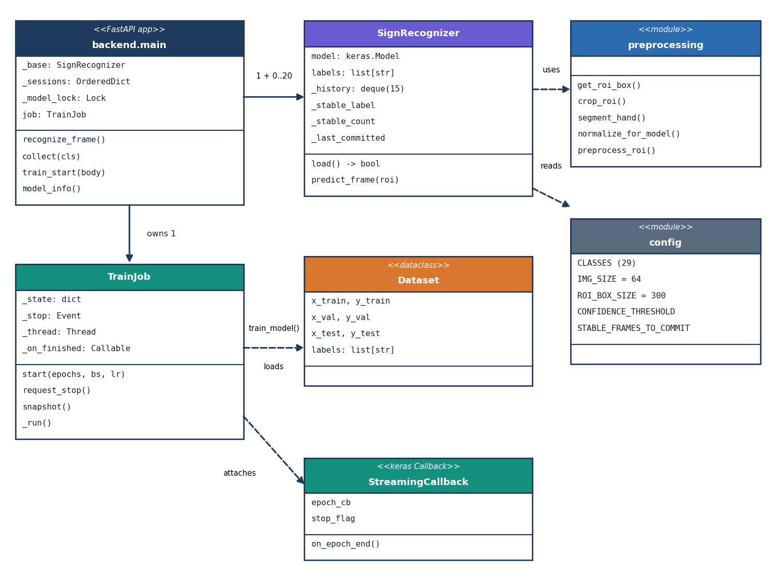
Figure 7: UML class diagram of the main classes and modules.
The code base is mostly modules of functions, so the diagram shows the real classes and the modules they use. backend.main owns one base SignRecognizer (which holds the Keras model), up to 20 per-session recognisers that share its model and labels, a model lock and a TrainJob. TrainJob runs train_model on a thread; the training code loads a Dataset dataclass (train, validation and test arrays plus the label list) and attaches a StreamingCallback that forwards each epoch's metrics and honours the stop flag. SignRecognizer uses the preprocessing module and reads thresholds from config.

5.5.2 Sequence diagram
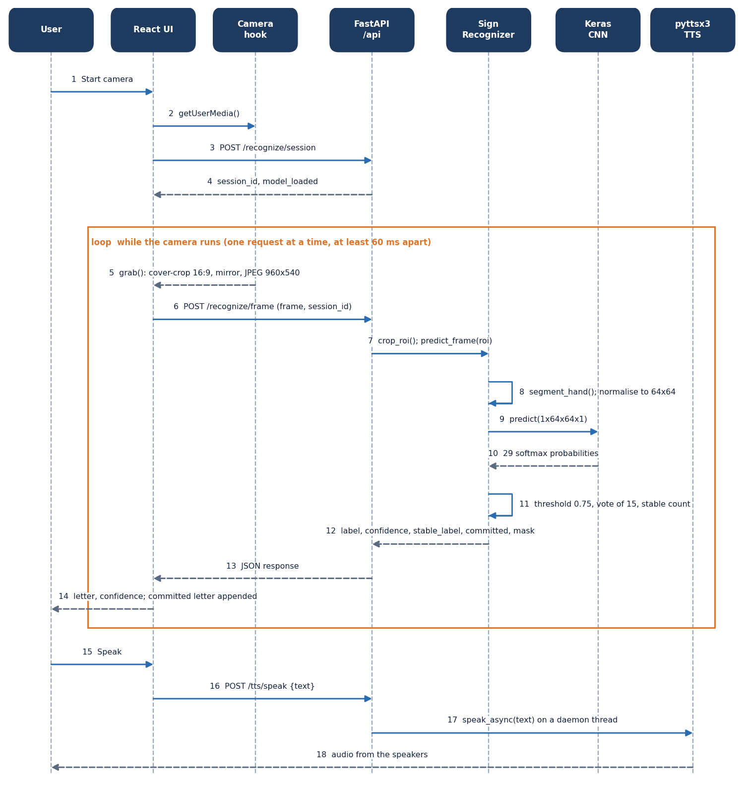
Figure 8: Sequence diagram of live recognition and speech.
The user starts the camera; the React page obtains the stream, opens a recognition session (steps 1-4) and then loops: grab a frame, post it, crop and preprocess it on the server, run the CNN, apply the threshold, vote and stable count, and return the result (steps 5-14). Only one request is in flight at a time and requests are at least 60 ms apart, so the loop cannot flood the server. Pressing Speak posts the sentence to /api/tts/speak, which starts the offline voice on a daemon thread (steps 15-18).

5.5.3 Use case diagram
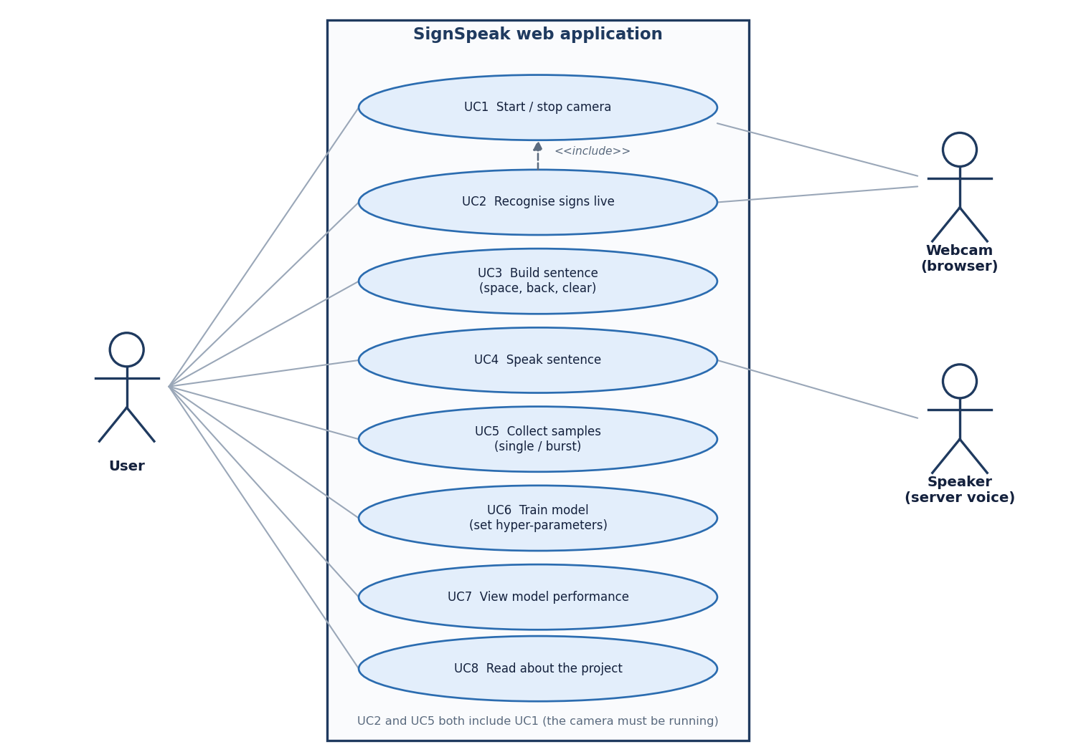
Figure 9: Use case diagram: eight use cases, one human actor and two system actors.
The user can start and stop the camera (UC1), recognise signs live (UC2), build a sentence with space, back and clear (UC3), speak it (UC4), collect samples singly or in bursts (UC5), train a model with chosen hyper-parameters (UC6), view model performance (UC7) and read about the project (UC8). UC2 and UC5 include UC1 because the camera must be running. The webcam (through the browser) and the speaker (the server voice) are the system actors. There are no accounts or roles.

5.6 Database design
A design chapter normally describes a database, so we state it plainly: SignSpeak has no SQL database. The reasons are practical. The only persistent data are image files and a model, both of which are naturally files; the user is single and local; and the session history is a transient 15-element queue. Adding a database would have added a dependency without adding a capability. The data model is therefore the file layout listed in the table below, drawn as an entity-relationship diagram after it.
Table 13: Persistent and in-memory data of SignSpeak
Location | Content | Format
data/<CLASS>/*.png|jpg | Training images, 29 folders (A-Z, space, del, nothing) | PNG 200x200 colour (own captures); JPEG 200x200 (public set)
models/asl_cnn_model.keras | Trained network (26.48 MB) | Keras native format
models/labels.json | Class order used by the network output | JSON list of 29 strings
models/training_history.json | Per-epoch loss and accuracy (train and validation) | JSON, four lists
models/classification_report.txt | Test accuracy, test loss and per-class precision/recall/F1 | Text
models/confusion_matrix.json | Labels and the 29x29 test confusion matrix | JSON
Recognition sessions | History of 15 votes, stable label and count, last committed letter | In memory only, at most 20, lost on restart

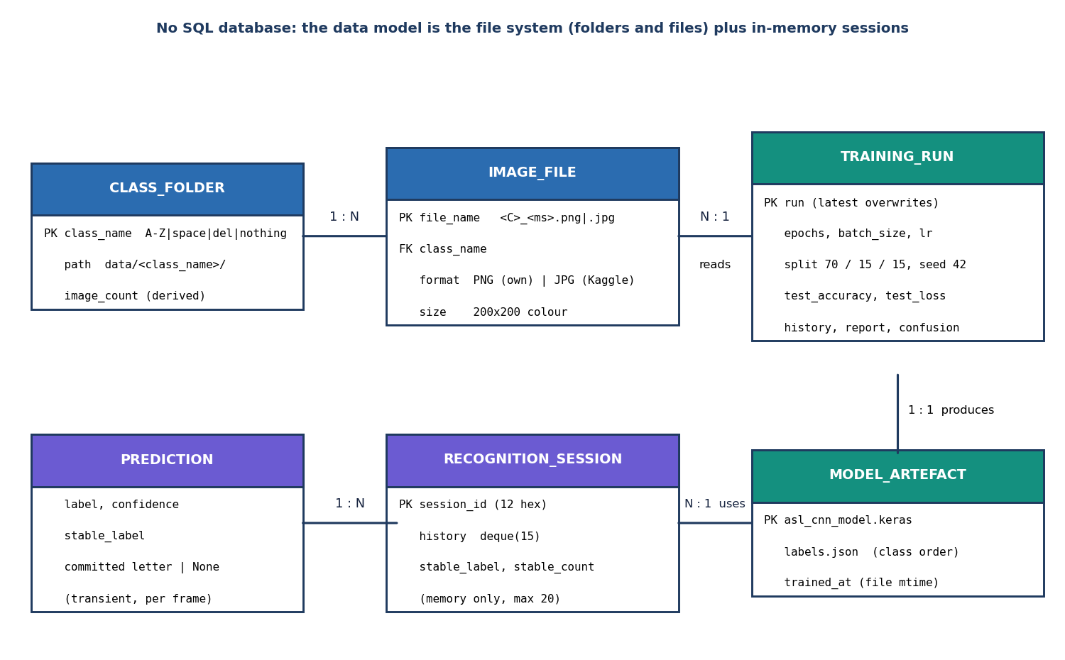
Figure 10: Entity-relationship diagram of the file-system data model; SignSpeak has no SQL database.
SignSpeak stores no records in a database. The data model is the file system: a class folder (one of 29) holds many image files; images are read by a training run; a run produces one model artefact (the Keras file, labels.json and the reports); a recognition session, kept only in memory, uses the model artefact and yields transient per-frame predictions. The diagram is drawn in entity-relationship style so that the relationships are explicit, but every PK is a file or folder name rather than a table key.

5.7 Module design
The table below lists the modules with their sizes (lines of code, measured with wc -l) and responsibilities. The desktop package is 1,648 lines, the API layer 530 lines, the web interface 5,268 lines of TypeScript and the test suite 398 lines.
Table 14: Module breakdown
Module | Lines | Responsibility | Key names
config.py | 69 | Paths, class list, image and ROI sizes, camera size, smoothing thresholds, training defaults | CLASSES, IMG_SIZE, CONFIDENCE_THRESHOLD
preprocessing.py | 102 | ROI box and crop, blur, Otsu and skin segmentation, normalisation | segment_hand, normalize_for_model, preprocess_roi
dataset.py | 109 | Class counts, loading and preprocessing images, 70/15/15 stratified split, label file | load_dataset, class_counts
model.py | 50 | The CNN architecture and its compilation | build_cnn
train.py | 121 | Augmentation, callbacks, fitting, evaluation, report and history files | train_model, StreamingCallback
recognizer.py | 86 | Model wrapper with confidence threshold, voting and auto-commit | SignRecognizer.predict_frame
tts.py | 31 | Offline speech on a short-lived engine thread | speak_async
camera.py, gui/ (desktop) | 60 + 1,019 | Threaded OpenCV camera and the customtkinter desktop interface (kept, not used by the web app) | -
backend/main.py | 367 | The 16 API endpoints, session store, model lock, report parsing | recognize_frame, collect, model_info
backend/train_job.py | 108 | Background training thread with a lock-guarded progress dictionary | TrainJob
backend/content.py | 55 | Text for the About screen (abstract, pipeline, base paper) | -
frontend/src | 5,268 | Seven pages, camera hook, data layer, charts, UI kit | Recognize.tsx, lib/camera.ts, lib/api.ts

5.8 Algorithm design

5.8.1 Core algorithm
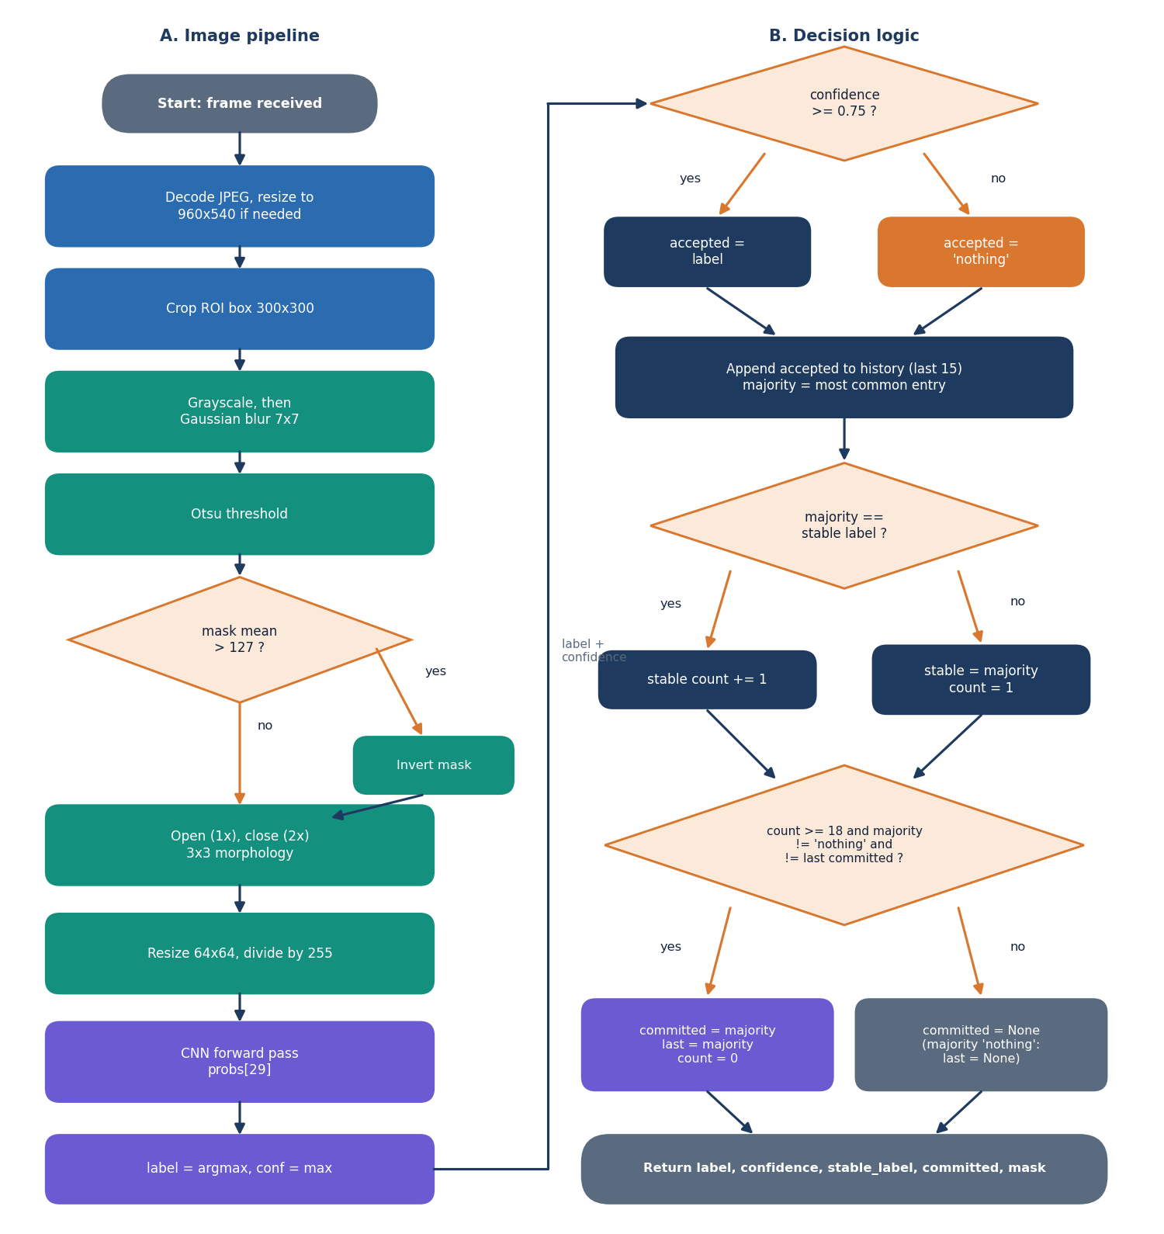
Figure 11: Flowchart of the core algorithm: (A) image pipeline and (B) decision logic.
Part A is the image pipeline: decode, crop, grayscale and blur, Otsu threshold, inversion when more than half the mask is white, morphological opening and closing, resize to 64x64, scaling and the CNN forward pass. Part B is the decision logic: a prediction below 0.75 confidence is replaced by nothing; the result joins a history of the last 15; the majority label is compared with the stable label and a counter is kept; a letter is committed when the counter reaches 18, the majority is not nothing and it differs from the last committed letter. A majority of nothing re-arms the repeat guard so that the same letter can be typed twice after the hand has been lowered.

5.8.2 Network architecture
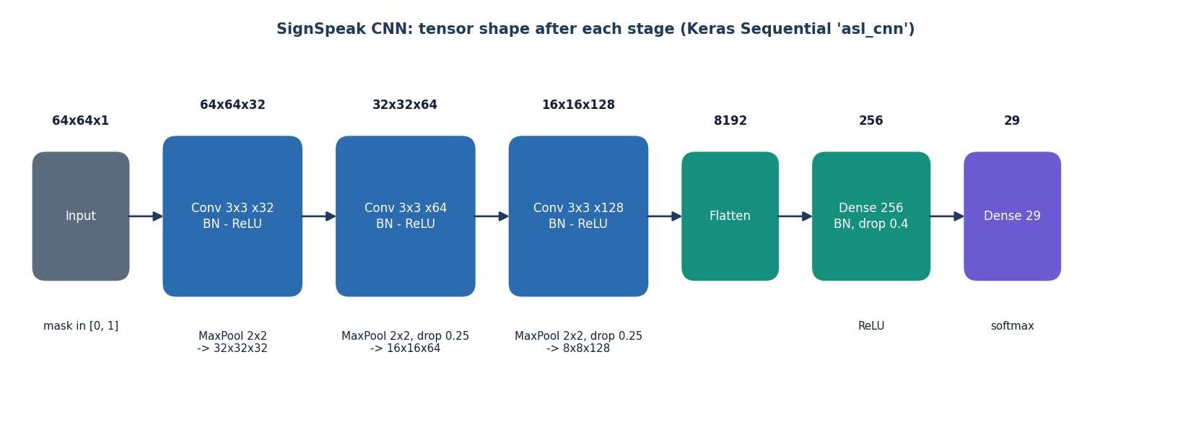
Figure 12: CNN architecture: three convolution blocks and a dense head (2,199,453 parameters).
The network takes a 64x64x1 mask. Block 1 is a 3x3 convolution with 32 filters, batch normalisation and 2x2 max pooling; block 2 doubles the filters to 64 and adds dropout 0.25; block 3 uses 128 filters with dropout 0.25. The 8x8x128 map is flattened to 8,192 values, passed through a dense layer of 256 units with batch normalisation and dropout 0.4, and a softmax layer of 29 units.
Table 15: Layers of the network
Layer | Output shape | Parameters
Input | 64 x 64 x 1 | 0
Conv2D 3x3, 32, ReLU | 64 x 64 x 32 | 320
BatchNormalization | 64 x 64 x 32 | 128
MaxPooling 2x2 | 32 x 32 x 32 | 0
Conv2D 3x3, 64, ReLU | 32 x 32 x 64 | 18,496
BatchNormalization | 32 x 32 x 64 | 256
MaxPooling 2x2 + Dropout 0.25 | 16 x 16 x 64 | 0
Conv2D 3x3, 128, ReLU | 16 x 16 x 128 | 73,856
BatchNormalization | 16 x 16 x 128 | 512
MaxPooling 2x2 + Dropout 0.25 | 8 x 8 x 128 | 0
Flatten | 8,192 | 0
Dense 256, ReLU | 256 | 2,097,408
BatchNormalization + Dropout 0.4 | 256 | 1,024
Dense 29, softmax | 29 | 7,453
Total |  | 2,199,453

Of the 2,199,453 parameters, 960 are the non-trainable moving statistics of the four batch-normalisation layers. The dense layer after the flatten holds 2,097,408 of them (95 %), which is why the model file is 26.48 MB although the network is only three convolution blocks deep.

5.8.3 Training pipeline
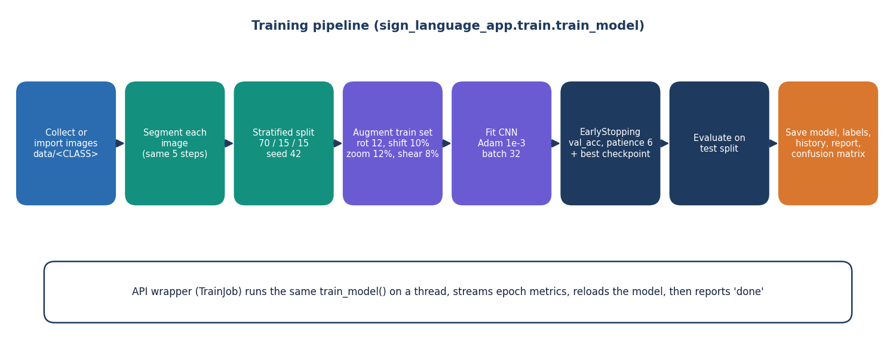
Figure 13: Training pipeline: load and preprocess, split, augment, fit with early stopping, evaluate, save.
All images in data/ are preprocessed once and cached in memory, then split 70/15/15 with a stratified split and seed 42. The training set is augmented on the fly (rotation 12 degrees, shifts 10 %, zoom 12 %, shear 8 %). Adam with learning rate 1e-3 minimises categorical cross-entropy; early stopping watches validation accuracy (patience 6, best weights restored) and the best model is checkpointed. After training the held-out test split gives the accuracy, the classification report and the confusion matrix, which are written next to the model.

5.9 API design
The API is a JSON/REST interface under /api, documented automatically at /docs (Swagger UI). The table below lists all 16 endpoints. Frames travel as multipart form data (field frame, plus session_id for recognition) because that avoids base-64 inflation of the JPEG; masks come back as small PNG data URLs. Errors are always {"detail": "message"} with a status code, which the interface shows in a toast.
Table 16: The 16 endpoints
Method | Path | Purpose | Errors
GET | /api/health | Liveness: status, model_loaded, model_file, training_state | -
GET | /api/config | Classes, frame size, ROI box, image size, thresholds, training defaults | -
GET | /api/about | Abstract, pipeline steps, base paper | -
GET | /api/dataset | Image count per class, total, trainable classes, ready_to_train | -
GET | /api/dataset/{cls}/images | Newest images of a class (limit 1-200) | 404 unknown class
GET | /api/dataset/{cls}/images/{name} | One stored image file | 400 bad name, 404 unknown
POST | /api/preview | Segmentation mask of the ROI of an uploaded frame | 400 empty / undecodable
POST | /api/collect/{cls} | Save the ROI as a 200x200 PNG; returns count and mask | 404, 400
POST | /api/recognize/session | Open a recognition session (at most 20 kept) | -
POST | /api/recognize/frame | Predict one frame: label, confidence, stable label, committed letter, mask | 409 no model, 404 session, 400
POST | /api/recognize/reload | Reload the model from disk | 404 no model
POST | /api/tts/speak | Speak text on the server (offline voice) | 400 empty or over 2,000 characters
POST | /api/train/start | Start training with epochs, batch size, learning rate | 400 out of range, 409 busy / < 2 classes
POST | /api/train/stop | Request an early stop | -
GET | /api/train/status | State, epoch, history and summary of the training job | -
GET | /api/model | Test accuracy and loss, per-class report, history, confusion matrix | 200 with trained = false when none

5.10 User interface design
The interface is a single-page React application with a landing page and six working screens (table below). It follows one design system (dark and light themes, a fixed navigation shell, cards, badges and charts from one component kit), is responsive from 360 px phones to 1440 px desktops and respects the user's reduced-motion setting. The Recognize screen is the centre of the product: a mirrored camera view with the region-of-interest box, the current letter and its confidence, the segmentation mask the network actually sees, and the sentence with space, back, clear and speak controls.
Table 17: Screens
Screen | Route | Content
Landing | / | Pitch, how it works, live pipeline preview, call to action
Dashboard | /app | Model status, image count, classes covered, accuracy, images per class, last run
Recognize | /app/recognize | Camera, live letter and confidence, mask preview, sentence builder, speak
Collect | /app/collect | Camera with ROI box, class picker, single and burst capture, recent images
Train | /app/train | Dataset coverage, hyper-parameters, progress, live accuracy and loss charts
Model | /app/model | Test accuracy, per-class table, confusion matrix, training curves
About | /app/about | Abstract, pipeline steps and the base paper

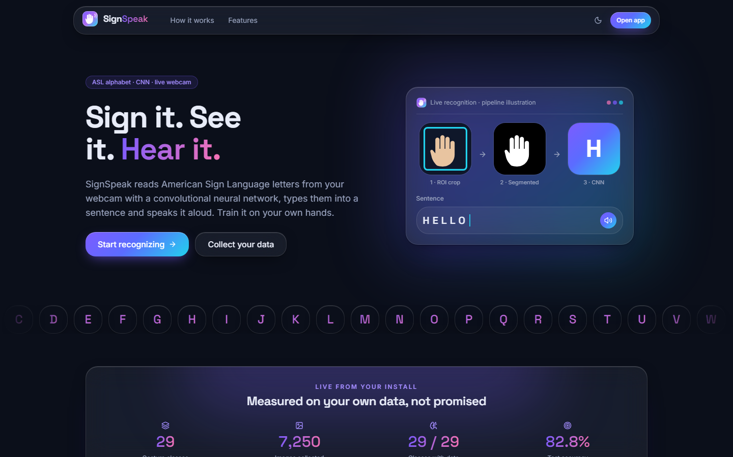
Figure 14: Landing page of the web application (dark theme).
Chapter 8 shows every working screen with real data. The visual language was taken from a component kit; the original desktop interface was not changed.

CHAPTER 6: METHODOLOGY AND SOFTWARE IMPLEMENTATION

6.1 Overall methodology
The method is an ordinary supervised image-classification pipeline, built so that the same code path serves three purposes. Hand images are cropped to a fixed region, reduced to a binary hand mask by classical image processing, resized to 64x64 and fed to a small convolutional network that outputs a probability for each of 29 classes: the 26 letters A-Z and three control signs (space, del, nothing). During live use a short temporal filter turns the stream of per-frame predictions into typed letters. The steps are:
1. Collect or import labelled hand images (own captures through the Collect screen, or the public Kaggle ASL Alphabet images).
2. Preprocess each image: ROI crop, grayscale, Gaussian blur, Otsu threshold, morphology, resize to 64x64, scale to [0, 1].
3. Split the images 70/15/15 into training, validation and test sets with a stratified split (seed 42).
4. Train the CNN with augmentation, the Adam optimiser and early stopping on validation accuracy.
5. Evaluate once on the held-out test split: accuracy, per-class precision/recall/F1, confusion matrix, threshold behaviour, robustness and latency.
6. Recognise live: send browser frames to the server, classify, apply the confidence threshold, vote over 15 frames and commit a letter after 18 stable frames.
7. Speak the finished sentence with an offline text-to-speech voice.
Figure 15: Training pipeline used for the saved model.

6.2 Dataset
The working dataset is a subset of the public Kaggle ASL Alphabet collection [25]. The archive on disk holds 87,000 training images (29 classes of 3,000 each, 200x200 colour JPEG) and 28 official test images (one per letter except del, plus space and nothing). A script (scripts/prepare_data.py) copies an evenly spaced subset of 250 images per class, 7,250 in all, into data/; on a CPU machine this keeps loading to 75 s and an epoch to about 9.9 s. The images are split with a stratified 70/15/15 split (seed 42) into 5,075 training, 1,087 validation and 1,088 test images (37-38 test images per class).
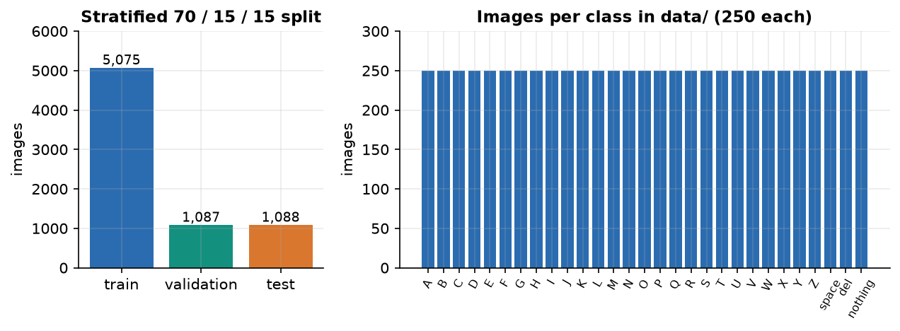
Figure 16: Class counts and the train/validation/test split.
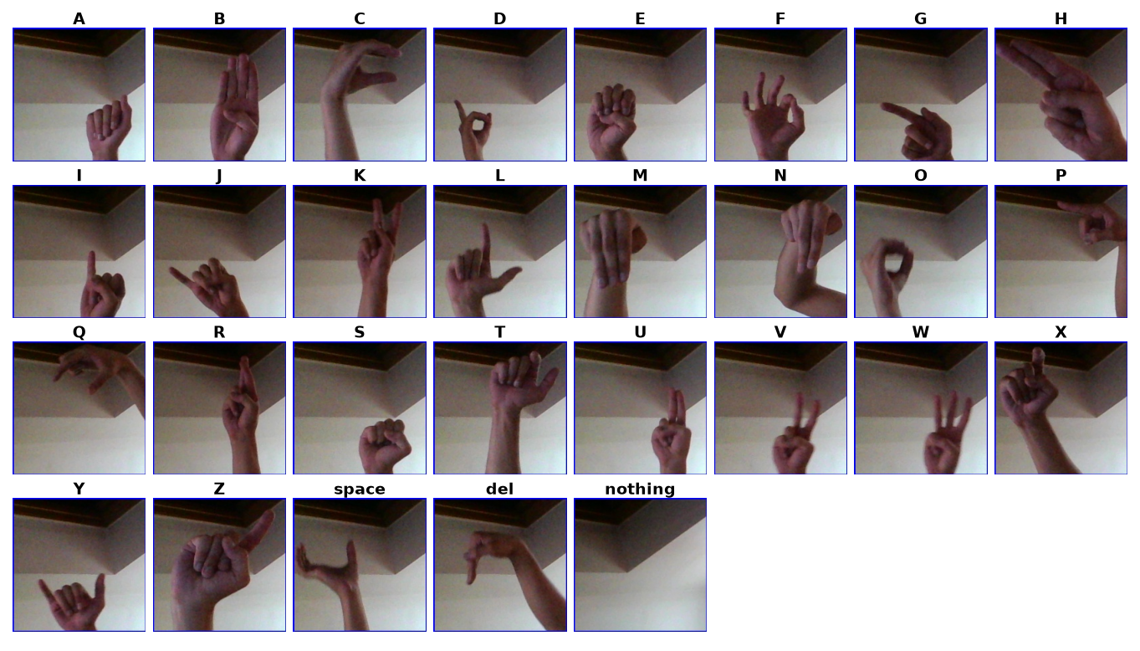
Figure 17: Sample images from the working dataset (one row of letters).
Two properties of the data decide how its results must be read. First, the images are frames cut from short videos of a few recordings, so neighbouring frames are near-duplicates; second, the archive carries no signer identifier. A random split therefore puts near-identical frames on both sides of the split, and the test accuracy measures how well the model reads held-out frames of the recorded signers and scenes, not how well it reads a new person in a new room. This is stated again wherever a number is quoted (Chapters 7 to 10). The archive does not bundle a licence file; its terms should be read on the dataset's Kaggle page before any redistribution, and the images are not redistributed with this submission.

6.3 Preprocessing
Preprocessing is one function (preprocess_roi) used by collection previews, training and live recognition, in the order given by the project abstract: region of interest, grayscale, noise reduction, segmentation, normalisation.
Table 18: Preprocessing steps and their reasons
Step | Operation (parameters) | Reason
1 ROI crop | 300x300 box at x 620-920, y 90-390 of the 960x540 frame | Fixed box on the right of the frame: the signer places the hand in it; background elsewhere is ignored.
2 Grayscale | BGR to gray | Hand shape, not colour, carries the letter; one channel is 3x cheaper.
3 Noise reduction | Gaussian blur 7x7 | Suppresses sensor noise and JPEG blocks before thresholding.
4 Segmentation | Otsu threshold; invert if the mask mean exceeds 127 | Chooses the threshold automatically per frame; the inversion keeps the hand as the bright region on bright and dark backgrounds.
5 Morphology | Opening x1, closing x2, 3x3 kernel | Removes specks and closes small holes in the silhouette.
6 Normalise | Resize to 64x64 (area interpolation), divide by 255 | Fixed small input; values in [0, 1] for stable training.

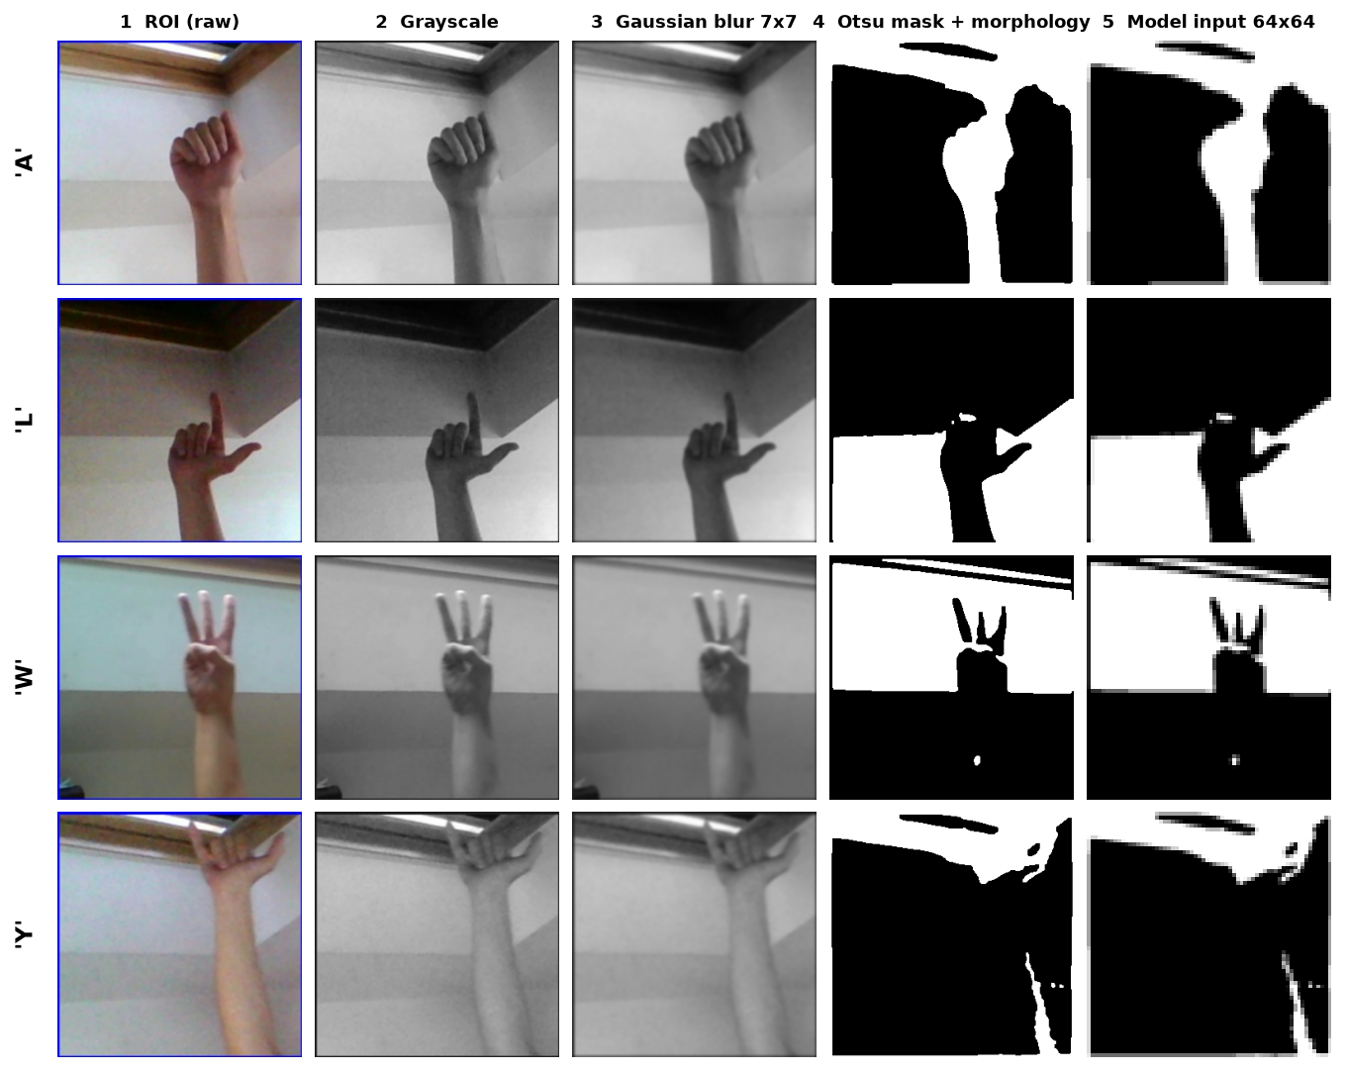
Figure 18: Preprocessing stages on real dataset images: colour crop, grayscale, blur, Otsu mask and the final 64x64 input.
The figure also shows the method's main weakness. Otsu's method finds the best single grey-level threshold, not the hand; where the background has structure of a similar brightness the mask contains background shapes next to the hand. The network can therefore partly learn the scene of the training recordings, which is one reason why the held-out accuracy of Chapter 8 should not be read as accuracy for a new user. A skin-colour mask (segment_skin, YCrCb) exists in the code as an alternative; it was not evaluated and the default is Otsu.

6.4 Algorithm choice and justification
Why a CNN. A convolutional network learns local shape features (edges, finger contours) and combines them hierarchically with far fewer parameters than a fully connected network on the same pixels [7], [8]. For a 64x64 binary mask this needs only three convolution blocks, which trains in about ten seconds per epoch on a CPU and answers in about 50 ms per frame.
Why a binary mask instead of the colour image. The mask removes skin tone, clothing and most lighting differences, so a small network and a small dataset suffice. The cost is that errors of the segmentation step reach the network unchanged.
Why not skeleton or landmark input. The base paper [1] works on 2D skeletons from a pose estimator (such as MediaPipe [13]) and a graph convolutional network, which is robust to background and suits moving word signs. It needs a pose-estimation stage in front of the classifier and, for its distillation, labels for a mask and several teacher models. For static fingerspelling letters on a CPU the direct image route is simpler and its 50 ms latency leaves no need for a second network; we did not test a landmark-based alternative, so we make no claim about which is more accurate.
Why batch normalisation, dropout and augmentation. Batch normalisation [19] stabilises training of the deeper layers; dropout [20] (0.25 after blocks 2 and 3, 0.4 before the output) limits over-fitting of the 2.1-million-weight dense layer; random rotation, shift, zoom and shear [22] stand in for the variety that a small dataset lacks.
Why a temporal filter. A single frame is noisy: the hand moves between letters and individual frames are misread. Thresholding the confidence (0.75), taking the majority of the last 15 predictions and requiring 18 consecutive stable frames before typing a letter converts noisy frame-level output into deliberate keystrokes, at the price of a short delay (about a second at the measured frame rate).

6.5 Mathematical formulation
For an input mask x of size 64x64, a convolution layer with kernels w and bias b computes, for output channel k at position (i, j):
y[i,j,k] = ReLU( b_k + Σ_c Σ_u Σ_v w[u,v,c,k] · x[i+u, j+v, c] ), ReLU(z) = max(0, z) (2)
Batch normalisation [19] rescales each channel over a mini-batch with mean μ_B and variance σ_B², then applies a learned scale γ and shift β:
x̂ = (x − μ_B) / √(σ_B² + ε), y = γ · x̂ + β (3)
The last layer turns the 29 logits z into probabilities, and the network is trained to minimise the categorical cross-entropy over N training images with one-hot targets t:
p_k = exp(z_k) / Σ_j exp(z_j) (4)
L = − (1/N) Σ_n Σ_k t[n,k] · log p[n,k] (5)
The Adam optimiser [21] keeps running averages of the gradient g and its square and updates the weights θ with learning rate α = 10⁻³ (Keras defaults β₁ = 0.9, β₂ = 0.999):
m_t = β₁ m_{t−1} + (1−β₁) g_t, v_t = β₂ v_{t−1} + (1−β₂) g_t², θ_t = θ_{t−1} − α · m̂_t / (√v̂_t + ε) (6)
The segmentation step uses Otsu's criterion [17]: the threshold t* that maximises the between-class variance of the grey-level histogram, with class weights ω₀, ω₁ and means μ₀, μ₁ of the pixels below and above t:
σ_B²(t) = ω₀(t) · ω₁(t) · [μ₀(t) − μ₁(t)]², t* = argmax_t σ_B²(t) (7)
The decision rule of the recogniser is as follows. With τ = 0.75 the accepted label of frame t is a_t = argmax_k p_k if max_k p_k ≥ τ, and nothing otherwise. The smoothed label m_t is the most frequent of the last 15 accepted labels. If m_t has been the same for s consecutive frames, the letter m_t is committed when s ≥ 18, m_t ≠ nothing and m_t differs from the last committed letter; a smoothed label of nothing clears the last committed letter. Evaluation uses accuracy, precision P = TP/(TP+FP), recall R = TP/(TP+FN), F1 = 2PR/(P+R) per class, their unweighted mean (macro F1) and top-3 accuracy (the true class among the three most probable).

6.6 Model architecture and training
The architecture (Chapter 5, with its layer table) has 2,199,453 parameters and a 26.48 MB model file. The table below lists the training configuration. The saved model was trained for 30 epochs (the interface default is 25); the best validation accuracy, 84.7%, was reached at the last epoch, so the run ended because it hit its epoch cap, not because early stopping fired, and accuracy was still slowly rising.
Table 19: Training configuration
Setting | Value
Optimiser / loss | Adam, learning rate 1e-3 / categorical cross-entropy
Batch size / steps per epoch | 32 / 158 (5,075 training images // 32)
Epochs | 30 in the saved run (default 25, allowed 1-500)
Split | 70 / 15 / 15 stratified, seed 42
Augmentation (training only) | rotation 12 deg, width/height shift 10 %, zoom 12 %, shear 8 %, nearest fill
Early stopping | monitor validation accuracy, patience 6, restore best weights
Checkpoint | best validation accuracy kept in models/asl_cnn_model.keras
Hardware | 12th Gen Intel Core i5-12500 (6 cores / 12 threads), 15.7 GB RAM, no GPU; about 9.9 s per epoch (2-epoch benchmark)
Software | Python 3.11.9, TensorFlow 2.15.0, OpenCV 4.11.0, NumPy 1.26.4

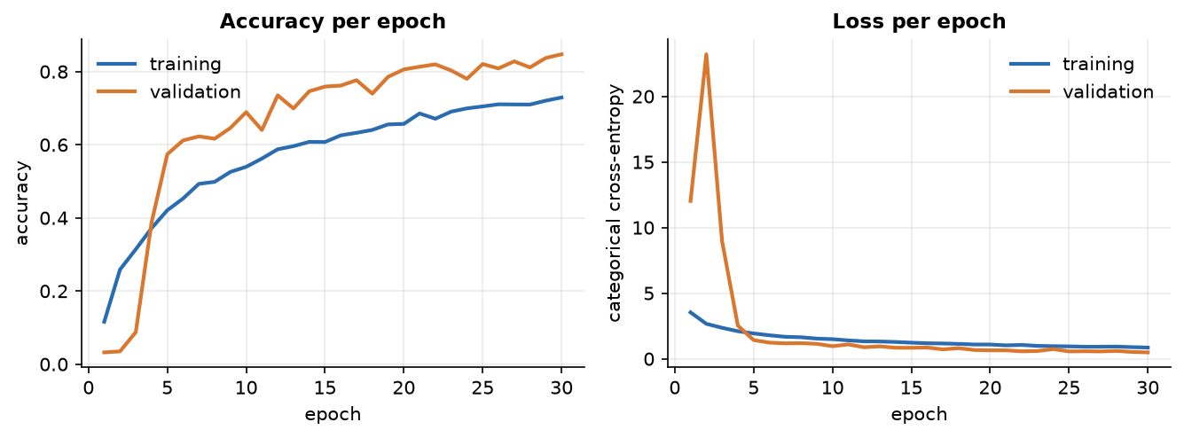
Figure 19: Training and validation accuracy and loss over the 30 epochs of the saved run.
The curves show training accuracy (72.9% at the end) below validation accuracy (84.7%). That is expected here: dropout and augmentation act only on the training pass, so the training figures are measured on harder inputs. The validation loss spikes in the first epochs (BatchNorm statistics are still warming up) and settles by epoch 6. The wall-clock time of the 30-epoch run itself was not recorded; the per-epoch figure comes from a separate 2-epoch benchmark on the same machine.

6.7 Application architecture and implementation
Server. backend/main.py creates one SignRecognizer that owns the Keras model, loaded on a background thread at start-up so that the first page loads at once. Each browser tab opens a session: a new SignRecognizer that shares the loaded model and labels but has its own history, stable counter and last committed letter, so two tabs cannot disturb each other's smoothing. At most 20 sessions are kept (the oldest is dropped). Keras inference is not re-entrant, so every prediction and every model reload runs under one lock. Training runs in TrainJob on a daemon thread; the job's state (loading, training, done, error), epoch and history live in a lock-guarded dictionary that /api/train/status returns, and the model is reloaded before the state becomes done.
Browser. The Recognize page (pages/Recognize.tsx with lib/camera.ts) opens the camera with getUserMedia, draws each video frame to a canvas after a 16:9 cover crop and a horizontal mirror, exports a 960x540 JPEG at quality 0.8 (about 27 KB) and posts it. A new request is sent only after the previous one has returned and at least 60 ms after it was sent, so the loop cannot queue frames. The result updates the large letter, the confidence bar and the mask preview; a committed letter is appended to the sentence. The Speak button posts the text to the server voice and falls back to the browser's speech synthesis if the server voice fails. TanStack Query caches the data of the other pages (dataset counts, model report, training status, which is polled while a run is active), and Recharts draws the charts.
Desktop application. The original customtkinter application (python run.py) was kept; it uses the same modules directly and a threaded OpenCV camera. The web version was added because a browser camera needs no native camera code and gives a better interface; the two share every line of recognition logic.

6.7.1 Key code: the recogniser
def predict_frame(self, roi_bgr):
model_input, mask = preprocess_roi(roi_bgr)
probs = self.model.predict(np.expand_dims(model_input, 0), verbose=0)[0]
top_idx = int(np.argmax(probs)); confidence = float(probs[top_idx])
label = self.labels[top_idx]
accepted = label if confidence >= config.CONFIDENCE_THRESHOLD else "nothing"
self._history.append(accepted) # deque(maxlen=15)
majority_label, _ = Counter(self._history).most_common(1)[0]
if majority_label == self._stable_label: self._stable_count += 1
else: self._stable_label, self._stable_count = majority_label, 1
committed = None
if (self._stable_count >= config.STABLE_FRAMES_TO_COMMIT and majority_label != "nothing"
and majority_label != self._last_committed):
committed, self._last_committed, self._stable_count = majority_label, majority_label, 0
elif majority_label == "nothing":
self._last_committed = None
return {"label": label, "confidence": confidence, "mask": mask,
"stable_label": majority_label, "committed": committed}

The function is a direct transcription of the flowchart in Chapter 5. It returns the raw label and confidence (so the interface can show what the network sees this instant) and the smoothed result (what is typed).

6.8 Security and error handling
• Input validation. Class names are checked against the 29-name whitelist (404 otherwise); stored-image names must match [\w\-. ]+\.(png|jpe?g) and are looked up inside the class folder only, so they cannot leave it; uploads must decode as images (400); training parameters are range-checked (epochs 1-500, batch 1-1,024, learning rate 1e-6 to 1) and at least two classes must have images (409); speech text is limited to 2,000 characters.
• State protection. One model lock; one collection lock so that two frames in the same millisecond get different file names; training refuses to start while another run is active (409); a session cap of 20.
• Failure messages. Every error is a JSON message the interface shows to the user (for example No trained model is loaded. Train one first); the interface also explains camera-permission and no-camera states.
• What is not protected. The API has no authentication and allows all origins, because it is designed for one user on one machine. It must not be exposed to a network as it stands. Uploaded frames are processed in memory and are not stored except by the explicit Collect action.
The 27 API tests of Chapter 7 exercise these checks.

6.9 Installation and execution
Quick start (Windows). Install Python 3.10 or 3.11 and Node.js 18 or newer and double-click run.bat. On first run it creates the virtual environment, installs the Python packages from requirements.txt (TensorFlow 2.15.0 is large; allow several minutes) and the frontend packages, starts the API on port 8316 in its own window, starts the web application on port 5316 and opens the browser. Ports can be changed in .env. Use Chrome or Edge on localhost: browsers allow webcam access only there or on HTTPS.
python -m venv .venv && .venv\Scripts\activate
pip install -r requirements.txt
python -m uvicorn backend.main:app --host 127.0.0.1 --port 8316 # terminal 1
cd frontend && npm install && npm run dev # terminal 2
python run.py # original desktop app
python scripts/prepare_data.py [archive_dir] [per_class] # copy a 250-per-class subset into data/
python -m pytest tests # 52 tests
python scripts/smoke_test.py # 26 live API checks in a temp copy

First use. The repository ships neither the dataset nor the trained model. The user either captures images in the Collect screen (150-250 per class is a good target) or imports a dataset into data/<CLASS>/, then opens the Train screen (at least two classes are needed) and, when it finishes, the Recognize screen. Appendix B gives the full user guide.

CHAPTER 7: SYSTEM TESTING

7.1 Testing strategy
Testing covers four layers. Small functions and the smoothing logic are tested in isolation; the API is tested in-process against the real application object; the whole stack is run in a throw-away copy with synthetic frames; and the web interface is walked in a real browser. All automated tests are in the repository (tests/, scripts/smoke_test.py) and can be re-run with one command. Before this documentation work the project had no automated tests; the 52 tests below were written for it. They test behaviour, not recognition quality: recognition quality is measured separately on held-out images (Chapter 8).
Table 20: Test layers and results
Layer | What it covers | How | Result
Unit: preprocessing | ROI box, crop, blur, Otsu mask, morphology, normalisation, skin mode | pytest, synthetic images | 10 passed
Unit: recogniser | Confidence threshold, majority vote, stable count, auto-commit, repeat guard | pytest, stub model | 7 passed
Unit: dataset and model | Class counts, 70/15/15 stratified split, reproducibility, label file, CNN shape and structure | pytest, temp folders | 8 passed
Integration: API | All endpoints, validation errors, collection, training validation, recognition flow | pytest + FastAPI TestClient | 27 passed
Functional: smoke test | Collect 80 images, long run stopped early, 3-epoch training, model report, live recognition, bad inputs | scripts/smoke_test.py, own server on port 8399 | 26 of 26 checks pass
Browser walk | Every screen at 360 / 768 / 1440 px, light and dark, reduced motion at 360 px; console, network and 404s | Playwright + Chromium, fake camera fed with real ASL photos | Clean (details below)
Build | TypeScript type-check and production bundle | npm run build | Passes

In total 52 pytest tests pass (about four seconds) and 26 of 26 smoke-test checks pass.

7.2 Unit testing
The most important unit tests are those of the temporal logic, because it decides what is typed. They use a stub model that returns a fixed probability vector, so they need no trained weights and no TensorFlow inference.
Table 21: Selected unit test cases
ID | Test | Input | Expected result | Result
U1 | Commit after stability | Letter A at 0.95 confidence for 28 frames | A committed exactly once, at frame 18 | Pass
U2 | No early commit | Letter B at 0.95 for 17 frames | No letter committed | Pass
U3 | Low confidence ignored | Letter A at confidence 0.65 for 40 frames | Nothing committed; stable label is nothing | Pass
U4 | Repeat guard | Letter A held 40 frames, held 40 more, then a nothing pause, then A again | No second commit without the pause; one commit after it | Pass
U5 | Control labels | space and del held steadily | Committed like letters | Pass
U6 | Noise tolerance | One wrong frame inside a steady run | Stable label unchanged | Pass
U7 | Not loaded | predict_frame before a model is loaded | Returns None | Pass
U8 | ROI box | Default 960x540 frame; small frame | (620, 90, 920, 390); box stays inside the frame | Pass
U9 | Mask polarity | Bright hand on dark and dark hand on bright background | Hand is the white minority region, corner is black, in both cases | Pass
U10 | Flat image | Uniform grey crop | No crash | Pass
U11 | Normalisation | Any mask | Shape (64, 64, 1), values in [0, 1] | Pass
U12 | Split | Two classes of 40 images | 56 / 12 / 12 images, equal class counts per part, identical test part on a second call (seed 42) | Pass
U13 | Network | Build for 29 classes | Softmax output of shape (1, 29) summing to 1; three convolution layers | Pass
U14 | No data | load_dataset with empty data/ | Raises an error with a clear message | Pass

7.3 Integration testing
The 27 API tests call the real FastAPI application in-process. Collection tests redirect the data folder to a temporary directory by patching config.DATA_DIR, so the real data/ is never touched. The tests check status codes and the shape of responses for every endpoint family.
Table 22: Selected integration test cases
ID | Test | Input | Expected result | Result
I1 | Health | GET /api/health | 200, status ok | Pass
I2 | Config | GET /api/config | 29 classes, image size 64, ROI (620, 90, 920, 390), stable frames from config | Pass
I3 | Unknown class | GET /api/dataset/Z9/images; POST /api/collect/Z9 | 404 for both | Pass
I4 | Hostile image names | ..%2F..%2Fsecret.png, a.txt, x y.exe | 400 or 404, no file read | Pass
I5 | Collect | POST a 960x540 frame to /api/collect/A | 200, count 1, a 200x200 PNG on disk, listed and fetchable | Pass
I6 | Preview | POST a frame to /api/preview | 200, PNG data URL | Pass
I7 | Bad frames | Empty body; text instead of an image | 400 | Pass
I8 | Odd frame size | 120x200 image | 200 (resized, not rejected) | Pass
I9 | Missing field | POST /api/preview with no frame | 422 | Pass
I10 | Unknown session | POST /api/recognize/frame, session nope | 404 or 409 | Pass
I11 | Hyper-parameter limits | epochs 0 or 501; batch 0 or 2,000; learning rate 0 or 2 | 400 for each of the six | Pass
I12 | Too few classes | POST /api/train/start with an empty data folder | 409 | Pass
I13 | Speech limits | Empty, blank and 2,001-character text | 400 for each | Pass
I14 | Model report | GET /api/model | trained; if true 29 labels and accuracy in (0, 1] | Pass
I15 | Recognition flow | Reload model, open session, post a frame | 200; label in the 29 classes; confidence in [0, 1]; mask data URL | Pass

7.4 Functional testing: the smoke test
scripts/smoke_test.py copies the application into a temporary folder, starts its own server on port 8399 and drives the full user flow with synthetic frames (a bright disc for class A, a square for class B). It checks 26 things: health, config, about; empty dataset and untrained model states; the 409 and 400 refusals (too few classes, bad hyper-parameters, unknown class, bad frame, empty speech, recognition without a model); collecting 40 images for each of two classes; listing and fetching images; the preview mask; a long training run that is stopped early (it stopped at epoch 2) and a second start that is refused while it runs; a three-epoch training that finishes; the training history and summary; the model report with per-class rows and the confusion matrix; automatic loading of the new model; recognition of frames with the smoothing fields present; and an unknown session. All 26 pass. The smoke test proves that the pieces are wired together; because its frames are synthetic it says nothing about recognition quality.

7.5 Security and validation testing
Security testing is limited to input validation, because the application is a single-user local tool: hostile file names (I4), unknown classes (I3), oversized speech text (I13), out-of-range training parameters (I11), undecodable and empty frames (I7), and concurrent access. A frame that is not 16:9 is resized and processed, not rejected (I8). Concurrency is handled by locks (one model lock, one collection lock) and by refusing a second training start (smoke test). No penetration test, dependency audit or authentication test was done, and the API has no authentication by design.

7.6 Performance testing
Latency was measured on the development PC (12th Gen Intel Core i5-12500 (6 cores / 12 threads), 15.7 GB RAM, no GPU) with a throw-away server, over 300 frames after warm-up. The table gives the median, mean and 95th percentile of each stage.
Table 23: Latency per frame (milliseconds, 300 frames)
Stage | Median | Mean | p95 | n
JPEG decode 960x540 | 1.67 | 1.69 | 2.01 | 300
ROI crop + segmentation + normalise | 0.83 | 0.88 | 1.30 | 300
CNN forward pass, batch 1 (model.predict) | 50.35 | 50.51 | 55.29 | 300
Server total per frame | 52.93 | 53.07 | 57.92 | 300
HTTP /recognize/frame round trip (localhost) | 56.70 | 57.92 | 67.61 | 300
HTTP /health | 1.05 | 1.07 | 1.27 | 50

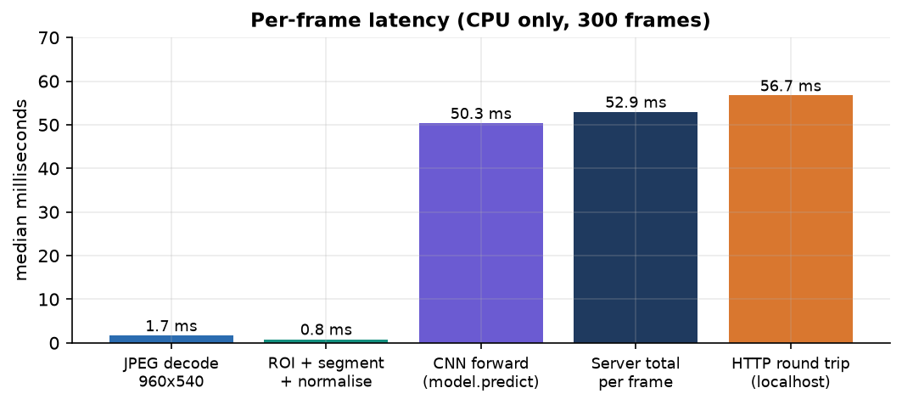
Figure 20: Median latency of each stage of one recognition request.
The server needs 52.9 ms per frame (a ceiling of about 18.9 frames per second) and a full HTTP round trip takes 56.7 ms, which gives about 17.6 frames per second with one request at a time. The convolutional network dominates: 50.3 ms of the 52.9 ms, whereas decoding and preprocessing together take about 2.5 ms. The cost is that of calling model.predict on a single image, which carries per-call overhead; calling the model directly, exporting it or quantising it would likely lower it, but none of that was tried. The JPEG payload averages 27 KB per frame. These figures are for one CPU and one client and are not a load test.

7.6.1 Robustness to image changes
Robustness was tested by perturbing 580 held-out photos (20 per class) and re-classifying them. Brightness, noise and blur change accuracy little, except for brighter images; a rotation of 10 degrees in either direction costs about 17 points.
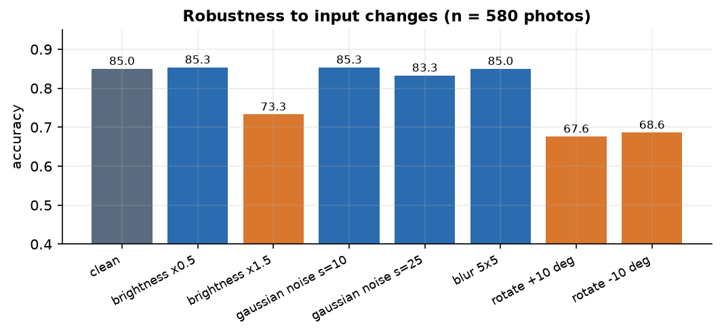
Figure 21: Accuracy under brightness, noise, blur and rotation changes (580 photos).
Table 24: Accuracy under perturbation
Condition | Accuracy
clean | 85.0%
brightness x0.5 | 85.3%
brightness x1.5 | 73.3%
gaussian noise s=10 | 85.3%
gaussian noise s=25 | 83.3%
blur 5x5 | 85.0%
rotate +10 deg | 67.6%
rotate -10 deg | 68.6%

The sensitivity to rotation is a real weakness: the training augmentation rotates by up to 12 degrees, yet 10 degrees of rotation of a held-out photo still reduces accuracy from 85.0 % to about 68 %. A signer who tilts the hand will be read less accurately.

7.7 User interface testing
A browser walk was run with Playwright and Chromium, using Chromium's fake camera fed with a clip assembled from real held-out ASL photos (there is no physical webcam on the build machine). Every screen was opened at 360, 768 and 1440 px in light and dark themes, and at 360 px with reduced motion. The console, the network log and 404 responses were clean; the navigation drawer closed with the Escape key; form validation (for example a hyper-parameter out of range) showed its message. The phone-width captures in Chapter 8 are from this walk.

7.7.1 Browser matrix and what was not covered
Only Chromium was used. Firefox and Safari, a physical webcam in varied rooms, screen readers and a keyboard-only pass beyond the drawer and focus checks were not tested.

7.8 User acceptance testing
No user study was carried out. Members of the project team used the application during development, but no test with deaf or hearing signers, and no usability questionnaire, was run, so we make no claim about acceptance. This is listed with the limitations in Chapter 8.

7.9 Limits of the testing done
• The held-out test images come from the same recordings as the training images (Chapter 6), so accuracy on a new signer or room is not measured.
• Recognition through the browser was tested with a fake camera, not a physical webcam; the camera hook was not tested against real hardware variation.
• There are no unit tests of the React components, no load or stress tests, and no security audit beyond input validation.
• Timing figures are for one machine and one client; they were measured on an otherwise idle PC and vary a little between runs.

CHAPTER 8: RESULTS AND OUTPUT SCREENS

8.1 Experimental setup and protocol
All figures in this chapter come from docs/metrics/metrics.json, written by scripts/measure_metrics.py from the saved model and the saved training files, on 12th Gen Intel Core i5-12500 (6 cores / 12 threads) with 15.7 GB RAM and no GPU (Python 3.11.9, TensorFlow 2.15.0). The headline protocol is the held-out test split: of the 7,250 working images, 15 % (1,088 images, 37-38 per class) were set aside by a stratified split with seed 42 and were never used for training or for choosing the model. We reproduced the saved test result independently from the model and the same seed: accuracy 0.8281 and loss 0.5569, identical to the training run's own report.
What this protocol does and does not show. The images are frames from video, so a random split puts neighbouring, almost identical frames in training and test. The result therefore measures how well the model reads held-out frames of the recorded signers and scenes. It is not a test on unseen signers (the archive has no signer identifiers), and the real-world accuracy of the system for a new person in a new room is expected to be lower. Every number below is stated with its protocol.

8.2 Output screens
All screens below are real captures (1440x900) of the application running on the development PC with the trained model loaded and the 7,250-image working dataset in data/. The Recognize capture was made with Chromium's fake camera fed with a clip assembled from real held-out ASL photos, because the build machine has no webcam; for each letter the clip uses the first of 12 photos that the live model reads correctly with at least 0.8 confidence, so that the demonstration is legible. The Model screen shows the true held-out accuracy.

8.2.1 Landing page
Figure 22: Landing page (dark theme): tagline, pipeline illustration (ROI crop, segmentation, CNN, sentence) and the statistics strip.
The landing page introduces SignSpeak ("Sign it. See it. Hear it."), says that it reads American Sign Language letters from a webcam with a convolutional neural network, types them into a sentence and speaks it, and shows the pipeline as three small panels. Below the fold a strip shows the live figures of this installation (29 classes, 7,250 images, 29 of 29 classes with data, 82.8 % test accuracy).
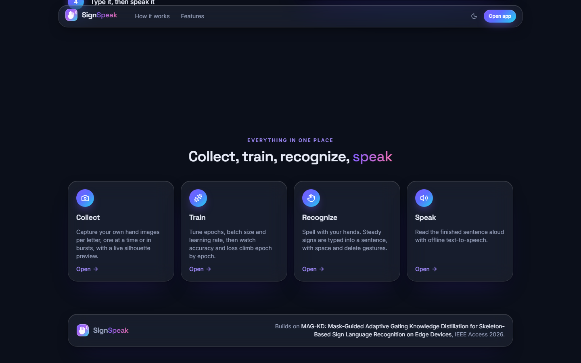
Figure 23: Landing page: the four features (collect, train, recognize, speak) and the reference to the base paper.

8.2.2 Dashboard
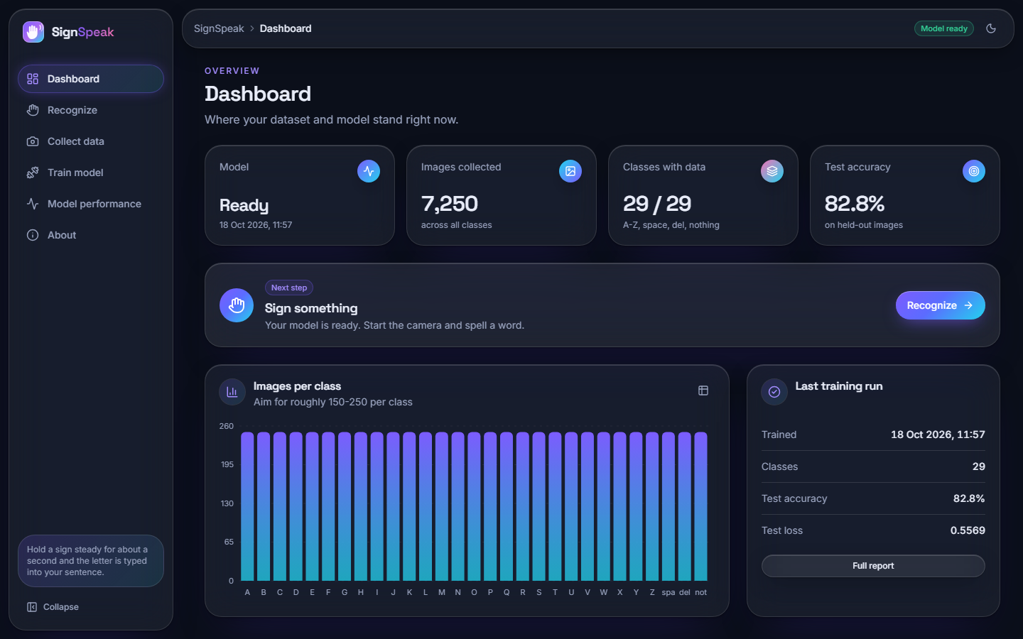
Figure 24: Dashboard: model ready, 7,250 images, 29 of 29 classes, 82.8 % test accuracy, images per class and the last training run.
The dashboard summarises the state of the system in one view: whether a model is loaded, the number of stored images (7,250, the same as the training set), the classes covered (29 of 29), the model's held-out accuracy (82.8 %), a bar chart of images per class and the last training run.

8.2.3 Live recognition
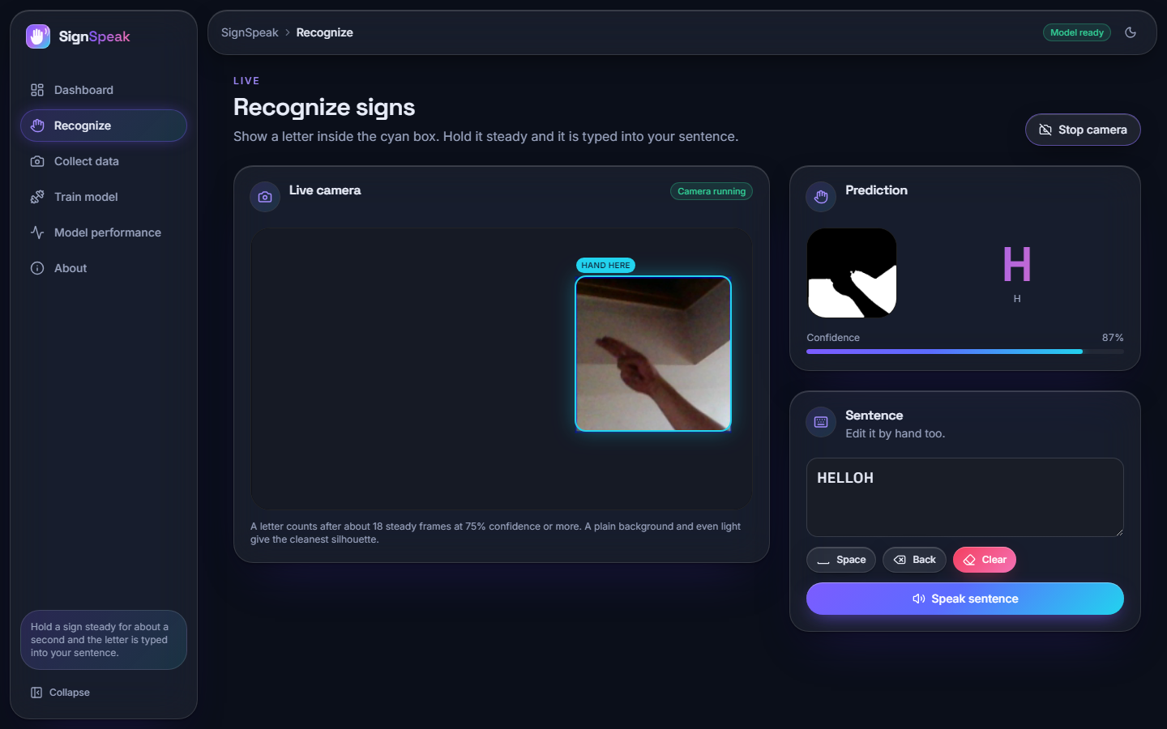
Figure 25: Recognize screen: letter H recognised at 87 %, the segmentation mask the network sees, and the sentence built so far.
The large letter and the confidence bar update with every frame; the mask panel shows the 300x300 region after segmentation, which is exactly what the network classifies (after resizing). The sentence ("HELLOH" in this capture) is built by committed letters; space, back, clear and speak are the controls beneath it. The trailing H is the fake-camera clip starting over.

8.2.4 Data collection
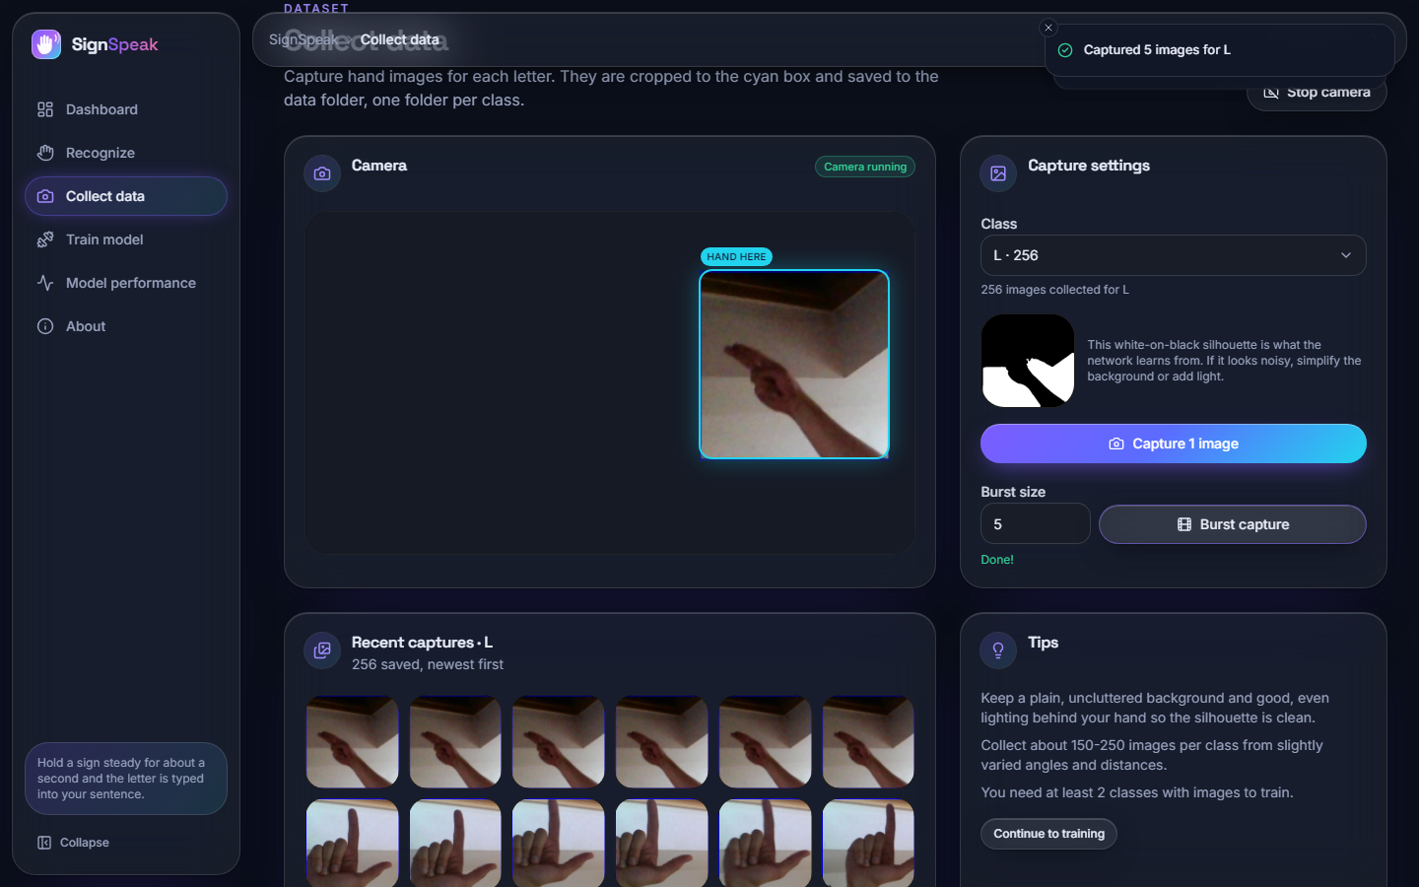
Figure 26: Collect screen: ROI box on the camera view, class L selected, "Captured 5 images for L", mask preview and recent captures.
The user picks a class, aligns the hand in the box and captures one image or a burst; each capture is saved as a 200x200 PNG in data/<class>/ and the thumbnail list and counts update at once.

8.2.5 Training
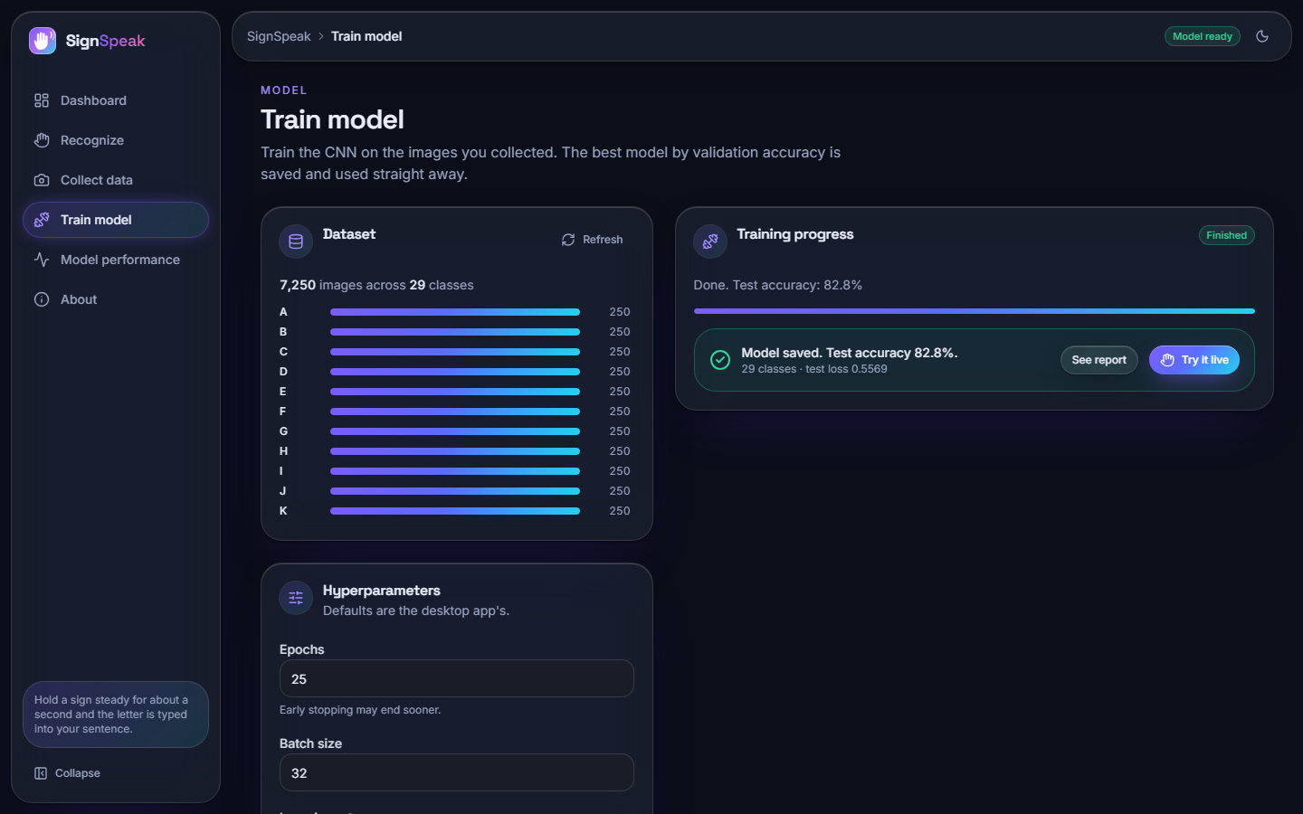
Figure 27: Train screen: dataset coverage of 7,250 images, hyper-parameter fields and the finished run (82.8 % test accuracy).
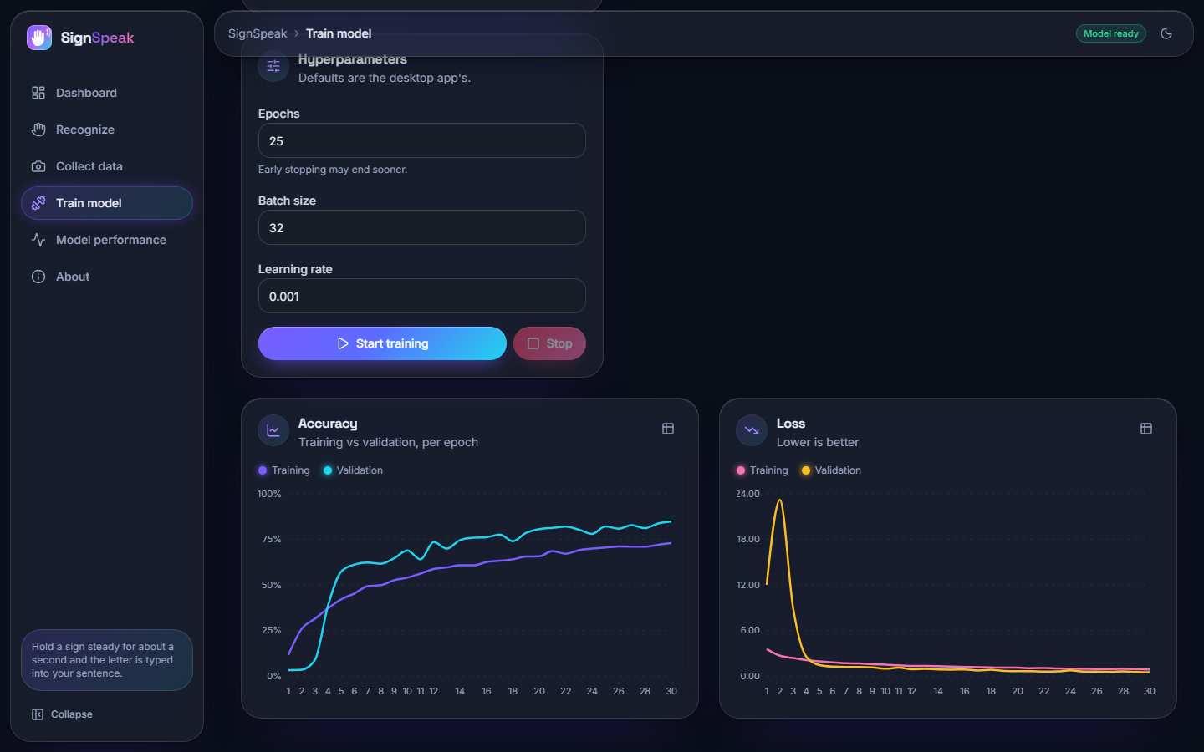
Figure 28: Train screen: live accuracy and loss charts of the run.
The screen refuses to start with fewer than two classes, validates the hyper-parameters, shows data-loading and per-epoch progress, plots training and validation accuracy and loss while the run proceeds, and ends with the test accuracy. The charts are those of the saved run.

8.2.6 Model performance
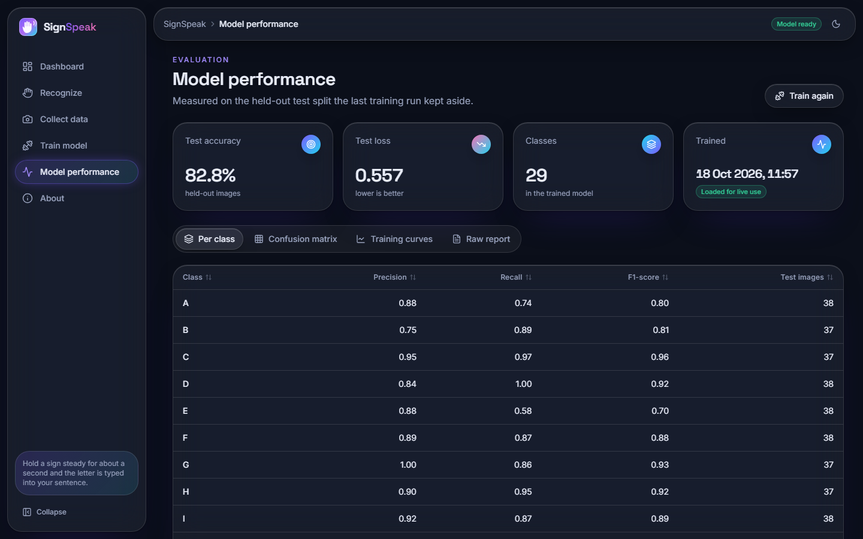
Figure 29: Model screen: test accuracy and the per-class precision, recall and F1 table.
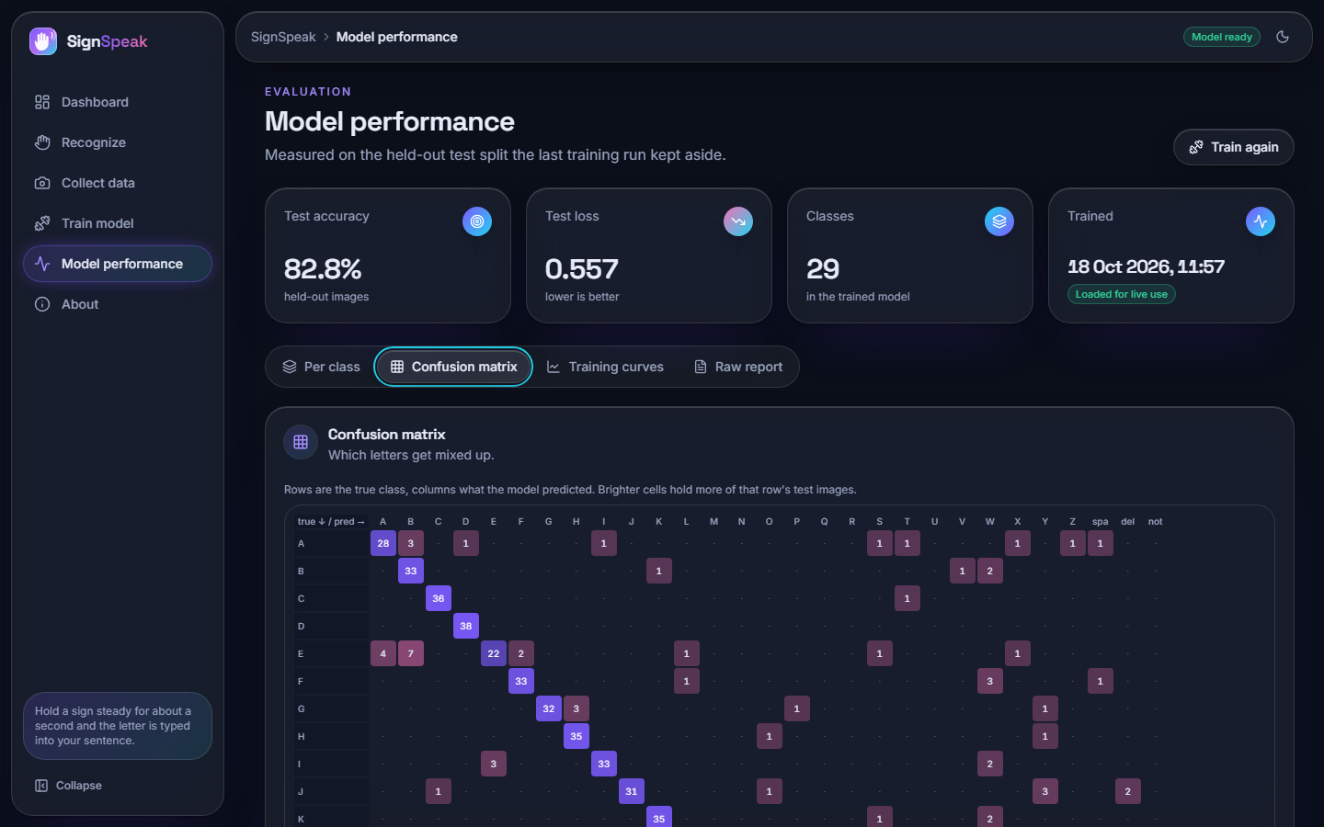
Figure 30: Model screen: confusion matrix of the 1,088 test images.
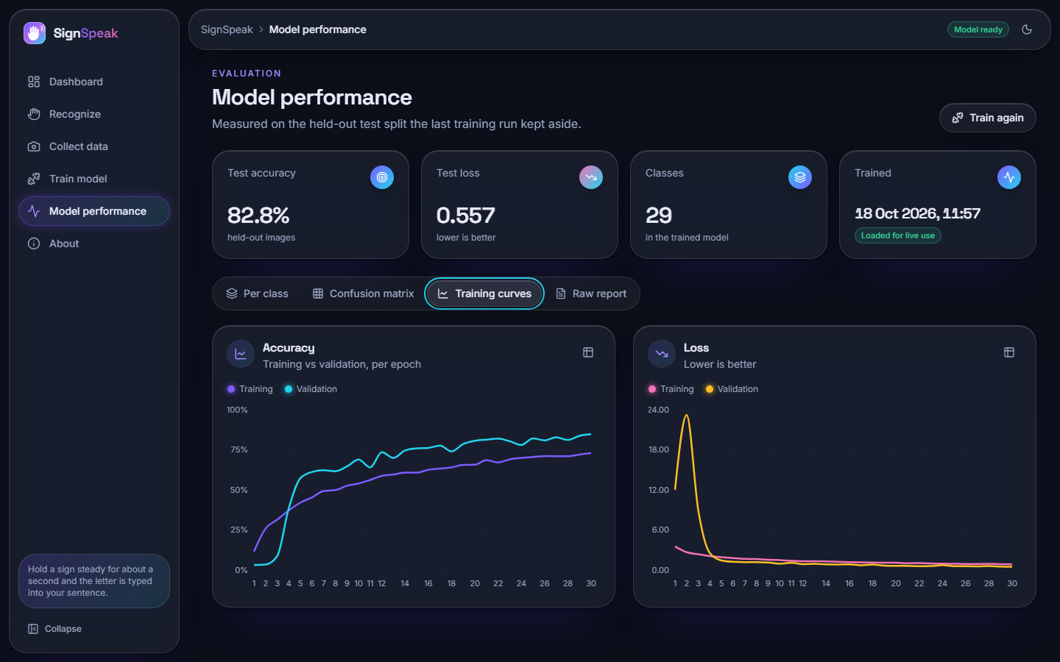
Figure 31: Model screen: training curves.
The Model screen reads the saved reports, so it always shows the numbers of the model that is loaded. It is the in-application counterpart of Sections 8.3 and 8.4.

8.2.7 About
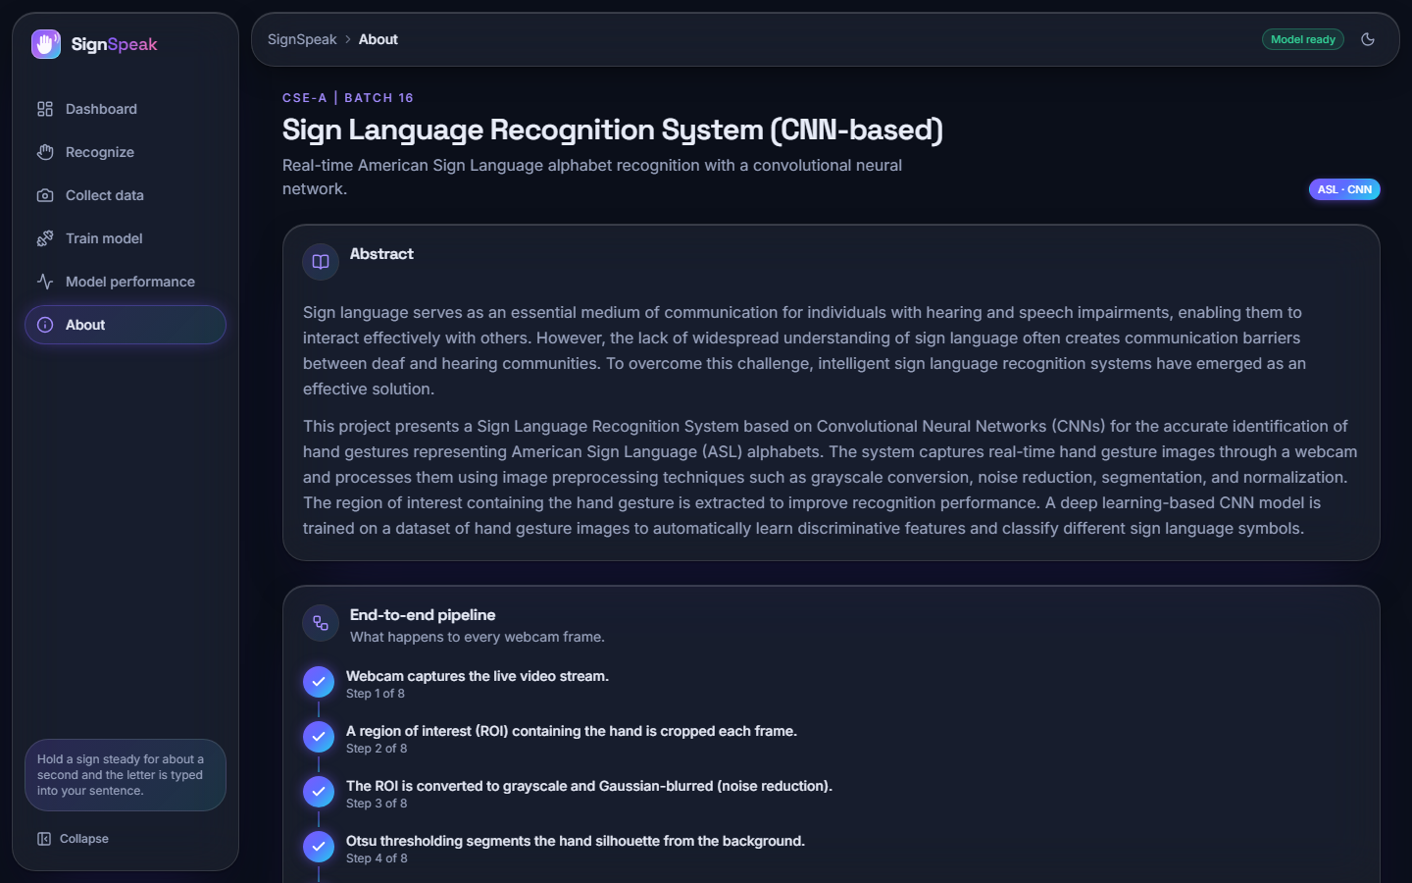
Figure 32: About screen: abstract, the eight pipeline steps and the base paper.

8.3 Model performance
The first table gives the summary and the second the per-class scores of the held-out test split.
Table 25: Held-out test split (n = 1,088)
Metric | Value
Accuracy | 82.81% (0.8281)
Loss (cross-entropy) | 0.5569
Macro F1 | 0.8302
Weighted F1 | 0.8298
Top-3 accuracy | 92.92%
Best classes (F1) | nothing 0.99, C 0.96, Q 0.96, G 0.93, K 0.93
Weakest classes (F1) | Y 0.62, V 0.69, X 0.69, U 0.70, W 0.70, E 0.70

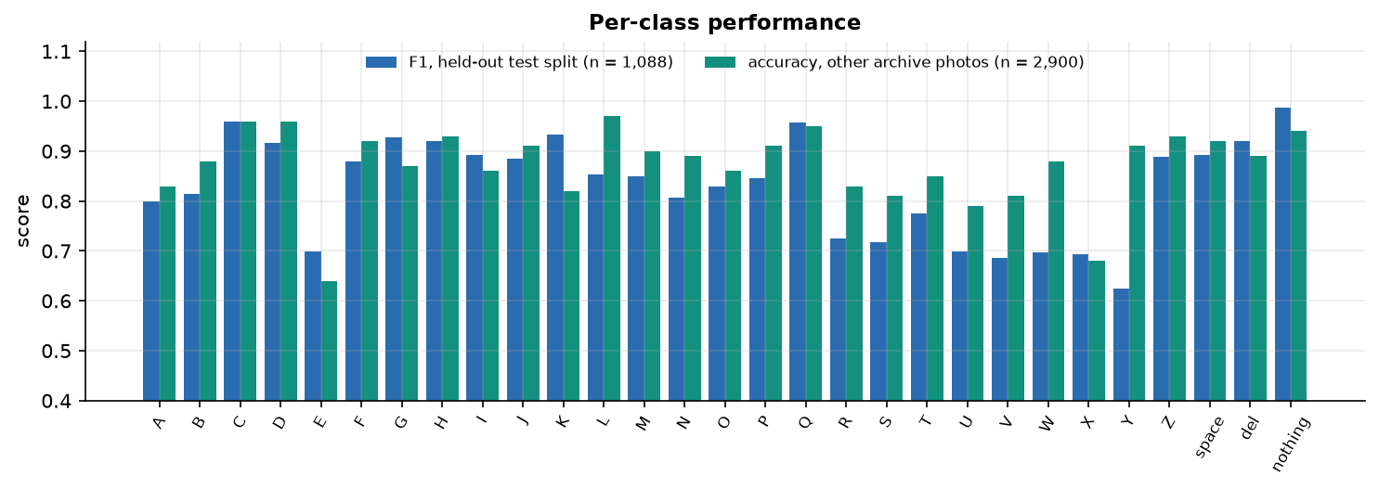
Figure 33: F1 of each of the 29 classes on the test split, beside accuracy on other archive photos (optimistic).
Table 26: Per-class precision, recall, F1 and support (test split)
Class | P | R | F1 | n | Class | P | R | F1 | n
A | 0.88 | 0.74 | 0.80 | 38 | P | 0.80 | 0.89 | 0.85 | 37
B | 0.75 | 0.89 | 0.81 | 37 | Q | 1.00 | 0.92 | 0.96 | 37
C | 0.95 | 0.97 | 0.96 | 37 | R | 0.78 | 0.68 | 0.72 | 37
D | 0.84 | 1.00 | 0.92 | 38 | S | 0.70 | 0.74 | 0.72 | 38
E | 0.88 | 0.58 | 0.70 | 38 | T | 0.87 | 0.70 | 0.78 | 37
F | 0.89 | 0.87 | 0.88 | 38 | U | 0.63 | 0.78 | 0.70 | 37
G | 1.00 | 0.86 | 0.93 | 37 | V | 0.75 | 0.63 | 0.69 | 38
H | 0.90 | 0.95 | 0.92 | 37 | W | 0.61 | 0.82 | 0.70 | 38
I | 0.92 | 0.87 | 0.89 | 38 | X | 0.70 | 0.68 | 0.69 | 38
J | 0.97 | 0.82 | 0.89 | 38 | Y | 0.52 | 0.79 | 0.62 | 38
K | 0.95 | 0.92 | 0.93 | 38 | Z | 0.84 | 0.95 | 0.89 | 38
L | 0.84 | 0.86 | 0.85 | 37 | space | 0.92 | 0.87 | 0.89 | 38
M | 0.86 | 0.84 | 0.85 | 37 | del | 0.90 | 0.95 | 0.92 | 37
N | 0.90 | 0.73 | 0.81 | 37 | nothing | 1.00 | 0.97 | 0.99 | 37
O | 0.91 | 0.76 | 0.83 | 38

The classes that the network finds hardest are letters whose hand shapes are close to others in a binary mask: Y (F1 0.62), V, X, U, W and E. The control class nothing (an empty box) is almost perfect (0.99), which matters because it is what keeps the system silent when no hand is shown.

8.3.1 Confusion matrix and the most frequent confusions
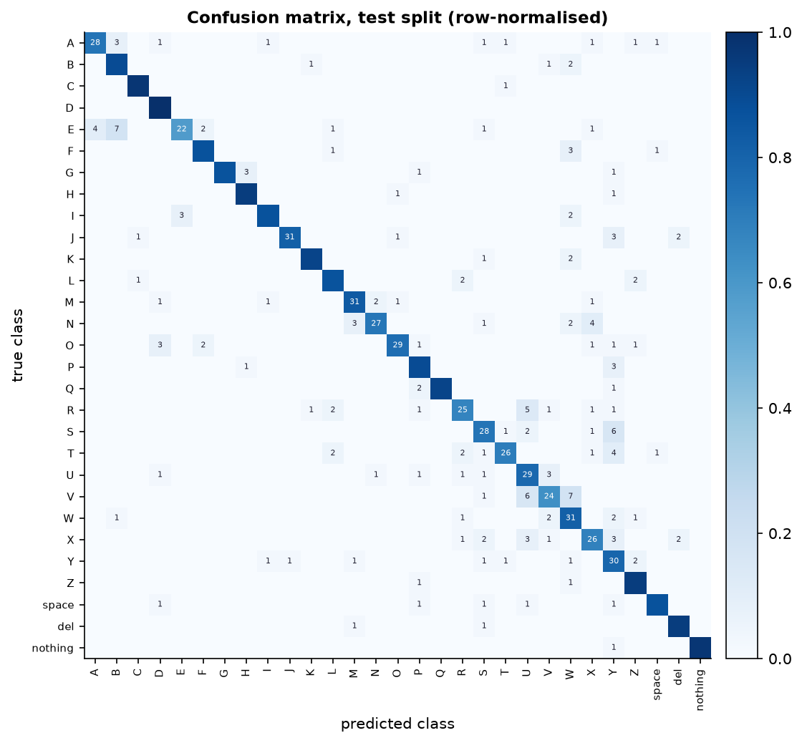
Figure 34: Confusion matrix of the 1,088 test images (rows true, columns predicted).
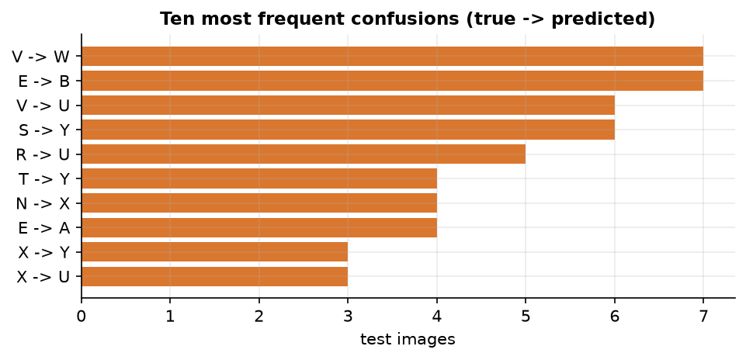
Figure 35: The most frequent confusions: V read as W (7), E as B (7), V as U (6), S as Y (6).
The matrix is concentrated on the diagonal. The off-diagonal mass is made of visually similar signs: V with W and U (extended fingers differing in spread), E with B and A (closed fingers versus a flat hand), S with Y. A human reader would expect these pairs to be the ones that are confused; the net does not make random errors.

8.4 Confidence threshold analysis
The recogniser accepts a prediction only if its confidence is at least 0.75; otherwise the frame counts as nothing. The test split shows what this buys. If every frame were accepted, 82.81 % would be correct. With the threshold at 0.75, 70.3% of the frames are accepted and 97.1% of those are correct; the rest are ignored and the user simply holds the sign a little longer. The trade-off is shown in the figure and the table.
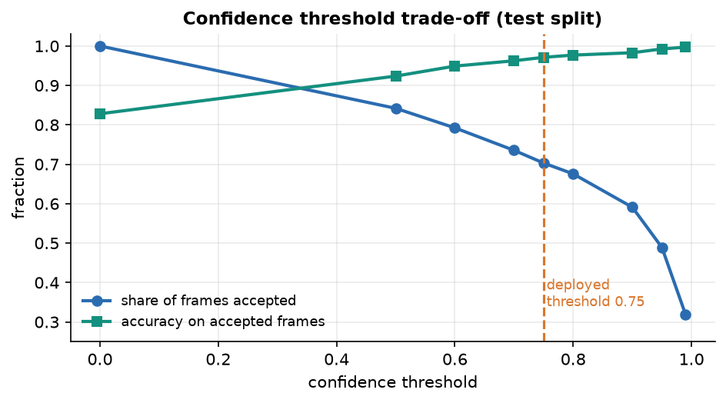
Figure 36: Share of frames accepted and accuracy on the accepted frames for confidence thresholds from 0 to 0.99.
Table 27: Confidence threshold trade-off (test split)
Threshold | Frames accepted | Accuracy on accepted frames
0.00 | 100.0% | 82.8%
0.50 | 84.2% | 92.4%
0.60 | 79.2% | 94.9%
0.70 | 73.5% | 96.2%
0.75 (used) | 70.3% | 97.1%
0.80 | 67.6% | 97.7%
0.90 | 59.1% | 98.3%
0.95 | 48.9% | 99.2%
0.99 | 31.9% | 99.7%

A higher threshold gives cleaner letters but makes the signer wait; at 0.95 only 48.9 % of frames pass. The threshold of 0.75 was chosen by design before these measurements and sits in the middle of the curve. Together with the 15-frame vote and the 18-frame stability rule (about a second at 17-19 frames per second), it is what turns a 82.8 % frame-level classifier into a keyboard that makes few wrong letters. We did not measure the letter error rate of whole typed words with real signers; that would need a user study.

8.5 Other evidence
Other archive photos. 2,900 further photos of the same archive (100 per class) that were never copied into data/ give 87.24% accuracy (macro F1 0.8735, top-3 96.10%). This number is optimistic and is not used as the headline: the photos come from the same recordings, and the training set took every 12th frame, so many of these photos are near neighbours of trained frames.
Official Kaggle test photos. The archive's own 28-image test set is read correctly in 26 of 28 cases. The two errors are A read as S (confidence 0.675) and I read as D (0.734). Twenty-eight images is far too few to estimate accuracy; the result is a sanity check.

8.6 Comparison with the base paper
The base paper [1] (MAG-KD) and SignSpeak solve different problems, so the comparison below is context, not a ranking, and no claim of superiority is made. MAG-KD recognises isolated word signs from video by classifying sequences of 2D skeletons with a graph network distilled from three teachers, and is evaluated on large benchmarks with several random seeds. SignSpeak recognises static fingerspelling letters from single frames with a plain CNN on a CPU and is evaluated once on a held-out split of a single dataset.
Table 28: SignSpeak against the base paper (different tasks, data and hardware)
Aspect | Base paper [1] | SignSpeak (this work)
Task | Isolated sign (word) recognition from video | Static fingerspelling letters (A-Z) and three control signs from single frames
Input representation | 2D skeleton sequences from a pose estimator (27 joints) | Binary hand mask, 64x64, from classical segmentation
Model | STA-GCN student distilled from SL-GCN, CTR-GCN and TD-GCN teachers (MAG-KD) | 3-block CNN, 2.20 M parameters, no distillation
Data | AUTSL: 38,336 videos, 43 signers, 226 signs; WLASL-100 | Kaggle ASL Alphabet subset: 7,250 images, 29 classes, no signer labels
Reported accuracy | 94.25 +/- 0.19 % Top-1 (AUTSL, 0.48 M parameters); 66.33 +/- 0.54 % (WLASL-100) | 82.81 % on a random held-out split (1,088 images); no unseen-signer test
Statistical care | Three seeds, mean and standard deviation | One seed, one run
Hardware and speed | NVIDIA Jetson Nano, TensorRT FP16: 33.13 FPS at 6.23 W | Intel i5-12500 CPU, TensorFlow: 17.6 FPS end to end (57 ms per frame); power not measured
Deliverable | Training method and edge deployment study | Working application: camera, recognition, sentence, speech, collection, training

What can be said fairly: both works are motivated by real-time sign recognition on modest hardware, and both report speed on the hardware they used. What cannot be said: that either accuracy is better, because one is a 226-way word problem on video and the other a 29-way letter problem on stills. The base paper's decisive ideas (distilling several teachers with a correctness mask, skeleton input) are not used in SignSpeak; Chapter 9 states what SignSpeak does contribute.

8.7 Success and failure analysis

8.7.1 Where it works
The network is strongest on shapes that are distinct in the mask: C, Q, G and K, and the empty-box class nothing (F1 0.99). With a clean mask, a steady hand and the box well filled, the live screen reads a letter at confidences of 0.85 or more (the Recognize capture shows H at 87 %), and the vote-and-hold logic then types it once.

8.7.2 Where it fails
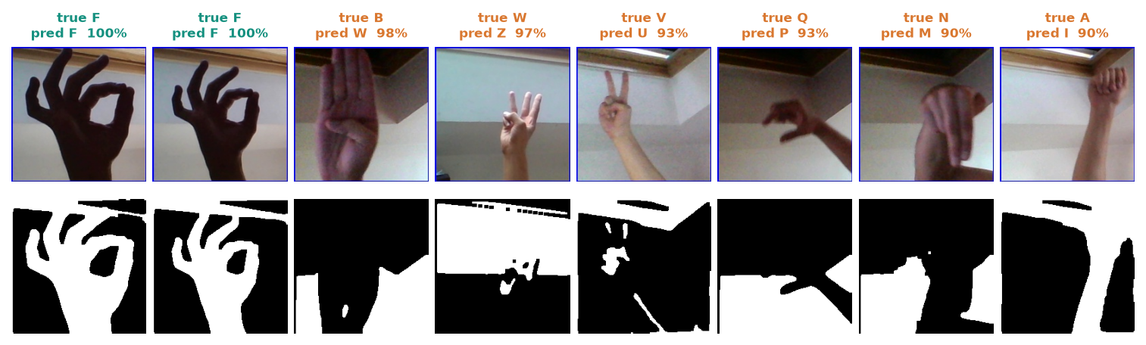
Figure 37: Confident mistakes on other archive photos: the raw crop, the mask and the wrong reading.
Of 1,160 other archive photos examined for failures, 147 (12.7 %) were read wrongly. The most confident mistakes include B read as W at 0.975; W read as Z at 0.975; V read as U at 0.934; Q read as P at 0.926. A wrong reading can therefore carry a high confidence, so the threshold reduces but cannot remove wrong letters.
• Look-alike signs. V, U, W and R differ in finger spread; E, S and A are closed fists differing in thumb position. The mask has little to separate them.
• Background structure in the mask. Otsu does not isolate the hand on a cluttered background, and the network partly learns the scenes it was trained on (Chapter 6).
• Rotation. Tilting the hand by 10 degrees lowers accuracy from 85.0 % to about 68 % (Chapter 7).
• Motion letters. J and Z are drawn in the air; a single frame cannot show the motion, so they are read from their start pose only (their F1 here is 0.89, so the dataset's J and Z images can be told apart from single frames, but the real motion is not captured).
• Brightness. A 1.5 times brighter image drops accuracy to 73.3 %; darker and noisier images matter little.

8.8 Limitations of the results
• No evaluation on unseen signers, new backgrounds or a physical webcam; the held-out split shares recordings with the training set.
• A single run with one seed; no confidence interval and no comparison of alternative architectures, preprocessing choices or hyper-parameters.
• Training used 250 of the 3,000 available images per class; more data was not tried.
• The 87.24 % figure on other archive photos is inflated by near-duplicate frames and should not be quoted as the accuracy.
• Latency was measured on one CPU with one client; power use was not measured.

8.9 Objectives against outcomes
Table 29: Objectives (from the project's objectives document) against outcomes
No. | Objective | Outcome
1 | Build a dataset of hand gesture images covering the target sign alphabet and common words. | Partly. Alphabet plus three control classes: 7,250 working images from the public archive, and the in-app collection tool. Common words: not done (static letters only).
2 | Preprocess images with segmentation, resizing and augmentation to improve generalisation. | Done. ROI crop, Otsu segmentation, 64x64 normalisation, training-time augmentation. Weakness: segmentation does not isolate the hand on cluttered backgrounds.
3 | Design and train a CNN architecture for gesture classification. | Done. 3-block CNN, 2.20 M parameters, 82.81 % held-out accuracy.
4 | Optimise the model for real-time inference from a live camera feed. | Partly. 17.6 frames per second end to end on a CPU with no model optimisation; the CNN call dominates (50 ms). No quantisation or export was tried.
5 | Convert recognised signs into on-screen text and synthesised speech output. | Done. Sentence builder with space, back and clear; offline speech (pyttsx3) with a browser-voice fallback.
6 | Evaluate accuracy, per-class performance and inference latency on unseen signers. | Partly. Accuracy, per-class precision/recall/F1, confusion matrix, robustness and latency are measured. Unseen signers: not done; the archive has no signer identifiers.

Objectives 2, 3 and 5 are met, and objectives 1, 4 and 6 are met in part. The gaps are stated so that they can be closed: words need a video or sequence model and a new dataset; unseen-signer evaluation needs a dataset with signer identifiers or new recordings of several people; inference speed can be raised with a lighter inference path.

CHAPTER 9: CONCLUSION

9.1 Summary
SignSpeak is a working sign language recognition system for the ASL manual alphabet. A browser camera feeds frames to a FastAPI service that crops a hand region, segments it with Otsu's method, resizes it to 64x64 and classifies it with a three-block CNN of 2,199,453 parameters. A temporal rule (confidence 0.75, majority of 15, 18 stable frames) decides when a letter is typed; the letters form a sentence that can be spoken. The application also collects images, trains models and shows their performance. It runs on one CPU-only PC.

9.2 Objectives achieved
Of the six objectives, three were met (preprocessing with segmentation and augmentation, a trained CNN, text and speech output) and three were met in part: the dataset covers the alphabet and control signs but not common words; real-time operation is achieved at about 17.6 frames per second on a CPU without model optimisation; and evaluation covers accuracy, per-class performance and latency but not unseen signers. Chapter 8 gives the table.

9.3 Key findings
1. A compact CNN on a 64x64 Otsu mask reads held-out frames of the dataset with 82.81% accuracy (macro F1 0.830, top-3 92.9%).
2. Confidence is informative: at the 0.75 threshold the system accepts 70.3% of frames and is right on 97.1% of them, so rejecting low-confidence frames is an effective filter.
3. Errors concentrate in look-alike signs (V with W and U, E with B and A, S with Y) and in rotated or brighter images (accuracy 85.0 % falls to about 68 % at +/-10 degrees of rotation).
4. The system is fast enough to be used live on a CPU: 52.9 ms per frame on the server, 17.6 frames per second end to end; the CNN call is 95 % of the server time.
5. Numbers measured on a random split of video frames are optimistic: other photos of the same archive score 87.24 %, but near-duplicate frames explain part of that, so the held-out 82.81 % is the figure we report.
6. A single code path for desktop and web, backed by 52 tests, made it possible to rebuild the interface without touching the recognition logic.

9.4 Practical applications
• A fingerspelling aid for a signer to spell a name or a technical term to a hearing person, with the sentence shown and spoken.
• A teaching tool for learners of the ASL alphabet, who can check whether a hand shape is read as intended.
• A platform for building personal or local-variant models: the Collect and Train screens let a user capture their own hands and retrain.
• A base for classroom exercises on the whole machine-learning cycle: data, preprocessing, training, evaluation and deployment.

9.5 Known limitations
The system recognises letters only, was evaluated on held-out frames of the same recordings as the training set and not on unseen signers, is sensitive to rotation and cluttered backgrounds, was tested end to end with a fake camera, has no authentication, and has had no user study. It is a research and teaching prototype, not a certified assistive device. Section 8.8 and the limitation table of the scope document give the full list.

CHAPTER 10: FUTURE SCOPE

10.1 Improvements to the recogniser
• Unseen-signer evaluation first. Record several signers in several rooms (or use a dataset with signer identifiers), split by signer, and report that accuracy as the headline; this is the most important missing measurement.
• More data and a proper search. Use more than 250 images per class, longer runs and a small hyper-parameter search; add ablations of the preprocessing (Otsu against skin mask against none) and of the dropout rates.
• Better hand isolation. Replace Otsu by a hand-landmark detector such as MediaPipe [13] and classify the landmarks (or crop around them), which would remove most background structure and bring SignSpeak closer to the skeleton idea of the base paper [1].
• Orientation robustness. Rotation-aware augmentation beyond 12 degrees, or normalising the hand's orientation, to address the drop to about 68 % at 10 degrees of tilt.
• Calibrated confidence. Temperature scaling so that a confidence of 0.8 means about 80 % right, and a per-user threshold.

10.2 Additional features
• Words and phrases. A sequence model over landmarks or frames (for example a small temporal CNN or a graph network) trained on a word-level dataset such as WLASL [15] or AUTSL [14], with a vocabulary beyond the alphabet.
• Motion letters. Recognise J and Z from a short window of frames instead of one frame.
• Two-way communication. Add speech-to-text so that a hearing person's reply is shown to the signer.
• Personalisation. A short calibration that fine-tunes the model on a new user's hand in a minute.
• Languages and voices. Other sign alphabets and text-to-speech voices.

10.3 Scalability and deployment
• Faster inference. Call the model directly instead of model.predict, export to a lighter runtime and quantise; the 50 ms CNN call is the main cost. Running the model in the browser (for example with TensorFlow.js) would remove the server round trip.
• Edge devices. Port to a phone or a Jetson-class board; the base paper's ONNX and TensorRT workflow [1] is a template, and its power and speed profiling would give a fair comparison of hardware cost.
• Packaging and sharing. Container image, authentication and restricted origins before any network use; a persistent session store if several users are to share one server.
• Continuous evaluation. Run the measurement script and the 52 tests in a CI pipeline so that every model change is evaluated automatically.

10.4 Further research
• Apply knowledge distillation, the base paper's technique [12], [1], to compress a stronger teacher into the small student used here, and measure the accuracy-latency trade-off on the same held-out and unseen-signer data.
• Study how much of the accuracy comes from the hand and how much from the scene by training on masks with the background removed.
• Run a user study with deaf and hearing participants to measure typing speed, error rate and acceptance.

REFERENCES
[1] D. T. D. Vo, V. D. Nguyen, T. H. M. Nguyen and M. H. Vo, "MAG-KD: Mask-guided adaptive gating knowledge distillation for skeleton-based sign language recognition on edge devices," IEEE Access, vol. 14, pp. 54761-54775, 2026, doi: 10.1109/ACCESS.2026.3681176.
[2] B. A. Al Abdullah, G. A. Amoudi and H. S. Alghamdi, "Advancements in sign language recognition: A comprehensive review and future prospects," IEEE Access, vol. 12, pp. 128871-128895, 2024.
[3] R. Rastgoo, K. Kiani and S. Escalera, "Sign language recognition: A deep survey," Expert Syst. Appl., vol. 164, Art. no. 113794, Feb. 2021.
[4] T. Starner, J. Weaver and A. Pentland, "Real-time American Sign Language recognition using desk and wearable computer based video," IEEE Trans. Pattern Anal. Mach. Intell., vol. 20, no. 12, pp. 1371-1375, Dec. 1998.
[5] N. Pugeault and R. Bowden, "Spelling it out: Real-time ASL fingerspelling recognition," in Proc. IEEE Int. Conf. Comput. Vis. Workshops (ICCV Workshops), Barcelona, Spain, Nov. 2011, pp. 1114-1119.
[6] V. Bheda and D. Radpour, "Using deep convolutional networks for gesture recognition in American Sign Language," 2017, arXiv:1710.06836.
[7] Y. LeCun, L. Bottou, Y. Bengio and P. Haffner, "Gradient-based learning applied to document recognition," Proc. IEEE, vol. 86, no. 11, pp. 2278-2324, Nov. 1998.
[8] A. Krizhevsky, I. Sutskever and G. E. Hinton, "ImageNet classification with deep convolutional neural networks," Commun. ACM, vol. 60, no. 6, pp. 84-90, May 2017.
[9] D. Tran, L. Bourdev, R. Fergus, L. Torresani and M. Paluri, "Learning spatiotemporal features with 3D convolutional networks," in Proc. IEEE Int. Conf. Comput. Vis. (ICCV), Dec. 2015, pp. 4489-4497.
[10] J. Carreira and A. Zisserman, "Quo vadis, action recognition? A new model and the Kinetics dataset," in Proc. IEEE Conf. Comput. Vis. Pattern Recognit. (CVPR), Jul. 2017, pp. 4724-4733.
[11] S. Yan, Y. Xiong and D. Lin, "Spatial temporal graph convolutional networks for skeleton-based action recognition," in Proc. AAAI Conf. Artif. Intell., vol. 32, no. 1, 2018.
[12] G. Hinton, O. Vinyals and J. Dean, "Distilling the knowledge in a neural network," 2015, arXiv:1503.02531.
[13] C. Lugaresi et al., "MediaPipe: A framework for building perception pipelines," 2019, arXiv:1906.08172.
[14] O. M. Sincan and H. Y. Keles, "AUTSL: A large scale multi-modal Turkish Sign Language dataset and baseline methods," IEEE Access, vol. 8, pp. 181340-181355, 2020.
[15] D. Li, C. R. Opazo, X. Yu and H. Li, "Word-level deep sign language recognition from video: A new large-scale dataset and methods comparison," in Proc. IEEE Winter Conf. Appl. Comput. Vis. (WACV), Mar. 2020, pp. 1448-1458.
[16] N. C. Camgoz, S. Hadfield, O. Koller, H. Ney and R. Bowden, "Neural sign language translation," in Proc. IEEE/CVF Conf. Comput. Vis. Pattern Recognit. (CVPR), Jun. 2018, pp. 7784-7793.
[17] N. Otsu, "A threshold selection method from gray-level histograms," IEEE Trans. Syst., Man, Cybern., vol. SMC-9, no. 1, pp. 62-66, Jan. 1979.
[18] R. C. Gonzalez and R. E. Woods, Digital Image Processing, 4th ed. New York, NY, USA: Pearson, 2018.
[19] S. Ioffe and C. Szegedy, "Batch normalization: Accelerating deep network training by reducing internal covariate shift," in Proc. 32nd Int. Conf. Mach. Learn. (ICML), 2015, pp. 448-456.
[20] N. Srivastava, G. Hinton, A. Krizhevsky, I. Sutskever and R. Salakhutdinov, "Dropout: A simple way to prevent neural networks from overfitting," J. Mach. Learn. Res., vol. 15, no. 56, pp. 1929-1958, 2014.
[21] D. P. Kingma and J. Ba, "Adam: A method for stochastic optimization," in Proc. Int. Conf. Learn. Represent. (ICLR), 2015, arXiv:1412.6980.
[22] C. Shorten and T. M. Khoshgoftaar, "A survey on image data augmentation for deep learning," J. Big Data, vol. 6, Art. no. 60, 2019.
[23] M. Abadi et al., "TensorFlow: A system for large-scale machine learning," in Proc. 12th USENIX Symp. Oper. Syst. Design Implement. (OSDI), 2016, pp. 265-283.
[24] G. Bradski, "The OpenCV library," Dr. Dobb's J. Softw. Tools, 2000.
[25] Akash, "ASL Alphabet," Kaggle dataset (grassknoted/asl-alphabet). [Online]. Available: https://www.kaggle.com/datasets/grassknoted/asl-alphabet (accessed Oct. 2026).
[26] F. Chollet et al., "Keras," 2015. [Online]. Available: https://keras.io
[27] S. Ramirez, "FastAPI." [Online]. Available: https://fastapi.tiangolo.com (accessed Oct. 2026).
[28] "Sign language recognition," in Sign Language Processing, 2024. (Listed in the project literature survey; authors not recorded there and not verified.)
[29] "Gesture recognition for sign language with AI," 2024. (Listed in the project literature survey; authors and venue not recorded there and not verified.)
[30] "Implementation of a dynamic gesture recognition based Indian Sign Language," i-manager's J. Pattern Recognit., 2024. (Listed in the project literature survey; authors not recorded there and not verified.)
[31] "Translation independent gesture recognition system for multilingual sign language," 2025. (Listed in the project literature survey; authors and venue not recorded there and not verified.)

APPENDIX A: IMPORTANT CODE
The listings are copied from the repository (8.ProjectCode) at the state in which the results of this report were measured. Docstrings are kept; nothing is shortened inside a listing.

A.1 Segmentation and normalisation (`sign_language_app/preprocessing.py`)
def segment_threshold(blurred_gray: np.ndarray) -> np.ndarray:
"""Otsu binary threshold -> isolates the hand silhouette from background."""
_, mask = cv2.threshold(
blurred_gray, 0, 255, cv2.THRESH_BINARY + cv2.THRESH_OTSU
)
# Ensure the hand (foreground) is the brighter region; if the mask is
# mostly white it likely inverted against a bright background, so flip it.
if np.mean(mask) > 127:
mask = cv2.bitwise_not(mask)
kernel = np.ones((3, 3), np.uint8)
mask = cv2.morphologyEx(mask, cv2.MORPH_OPEN, kernel, iterations=1)
mask = cv2.morphologyEx(mask, cv2.MORPH_CLOSE, kernel, iterations=2)
return mask

def segment_skin(roi_bgr: np.ndarray) -> np.ndarray:
"""YCrCb skin-color mask; more robust against cluttered backgrounds."""
ycrcb = cv2.cvtColor(roi_bgr, cv2.COLOR_BGR2YCrCb)
lower = np.array([0, 133, 77], dtype=np.uint8)
upper = np.array([255, 173, 127], dtype=np.uint8)
mask = cv2.inRange(ycrcb, lower, upper)
kernel = np.ones((3, 3), np.uint8)
mask = cv2.morphologyEx(mask, cv2.MORPH_OPEN, kernel, iterations=1)
mask = cv2.morphologyEx(mask, cv2.MORPH_CLOSE, kernel, iterations=2)
mask = cv2.GaussianBlur(mask, (5, 5), 0)
return mask

def segment_hand(roi_bgr: np.ndarray, mode: str | None = None) -> np.ndarray:
"""Full grayscale -> blur -> segmentation pipeline. Returns a uint8 mask."""
mode = mode or config.SEGMENTATION_MODE
gray = cv2.cvtColor(roi_bgr, cv2.COLOR_BGR2GRAY)
blurred = reduce_noise(gray)

if mode == "skin":
return segment_skin(roi_bgr)
return segment_threshold(blurred)

def normalize_for_model(mask: np.ndarray, size: int = config.IMG_SIZE) -> np.ndarray:
"""Resize + scale to [0, 1], shaped (size, size, 1) float32."""
resized = cv2.resize(mask, (size, size), interpolation=cv2.INTER_AREA)
normalized = resized.astype("float32") / 255.0
return np.expand_dims(normalized, axis=-1)

def preprocess_roi(roi_bgr: np.ndarray, mode: str | None = None):
"""Convenience: full pipeline from a raw color ROI crop to model input.

Returns (model_input, display_mask) where model_input is ready to feed
into the CNN (with an added batch dimension by the caller) and
display_mask is a uint8 image suitable for on-screen preview.
"""
mask = segment_hand(roi_bgr, mode=mode)
model_input = normalize_for_model(mask)
return model_input, mask

A.2 The network (`sign_language_app/model.py`)
model = models.Sequential(name="asl_cnn")
model.add(layers.Input(shape=(img_size, img_size, channels)))

# Block 1
model.add(layers.Conv2D(32, (3, 3), padding="same", activation="relu"))
model.add(layers.BatchNormalization())
model.add(layers.MaxPooling2D((2, 2)))

# Block 2
model.add(layers.Conv2D(64, (3, 3), padding="same", activation="relu"))
model.add(layers.BatchNormalization())
model.add(layers.MaxPooling2D((2, 2)))
model.add(layers.Dropout(0.25))

# Block 3
model.add(layers.Conv2D(128, (3, 3), padding="same", activation="relu"))
model.add(layers.BatchNormalization())
model.add(layers.MaxPooling2D((2, 2)))
model.add(layers.Dropout(0.25))

# Classifier head
model.add(layers.Flatten())
model.add(layers.Dense(256, activation="relu"))
model.add(layers.BatchNormalization())
model.add(layers.Dropout(0.4))
model.add(layers.Dense(num_classes, activation="softmax"))

model.compile(
optimizer=optimizers.Adam(learning_rate=learning_rate),
loss="categorical_crossentropy",
metrics=["accuracy"],
)
return model

A.3 The recogniser (`sign_language_app/recognizer.py`)
class SignRecognizer:
def __init__(self):
self.model = None
self.labels: list[str] = []
self._history: deque[str] = deque(maxlen=config.PREDICTION_HISTORY_LEN)
self._stable_label = None
self._stable_count = 0
self._last_committed = None

@property
def is_loaded(self) -> bool:
return self.model is not None

def load(self) -> bool:
if not config.MODEL_PATH.exists():
return False
from tensorflow.keras.models import load_model # local import: slow to import

self.model = load_model(config.MODEL_PATH)
self.labels = load_labels()
self._history.clear()
self._stable_label = None
self._stable_count = 0
return True

def predict_frame(self, roi_bgr: np.ndarray):
"""Run one frame through the pipeline.

Returns a dict: {label, confidence, mask, committed}
`committed` is the letter to append to the output sentence, or None
if the current prediction hasn't been held stably for long enough.
"""
if not self.is_loaded:
return None

model_input, mask = preprocess_roi(roi_bgr)
batch = np.expand_dims(model_input, axis=0)
probs = self.model.predict(batch, verbose=0)[0]
top_idx = int(np.argmax(probs))
confidence = float(probs[top_idx])
label = self.labels[top_idx] if top_idx < len(self.labels) else "?"

accepted = label if confidence >= config.CONFIDENCE_THRESHOLD else "nothing"
self._history.append(accepted)
majority_label, _ = Counter(self._history).most_common(1)[0]

if majority_label == self._stable_label:
self._stable_count += 1
else:
self._stable_label = majority_label
self._stable_count = 1

committed = None
if (
self._stable_count >= config.STABLE_FRAMES_TO_COMMIT
and majority_label not in ("nothing",)
and majority_label != self._last_committed
):
committed = majority_label
self._last_committed = majority_label
self._stable_count = 0
elif majority_label == "nothing":
self._last_committed = None

return {
"label": label,
"confidence": confidence,
"mask": mask,
"stable_label": majority_label,
"committed": committed,
}

A.4 Training core (`sign_language_app/train.py`)
def train_model(
epochs: int = config.DEFAULT_EPOCHS,
batch_size: int = config.DEFAULT_BATCH_SIZE,
learning_rate: float = config.DEFAULT_LEARNING_RATE,
data_progress_cb=None,
epoch_cb=None,
stop_flag=None,
):
"""Loads data, trains the CNN, evaluates it, and persists artifacts.

Returns a dict summary (final metrics + history) for the caller to
display.
"""
dataset: Dataset = load_dataset(progress_cb=data_progress_cb)
save_labels(dataset.labels)

model = build_cnn(num_classes=len(dataset.labels), learning_rate=learning_rate)

augmenter = ImageDataGenerator(
rotation_range=12,
width_shift_range=0.1,
height_shift_range=0.1,
zoom_range=0.12,
shear_range=0.08,
fill_mode="nearest",
)
train_flow = augmenter.flow(
dataset.x_train, dataset.y_train, batch_size=batch_size, seed=config.RANDOM_SEED
)

callbacks = [
StreamingCallback(epoch_cb=epoch_cb, stop_flag=stop_flag),
EarlyStopping(monitor="val_accuracy", patience=6, restore_best_weights=True),
ModelCheckpoint(
str(config.MODEL_PATH), monitor="val_accuracy", save_best_only=True
),
]

history = model.fit(
train_flow,
steps_per_epoch=max(1, len(dataset.x_train) // batch_size),
epochs=epochs,
validation_data=(dataset.x_val, dataset.y_val),
callbacks=callbacks,
verbose=0,
)

model.save(config.MODEL_PATH)

test_loss, test_acc = model.evaluate(dataset.x_test, dataset.y_test, verbose=0)

y_pred = np.argmax(model.predict(dataset.x_test, verbose=0), axis=1)
y_true = np.argmax(dataset.y_test, axis=1)
report = classification_report(
y_true, y_pred, target_names=dataset.labels, zero_division=0
)

A.5 Recognition and collection endpoints (`backend/main.py`)
@app.post("/api/preview")
async def preview(frame: UploadFile = File(...)):
img = await _read_frame(frame)
return {"mask": _png_data_url(segment_hand(_roi(img)))}

_collect_lock = threading.Lock()

@app.post("/api/collect/{cls}")
async def collect(cls: str, frame: UploadFile = File(...)):
_check_class(cls)
img = await _read_frame(frame)
roi = _roi(img)
resized = cv2.resize(roi, (config.RAW_SAVE_SIZE, config.RAW_SAVE_SIZE), interpolation=cv2.INTER_AREA)
folder = config.DATA_DIR / cls
with _collect_lock:
folder.mkdir(parents=True, exist_ok=True)
path = folder / f"{cls}_{int(time.time() * 1000)}.png"
n = 0
while path.exists(): # two frames inside the same millisecond
n += 1
path = folder / f"{cls}_{int(time.time() * 1000)}_{n}.png"
cv2.imwrite(str(path), resized)
return {
"class": cls,
"saved": path.name,
"count": class_counts().get(cls, 0),
"mask": _png_data_url(segment_hand(roi), 96),
}

@app.post("/api/recognize/session")
def recognize_session():
sid = uuid.uuid4().hex[:12]
rec = SignRecognizer()
rec.model, rec.labels = _base.model, _base.labels
_sessions[sid] = rec
while len(_sessions) > _MAX_SESSIONS:
_sessions.popitem(last=False)
return {"session_id": sid, "model_loaded": _base.is_loaded}

@app.post("/api/recognize/reload")
def recognize_reload():
if not config.MODEL_PATH.exists():
raise HTTPException(404, "No trained model found. Train one first.")
ok = _reload_model()
return {"model_loaded": ok, "labels": _base.labels}

@app.post("/api/recognize/frame")
async def recognize_frame(frame: UploadFile = File(...), session_id: str = Form(...)):
if not _base.is_loaded:
raise HTTPException(409, "No trained model is loaded. Train one in the Train tab first.")
rec = _sessions.get(session_id)
if rec is None:
raise HTTPException(404, "Unknown session. Restart the camera to start a new one.")
img = await _read_frame(frame)
roi = _roi(img)
with _model_lock:
result = rec.predict_frame(roi)
return {
"label": result["label"],
"confidence": result["confidence"],
"stable_label": result["stable_label"],
"committed": result["committed"],
"mask": _png_data_url(result["mask"]),
}

A.6 Browser camera (`frontend/src/lib/camera.ts`, frame grab)
const grab = useCallback((quality = 0.85) => {
const video = videoRef.current;
if (!video || video.readyState < 2 || !video.videoWidth) return Promise.resolve<Blob | null>(null);
const canvas = (canvasRef.current ??= document.createElement("canvas"));
canvas.width = FRAME_W;
canvas.height = FRAME_H;
const ctx = canvas.getContext("2d");
if (!ctx) return Promise.resolve<Blob | null>(null);
// cover-crop the native frame to 16:9, then mirror horizontally
const vw = video.videoWidth;
const vh = video.videoHeight;
const target = FRAME_W / FRAME_H;
let sw = vw;
let sh = vh;
if (vw / vh > target) sw = vh * target;
else sh = vw / target;
const sx = (vw - sw) / 2;
const sy = (vh - sh) / 2;
ctx.save();
ctx.translate(FRAME_W, 0);
ctx.scale(-1, 1);
ctx.drawImage(video, sx, sy, sw, sh, 0, 0, FRAME_W, FRAME_H);
ctx.restore();
return new Promise<Blob | null>((resolve) => canvas.toBlob(resolve, "image/jpeg", quality));
}, []);

return { videoRef, state, error, start, stop, grab, running: state === "running" };

A.7 Unit tests of the decision logic (`tests/test_recognizer.py`)
"""Unit tests for the temporal smoothing / auto-commit logic of SignRecognizer (stub model, no TensorFlow weights)."""

import numpy as np

from sign_language_app import config
from sign_language_app.recognizer import SignRecognizer

LABELS = ["A", "B", "space", "del", "nothing"]

class StubModel:
"""Returns a fixed probability vector; set .probs between calls."""

def __init__(self):
self.probs = np.array([0.0] * len(LABELS))

def predict(self, batch, verbose=0):
return np.array([self.probs])

def make(label, confidence):
p = np.full(len(LABELS), (1 - confidence) / (len(LABELS) - 1))
p[LABELS.index(label)] = confidence
return p

def recognizer():
rec = SignRecognizer()
rec.model, rec.labels = StubModel(), LABELS
return rec

ROI = np.zeros((300, 300, 3), np.uint8)

def feed(rec, label, confidence, frames):
rec.model.probs = make(label, confidence)
return [rec.predict_frame(ROI) for _ in range(frames)]

def test_not_loaded_returns_none():
assert SignRecognizer().predict_frame(ROI) is None

def test_commits_after_stable_frames_exactly_once():
rec = recognizer()
results = feed(rec, "A", 0.95, config.STABLE_FRAMES_TO_COMMIT + 10)
committed = [r["committed"] for r in results if r["committed"]]
assert committed == ["A"]
first = next(i for i, r in enumerate(results) if r["committed"])
assert first == config.STABLE_FRAMES_TO_COMMIT - 1

APPENDIX B: INSTALLATION AND USER GUIDE

B.1 Requirements
• Windows PC with a webcam and speakers (the build machine was an Intel Core i5-12500 with 15.7 GB RAM and no GPU; these are the machine's figures, not stated minimums).
• Python 3.10 or 3.11 on the PATH and Node.js 18 or newer.
• Chrome or Edge, opened on http://localhost: browsers allow webcam access only on localhost or HTTPS.
• An internet connection for the first installation (TensorFlow 2.15.0 and the frontend packages are large).

B.2 Installation and start
1. Open the project folder 8.ProjectCode and double-click run.bat. It creates .venv, runs pip install -r requirements.txt, installs the frontend packages and starts both servers.
2. The browser opens http://localhost:5316; the API runs in its own window on port 8316 (documentation at http://127.0.0.1:8316/docs). The first request waits a few seconds while TensorFlow loads.
3. To stop, press Ctrl+C in the web window and close the API window. Ports are set in .env (BACKEND_PORT, FRONTEND_PORT).
Manual start: create a virtual environment, pip install -r requirements.txt, then python -m uvicorn backend.main:app --host 127.0.0.1 --port 8316 in one terminal and cd frontend && npm install && npm run dev in another. The original desktop application starts with python run.py.

B.3 Preparing data and a model
1. Use a public dataset. Copy an evenly spaced subset of the Kaggle ASL Alphabet images into data/<CLASS>/ with python scripts/prepare_data.py [archive_dir] [per_class] (default 250 per class), or
2. Collect your own. Open Collect data, start the camera, pick a letter, place the hand inside the cyan box and press Capture (one image) or Burst (several). 150 to 250 images per class is a good target; vary the hand position a little.
3. Open Train model. At least two classes need images. Choose epochs, batch size and learning rate (defaults 25, 32 and 0.001), press Start and watch the charts. The model, labels, history, report and confusion matrix are saved in models/.

B.4 Using the screens
Table 30: User guide
Screen | How to use it
Dashboard | Check that a model is ready, how many images each class has and the last test accuracy.
Recognize | Press Start camera (allow the camera in the address bar). Show a letter inside the box and hold it for about a second: it is typed into the sentence. Use Space, Back and Clear to edit and Speak sentence to hear it. A plain background and even light give the cleanest mask.
Collect data | Capture images for a class; the strip below shows recent captures.
Train model | Set the hyper-parameters and start; Stop ends a run early; the best weights are kept.
Model performance | Per-class precision, recall and F1, the confusion matrix and the training curves of the saved model.
About | The project abstract, the pipeline steps and the base paper.

B.5 Running the tests
python -m pytest tests # 52 tests, about 4 seconds
python scripts/smoke_test.py # 26 live API checks in a temporary copy (port 8399)
python scripts/measure_metrics.py # re-measure accuracy, threshold curve, robustness, latency
python scripts/verify_docs.py # check the submission documents

B.6 Troubleshooting
Table 31: Common problems
Symptom | Fix
"Can't reach the SignSpeak server" | The API window is not running or is still loading TensorFlow; wait about 20 seconds or run run.bat again.
Camera permission message | Allow the camera in the address bar; close other programs that use the webcam.
Port already in use | netstat -ano | findstr :5316, then taskkill /PID <pid> /F.
"No trained model" on Recognize | Train one first on the Train model screen.
Speak does nothing | The server voice plays on this PC's speakers; if it fails, the browser voice is used.
Letters are typed wrongly | Use a plain background and even light, keep the hand upright and inside the box, and hold the sign steady.

APPENDIX C: ADDITIONAL SCREENS
These captures complement Chapter 8: the light theme and the phone-width layout (390x844 px) of real screens with the trained model and the 7,250-image dataset loaded.
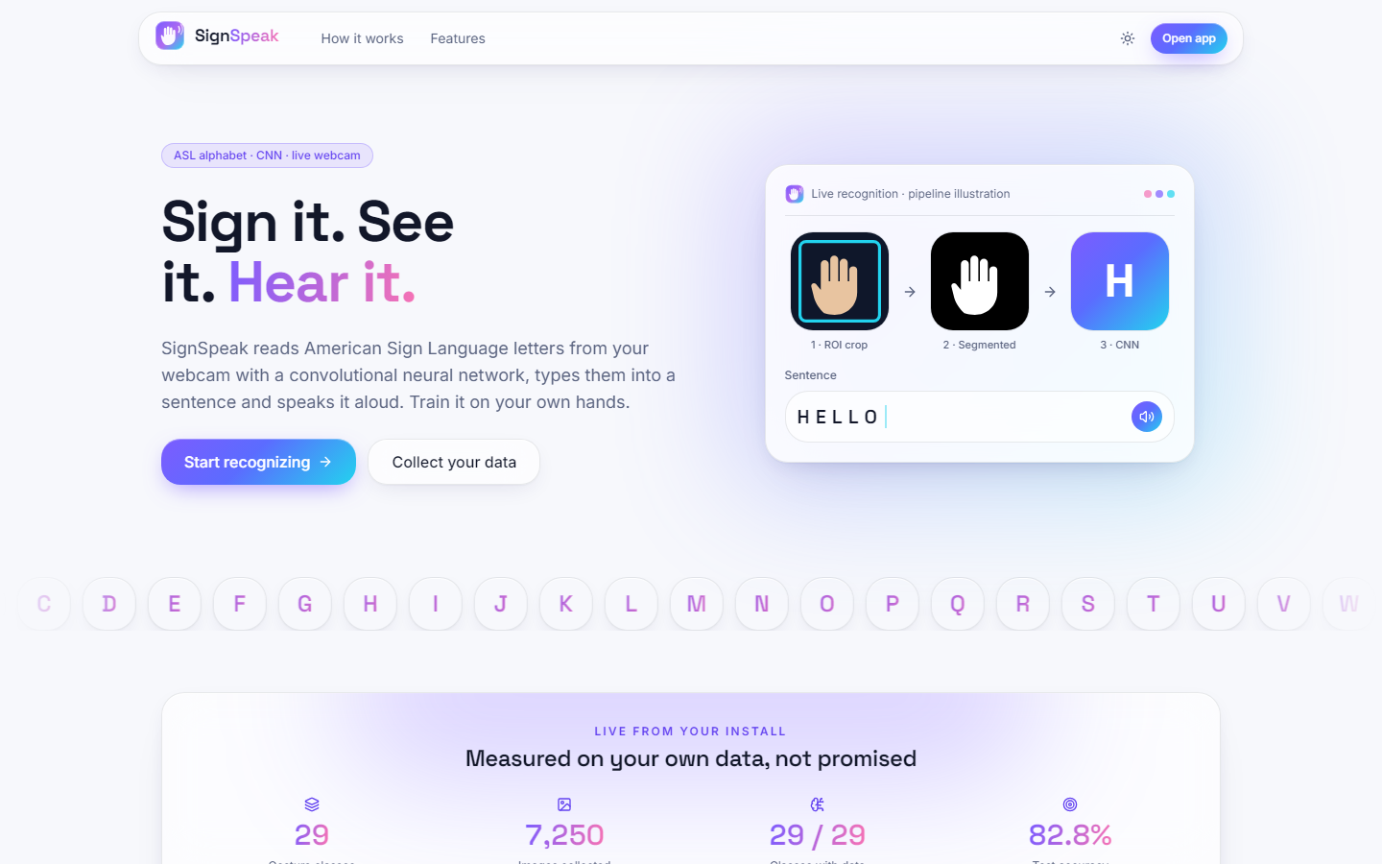
Figure 38: Landing page, light theme.
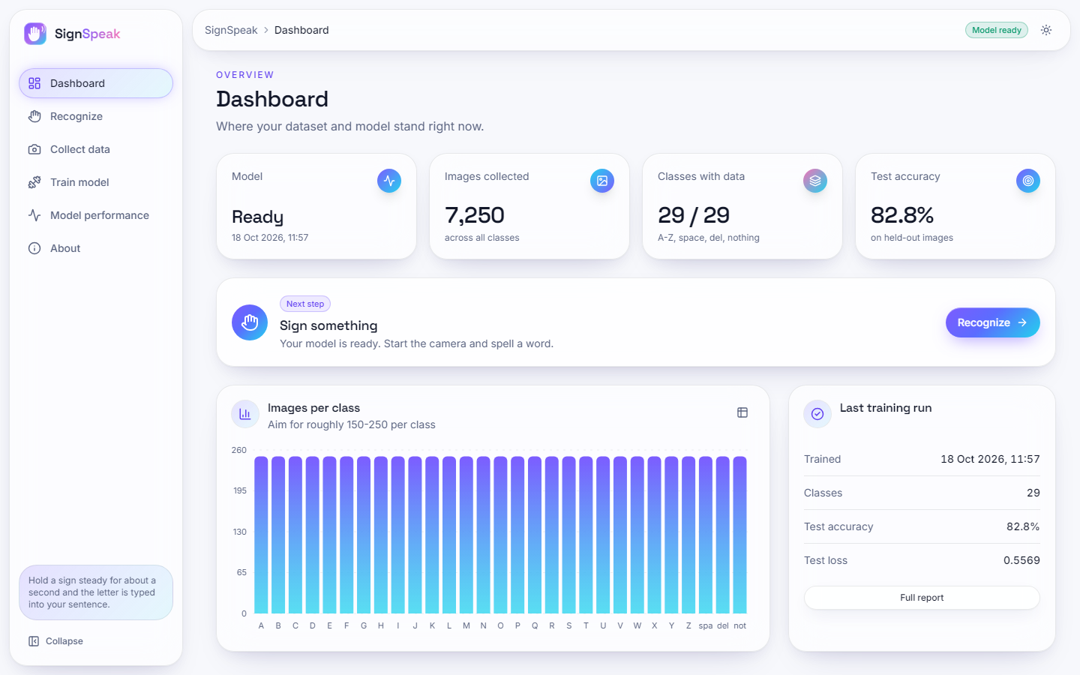
Figure 39: Dashboard, light theme.
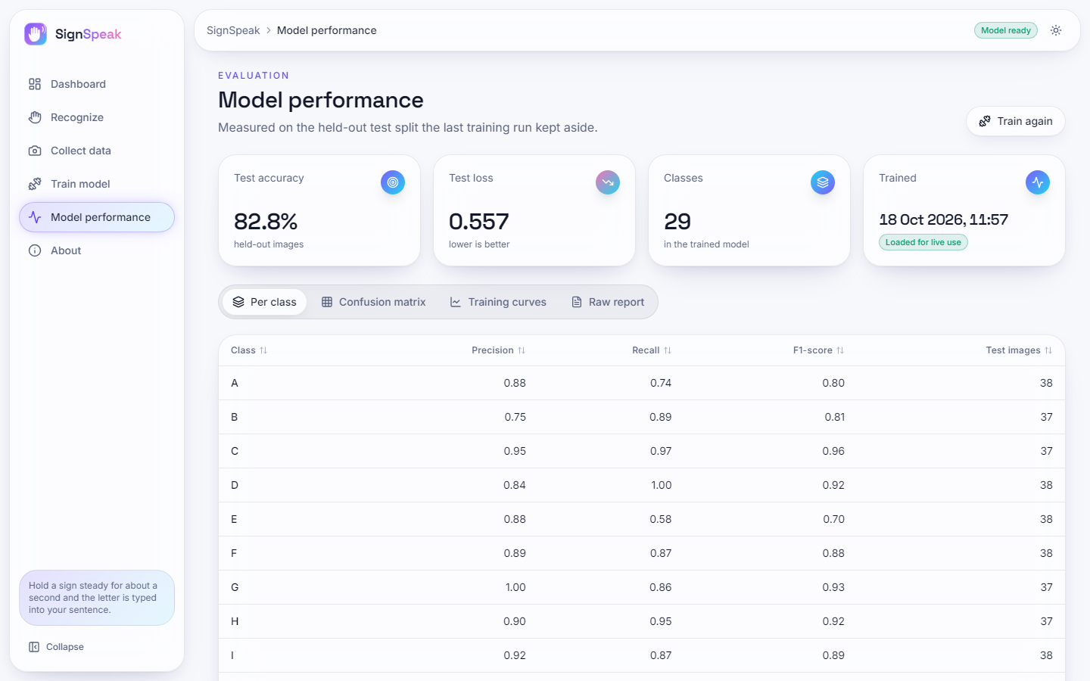
Figure 40: Model performance screen, light theme.
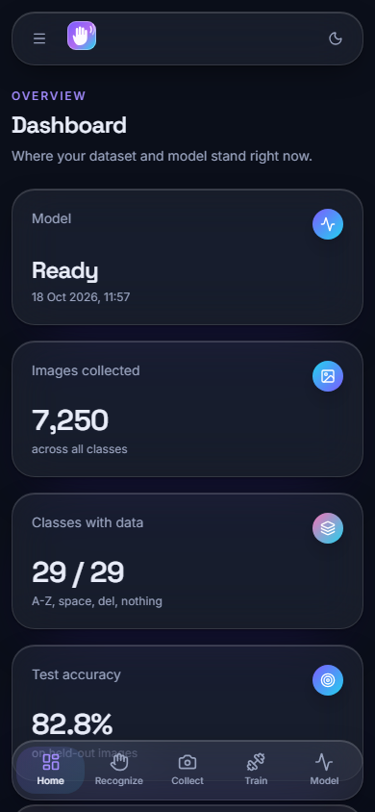  Figure 41: Dashboard at phone width (390x844). | 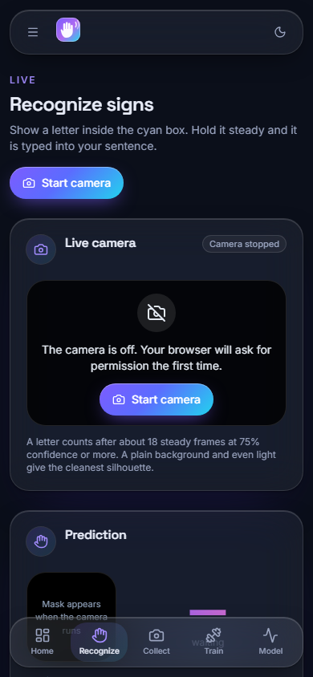  Figure 42: Recognize screen at phone width (390x844).

At phone width the navigation collapses into a drawer and the cards stack in one column; no content is cut off and the text stays readable. The browser walk checked every screen at 360, 768 and 1440 px.

